|  |  |
| --- | --- |
|  | **MINISTRY OF EDUCATION AND TRAINING** |

|  |
| --- |
| **FPT UNIVERSITY** |
| Capstone Project Document |
| SPA SERVICE PROVIDING SYSTEM |

|  |  |
| --- | --- |
| **SWP490_G51** | |
| **Group Members** | Hoang Manh Ha – HE140295  Nguyen Nhu Chuong – HE140285  Pham Kieu Trinh – HE140643  Tran Nam Long – HE140955  Nguyen Trung Dung – HE140858 |
| **Supervisor** | Le Thanh Hai |
| **Ext Supervisor** |  |
| **Capstone Project code** |  |

- Hanoi, September 2022 -

**Table of Contents**

Acknowledgement 4

Definition and Acronyms 4

I. Project Introduction 5

1. Overview 5

2. Product Background 5

3. Existing Systems 5

4. Business Opportunity 5

5. Software Product Vision 5

6. Project Scope & Limitations 5

II. Project Management Plan 6

1. Overview 6

2. Management Approach 6

3. Master Schedule 6

4. Project Organization 6

5. Project Communication 6

6. Configuration Management 6

III. Software Requirement Specification 7

1. Overall Description 7

2. User Requirements 7

3. Functional Requirements 7

4. Non-Functional Requirements 7

5. Other Requirements 7

IV. Software Design Description 8

1. Overall Description 8

2. System Architecture Design 8

3. System Detailed Design 8

4. Class Specification 8

5. Data & Database Design 8

V. Software Testing Documentation 9

1. Overall Description 9

2. Test Plan 9

3. Test Cases 9

4. Test Reports 9

VI. Release Package & User Guides 10

1. Deliverable Package 10

2. Installation Guides 10

3. User Manual 10

VII. Appendix 10

1. Glossary [Optional] 10

2. References [Optional] 10

3. Others [Optional] 10

# Acknowledgement

*[Fill team’s acknowledgement here…]*

# Definition and Acronyms

|  |  |
| --- | --- |
| **Acronym** | **Definition** |
| PWM | Psychology website |
| AWS | Amazon Web Services |
| BA | Business Analysis |
| BR | Business Rule |
| ERD | Entity Relationship Diagram |
| GUI | Graphical User Interface |
| PM | Project Manager |
| SDD | Software Design Description |
| SPMP | Software Project Management Plan |
| SRS | Software Requirement Specification |
| UAT | User Acceptance Test |
| UC | Use Case |
| API | Application Program Interface |

# I. Project Introduction

## 1. Overview

### 1.1 Project Information

* Project name: Spa Service Providing System
* Project code: SSDS
* Group name: SWP490_G51
* Software type: Web application

### 1.2 Project Team

|  |  |  |  |
| --- | --- | --- | --- |
| **Full Name** | **Role** | **Email** | **Mobile** |
| Le Thanh Hai | Lecturer | Hailt10@fe.edu.vn | 0912656836 |
| Hoang Manh Ha | Leader | HaHMHE140295@fpt.edu.vn |  |
| Nguyen Nhu Chuong | Member | ChuongNNHE140285@fpt.edu.vn |  |
| Pham Kieu Trinh | Member | TrinhPKHE140643@fpt.edu.vn |  |
| Tran Nam Long | Member | LongTNHE140955@fpt.edu.vn |  |
| Nguyen Trung Dung | Member | DungNTHE140858@fpt.edu.vn |  |

## 2. Product Background

Currently, people have more and more health care need and people's use of spa and beauty care services is increasing. More and more spa service establishments are springing up all over the country. Famous brands such as Beauty Beyond Spa, Thu Cuc Clinic, [herskincare.vn](http://herskincare.vn/), Skin Wisdom, etc. have affirmed their reputation and prestige over the past many years. Although they have built a brand, the above spas still do not have a website that provides good enough services to customers. Their website at first glance is quite full of functions to serve customer needs, but if you go into details, those functions are still only at a basic level. In addition, there are some spas that still use the method of contacting and replying to customers via chat box on Facebook, Instagram. This can take up too much of the customer's time and still not meet their actual needs.

## 3. Existing Systems

### 3.1 herskincare.vn

- Link web: herskincare.vn

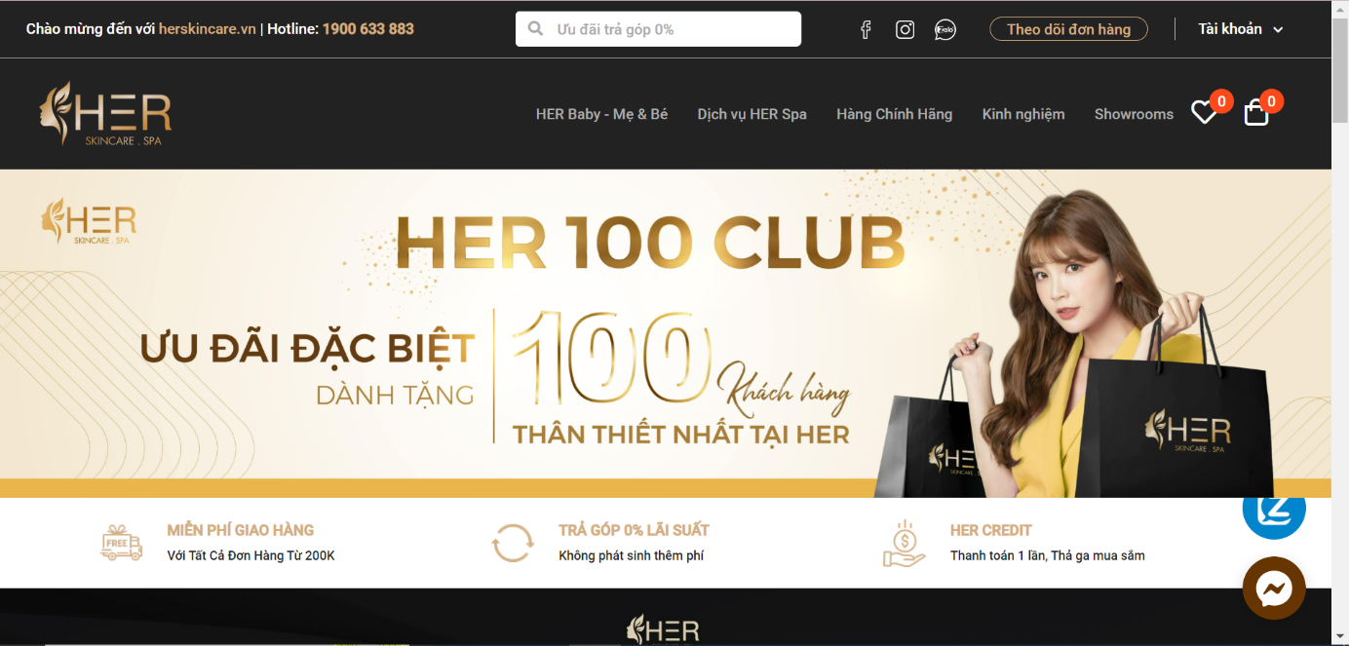

*Figure 3.1.1: herskincare Home Page*

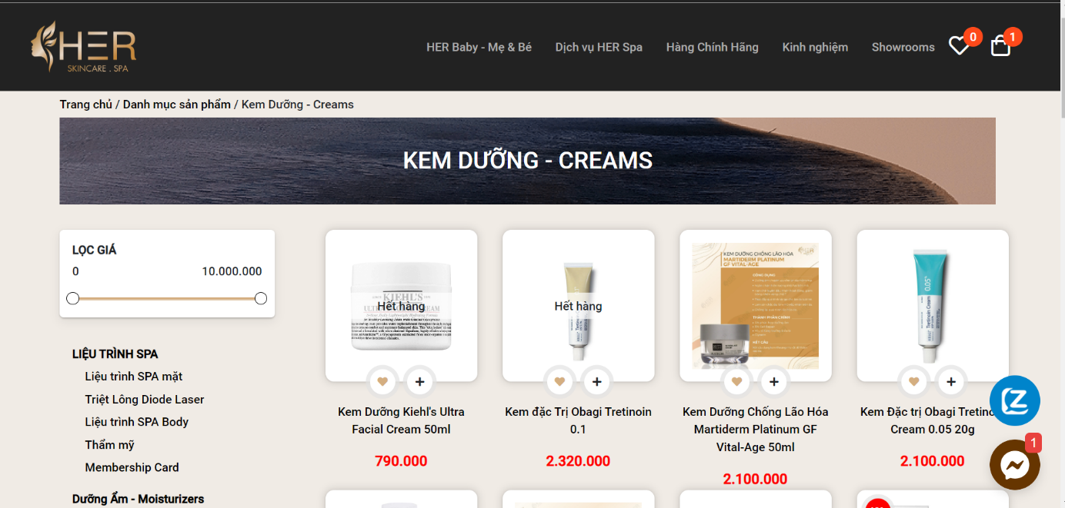

*Figure 3.1.2: Product Selling Page*

Customers can visit the website to view information about the spa services that Her provides as well as the products that Her sells. In addition, customers can also buy spa treatments and products right on the website.

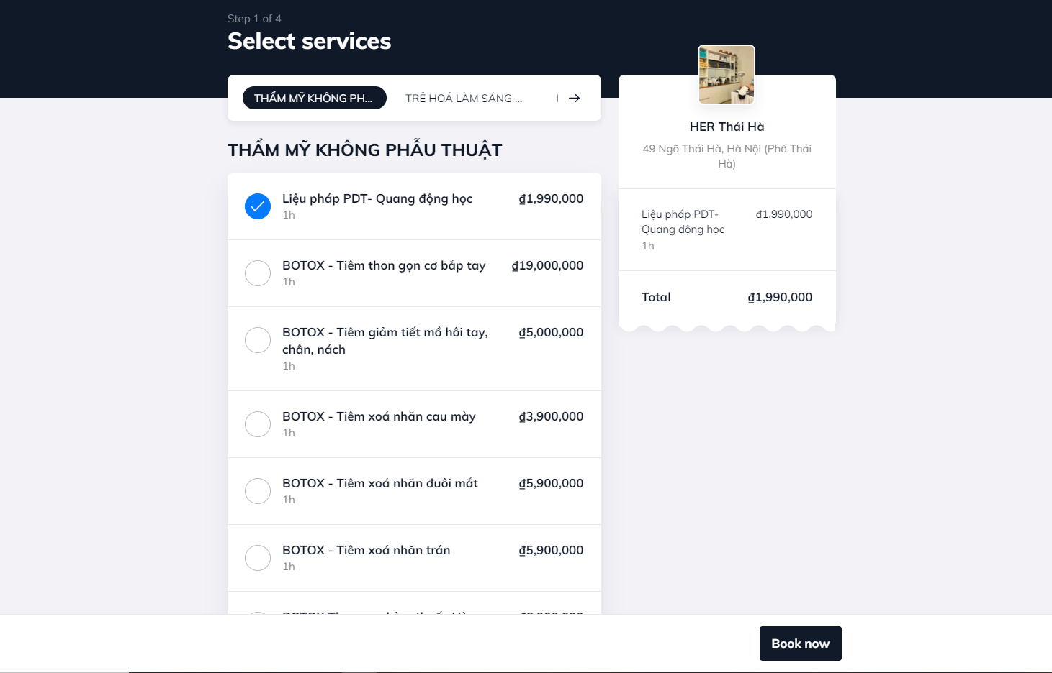

*Figure 3.1.3: Booking Page*

Customers can select services and choose time base on calendar.

|  |  |
| --- | --- |
| **Advantages** | **Disadvantages** |
| * Have full basic functions * Succinct, beauty layout * Wide range of services, products for customer to choose * Fast reload, forward page | * Cannot cancel booked appointment schedule |

### 3.2 Thu Cuc Clinic

- Link web: thucucclinics.com

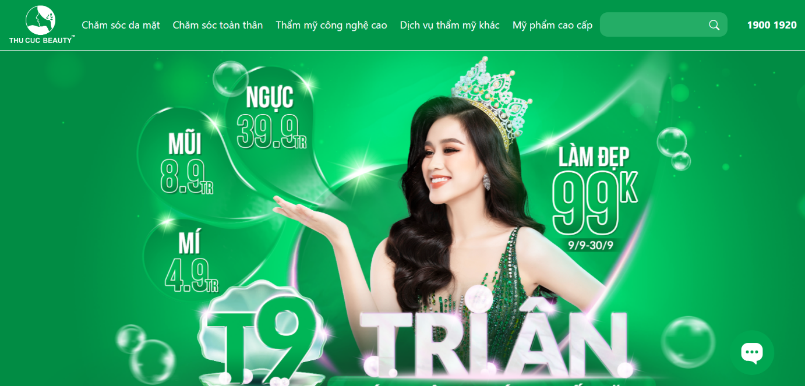

*Figure 3.2.1: Thu Cuc Clinic Home Page*

thucucclinics.com is a website that provides information about services, products, and technologies that Beauty Thu Cuc provides.

Customers can access the website to see detailed information of each service such as: Introduction, process, time, cost, …

## 

*Figure 3.2.2: Service detail page*

For consultation, customers need to leave their name, email address, question, phone number and wait for a response from the clinic.

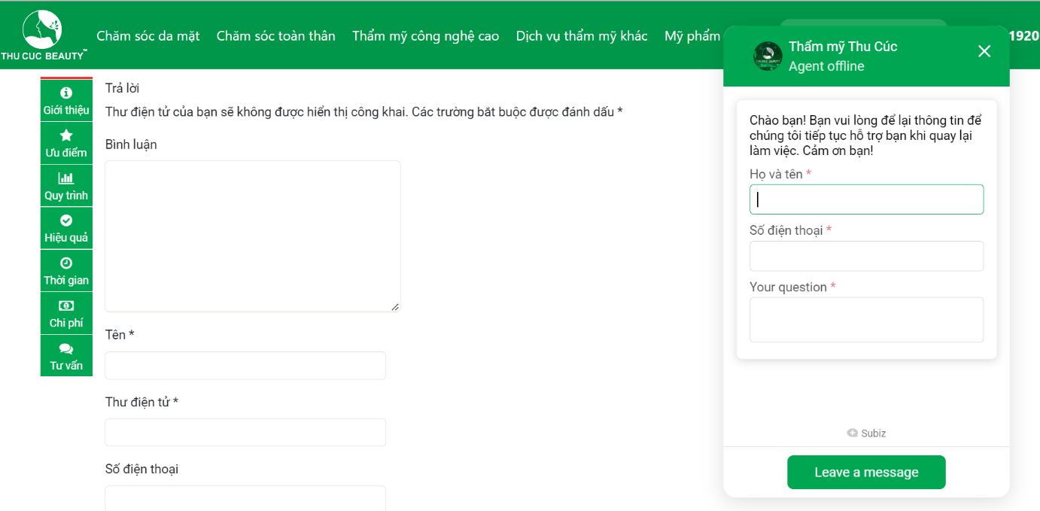

*Figure 3.2.3: Question and message form*

|  |  |
| --- | --- |
| **Advantages** | **Disadvantages** |
| * Provide very detail information about services * Succinct, beauty layout | * Don’t have booking function * Some links cannot connect |

## 4. Business Opportunity

There are many big spa brands but there are very few of them establish a convenient website for customer. Through the shortcomings in the current market, we want to develop a website providing spa services. We see this as a great potential that we can compete with existing brands on the market based on our superior technology. We guarantee that: On the customer side, it can be easily used, shorten the service selection time, provide real needs. Customers' needs while still ensuring the best efficiency. On the store owner's side, it is easy and quick to grasp the actual needs of customers to manage the store appropriately, helping customers and store owners communicate with each other conveniently.

## 5. Software Product Vision

For healthcare clients looking to book an appointment, the Spa Execution System is an internet-based and smartphone-enabled application that will accept individual and group appointments, process payments and distributing appointments to each spa facility. Unlike the process of booking appointments by phone, Facebook, Instagram... takes time and effort. Customers of Spa Execution System will not have to spend time waiting for answer from the shop owner which will help them be proactive in arranging and saving their own time.

## 6. Project Scope & Limitations

### 6.1 Major Features

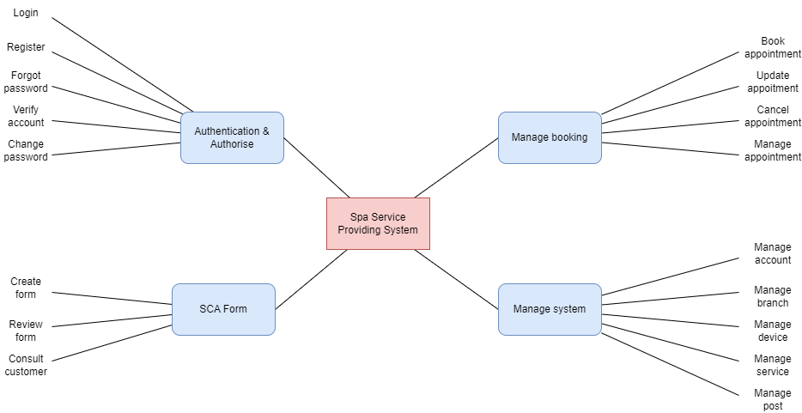

*Figure 6.1.1: Major Features of Spa Service Providing System*

|  |  |  |
| --- | --- | --- |
| **ID** | **Major Features** | **Description** |
| FE-01 | Authentication & authorise | User uses account to access the system, different roles access different features of this system. User can register by Google account. |
| FE-02 | Manage booking | This is our main feature. This feature includes different roles:   * Customer role: User can choose services and book an appointment. * Receptionist & Manager role: User can manage all appointments of customer. |
| FE-03 | SCA form | The website has a set of questions about health status for customer. Customer enters their information and problems they are facing. Based on the answers, the website will return a best result for them and recommend services which should be used. |
| FE-04 | Manage system | This feature is designed only for Manager role. Manager will have permission to manage the whole system includes create, update, delete, deactivate account, branch, device, post, service, course, category, data config, voucher, feedback. |

### 6.2 Limitations & Exclusions

**6.2.1 Limitations**

|  |  |
| --- | --- |
| **ID** | **Description** |
| LI-01 | New customers still cannot check the details of health assessment such as body, facial skin, stress, … to be able to advise the best service for customers. |
| LI-02 | Chat realtime don’t activate |
| LI-03 | Some functions need a person to confirm for the system |

**6.2.2 Exclusions**

|  |  |
| --- | --- |
| **ID** | **Description** |
| EX-01 | There is currently no actual payment function |

# II. Project Management Plan

## 1. Overview

### 1.1 Scope & Estimation

|  |  |  |  |
| --- | --- | --- | --- |
| **#** | **WBS Item** | **Complexity** | **Est. Effort**  **(man-days)** |
| **1** | **Pre-Initiation Phase** |  | ***5*** |
| 1.1 | Come up with ideas | Complex | 2.5 |
| 1.2 | Determine the role of team members | Simple | 1 |
| 1.3 | Choose topic | Medium | 1 |
| 1.4 | Register Capstone Project | Simple | 0.5 |
| **2** | **Initiation Phase** |  | ***10*** |
| 2.1 | Kick-offs meeting | Simple | 1 |
| 2.2 | Identify stakeholders | Medium | 4 |
| 2.3 | Meet Instructor | Simple | 1 |
| 2.4 | Project introduction | Medium | 4 |
| **3** | **Planning Phase** |  | ***23*** |
| 3.1 | Define project scope | Simple | 3 |
| 3.2 | Choose working model process | Simple | 2 |
| 3.3 | Select tools and techniques | Simple | 1 |
| 3.4 | Project schedule planning | Complex | 7 |
| 3.5 | Risk management plan | Medium | 5 |
| 3.6 | Project organization | Simple | 3 |
| 3.7 | Software project management planning | Medium | 3 |
| **4** | ***Execution Phase*** |  | ***225*** |
| 4.1 | **Requirements Analysis** |  | ***20*** |
| 4.1.1 | User Requirements | Medium | *8* |
| 4.1.2 | Functional Requirements | Medium | *8* |
| 4.1.3 | Non-Functional Requirements | Simple | *4* |
| 4.2 | **Design** |  | ***25*** |
| 4.2.1 | Basic architecture design | Medium | *5* |
| 4.2.2 | Detail design | Medium | *10* |
| 4.2.3 | Data & Database Diagram design | Complex | *10* |
| 4.3 | **Coding** |  | ***160*** |
| 4.3.1 | Back-end | Complex | *65* |
| 4.3.2 | Front-end | Complex | *65* |
| 4.3.3 | Fix bugs | Medium | *30* |
| 4.4 | **Testing** |  | ***40*** |
| 4.4.1 | Unit test | Medium | *14* |
| 4.4.2 | Integration test | Medium | *14* |
| 4.4.3 | System test | Medium | *8* |
| 4.4.4 | Acceptance test | Medium | *4* |
| **5** | **Monitoring and Controlling Phase** |  | ***23*** |
| 5.1 | Meet instructor | Simple | 3 |
| 5.2 | Control risk scope | Medium | 5 |
| 5.3 | Control cost | Medium | 5 |
| 5.4 | Process report | Medium | 10 |
| **6** | **Closing Phase** |  | ***25*** |
| 6.1 | Complete final report | Complex | 10 |
| 6.2 | Prepare for final project presentation | Medium | 9 |
| 6.3 | Present final report | Complex | 5 |
| 6.4 | Project closed | Simple | 1 |
| **Total Estimated Effort (man-days)** | | | ***311*** |

### 1.2 Project Objectives

|  |  |  |  |  |  |
| --- | --- | --- | --- | --- | --- |
| **#** | **Testing Stage** | **Test Coverage** | **No. of Defects** | **% of Defect** | **Notes** |
| 1 | Unit Test | 100% | 50 |  | Reviewing and tests |
| 2 | Integration Test | 100% | 30 |  | Tester creates and tests |
| 3 | System Test | 100% | 20 |  | Tester creates and tests |
| 4 | Acceptance Test | 100% | 10 |  | User verifies system |

Project must be finished before 15/12/2022 with three main deliverables:

* Web App (Cover 100% requirement)
* Project documentation (FPT University capstone project)
* Project presentation slides

### 1.3 Project Risks

|  |  |  |  |  |
| --- | --- | --- | --- | --- |
| **#** | **Risk Description** | **Impact** | **Possibility** | **Response Plans** |
| 1 | Absence of team members, especially by mental and physical illness | High | Low | Members must notify the team about the absence period, personal schedule, and the plan of how to keep up with the work process.  Ensure that the absence of a member won’t affect others and always have plans to deal with this problem. The PM reminds team members about task deadlines. |
| 2 | Broken devices or internet during working on project | High | Low | Carefully prepare personal device.  If the network is disconnected suddenly then use 4G. |

## 2. Management Approach

### 2.1 Project Process

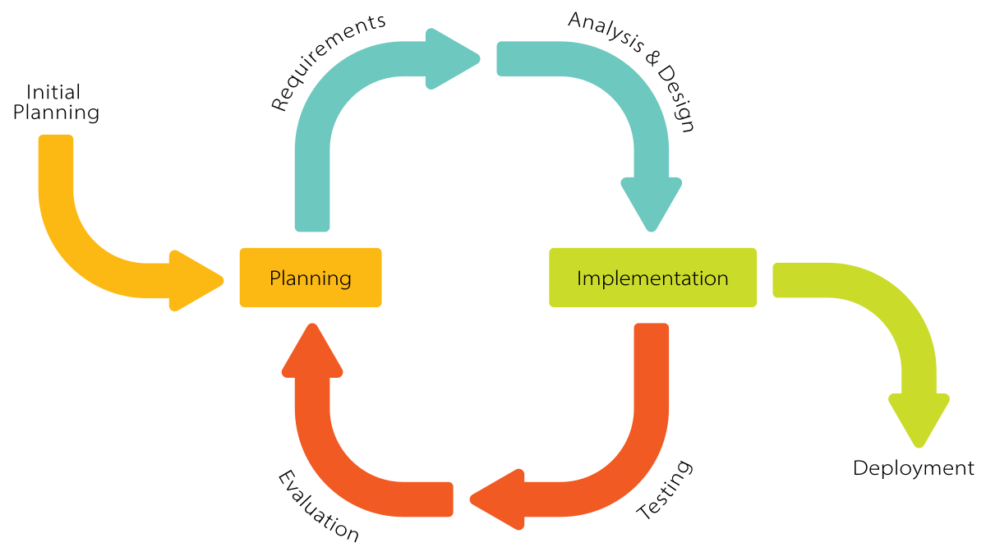

After researching the software development model carefully, the project will use the Iterative and Incremental Software Process Model. In an Iterative & Incremental model, initially, a partial implementation of a total system is constructed so that it will be in a deliverable state. The Iterative & Incremental model is mostly used when the scope of the project is big, the major requirements are defined clearly, some more details will be added later in software development. By using this software process model, we break down the developing system task into a series of smaller tasks which will be completed separately, allowing us to take advantage of what was learned during the development of earlier parts of the system. The reasons for the project to choose this model are:

* You can develop some main functions that prioritize requirements first.
* Requirements changes can be easily accommodated.
* Testing and debugging during smaller iterations is easy.
* Easier to manage risk easier because risk segments are identified and dealt with during its  iteration.
* Customers can provide feedback to each product increment, thus avoiding surprises at the end of development.
* Customers get important functionality early

### 2.2 Quality Management

**2.2.1 Defect Prevention:**

* If any defect is found, the related person must be notified immediately at that time.
* Defects must be carefully evaluated such as "How bad is the defect and can it damage the system?", "How long is the time to fix that defect?".
* The deadline for fixing the defect must be specified clearly.
* There is always a plan to prepare for what could happen at any time.

**2.2.2 Reviewing:**

* The curator must be honest and not biased towards any of the project members. If there is an error, the person must immediately notify the person responsible for the defect.
* Defects should be recorded on the Bug Tracking software with details such as priority.
* The person responsible for defects found must-have solutions to fix the defect as quickly as possible.

**2.2.3 Unit Testing:**

* The curator must prepare the test cases carefully and accurately and must not ignore any cases. Test cases should be appropriate for the functionality of the system.
* Defects should be recorded on the Bug Tracking software with details such as priority.
* The person responsible for defects found must-have solutions to fix the defect as quickly as possible.

**2.2.4 Integration Testing:**

* The curator must prepare the test cases carefully and accurately and must not ignore any cases. Test cases should be appropriate for the functionality of the system.
* Defects should be recorded on the Bug Tracking software with details such as priority.
* The person responsible for defects found must-have solutions to fix the defect as quickly as possible.
* Internal modules within the system work smoothly.

**2.2.5 System Testing:**

* The curator must prepare test cases carefully and accurately. The test cases must match well with the system and system and architecture design.
* Defects should be recorded on the Bug Tracking software with details such as priority.
* The person responsible for defects found must-have solutions to fix the defect as quickly as possible.
* System testing test cases cover the entire system functionality and the communication under development with external systems.

**2.2.6 Acceptance Testing:**

* The curator must prepare test cases carefully and accurately. The test cases must match well with the system and system and architecture design.
* Defects should be recorded on the Bug Tracking software with details such as priority.
* The person responsible for defects found must-have solutions to fix the defect as quickly as possible.
* The test should cover non-functional issues such as load and performance defects.

### 2.3 Training Plan

|  |  |  |  |
| --- | --- | --- | --- |
| Training Area | Participants | When, Duration | Waiver Criteria |
| Java Spring Boot | Backend Members | 15/09/2022 to 29/09/2022 | Mandatory |
| React JS | Frontend Members | 15/09/2022 to 29/09/2022 | Mandatory |
| Gitlab | All Team members | 15/09/2022 to 21/09/2022 | Mandatory |

## 3. Project Deliverables

|  |  |  |  |
| --- | --- | --- | --- |
| **#** | **Deliverable** | **Due Date** | **Notes** |
| 1 | Project Introduction | 15/09/2022 | Prepare project ideals/ Intro |
| 2 | Project Management Plan | 17/09/2022 | Prepare Project Plan, Create Technical Prototype |
| 3 | Software Requirement Specification (SRS) | 25/09/2022 | Write SRS Document and Create Test Plan |
| 4 | Software Design Specification (SDS) | 30/09/2022 | Architecture Design, Detailed Design, Database |
| 5 | Code and Implement Iteration 1 | 13/10/2022 | Code & Unit test, Integration test and System test |
| 6 | Code and Implement Iteration 2 | 27/10/2022 | Code & Unit test, Integration test and System test |
| 7 | Code and Implement Iteration 3 | 10/11/2022 | Code & Unit test, Integration test and System test |
| 8 | Test Documentation | 24/11/2022 | Write test documents and synthesize test cases |
| 9 | Software User Guildes | 30/11/2022 | Write user manuals document |
| 10 | Final code and report | 08/12/2022 | Final Code, System test reports |

## 4. Responsibility Assignments

*D~Do; R~Review; S~Support; I~Informed; <blank>- Omitted*

|  |  |  |  |  |  |
| --- | --- | --- | --- | --- | --- |
| **Responsibility** | **ChuongNNHE14028** | **DungNTHE140858** | **TrinhPKHE140643** | **LongTNHE140955** | **HaHMHE140295** |
| Project Planning | S | S | R | R | D |
| Project Tracking | I | I | I | S | D |
| Project Introduction Document | S | D | R | R | D |
| Prepare SRS Document | S | I | I | S | D |
| Prepare SDD Document | S | I | I | S | D |
| Code Backend | I | I | D | D | I |
| Code Fronted App | D | D | I | S | I |
| Test Document and Report | S | S | S | D | R |

## 5. Project Communications

|  |  |  |  |  |
| --- | --- | --- | --- | --- |
| **Communication Item** | **Who/ Target** | **Purpose** | **When, Frequency** | **Type, Tool, Method(s)** |
| Weekly Meeting with Supervisor | Team members and supervisor | Report project progress.  Seek advice.  Submit documentation | Thursday | Offline |
| Weekly Meeting | Team members | Reports Review, tracking progress | Sunday, Tuesday | Google Meet |
| Daily Meeting | Team members | Task Review | Daily | Google Meet |
| Additional Meeting | Team members | Solving Issues | Unspecified | Google Meet |

## 6. Configuration Management

### 6.1 Document Management

Our project uses Confluence and Google Drive to manage project documents.

**- Confluence:**



Confluence is a web-based corporate [wiki](https://en.wikipedia.org/wiki/Wiki) ([collaboration software](https://en.wikipedia.org/wiki/Collaboration_software)) developed by Australian software company [Atlassian](https://en.wikipedia.org/wiki/Atlassian). Atlassian wrote Confluence in the [Java](https://en.wikipedia.org/wiki/Java_(programming_language)) programming language and first published it in 2004. Confluence Standalone comes with a built-in Tomcat web server and [hsql](https://en.wikipedia.org/wiki/Hsql) database, and also supports other databases.

### Break down team silos

An open, connected structure allows information to flow freely among everyone at the organization.

### Turn conversations into action

Built for lasting knowledge so you never lose great ideas or context in a transient notification or chat.

### Organize everything in one place

From quarterly planning docs to new hire blogs, everything lives on Confluence.

### Build a culture of open teamwork

With social features, employees at every level have a voice to contribute, share, and receive feedback.

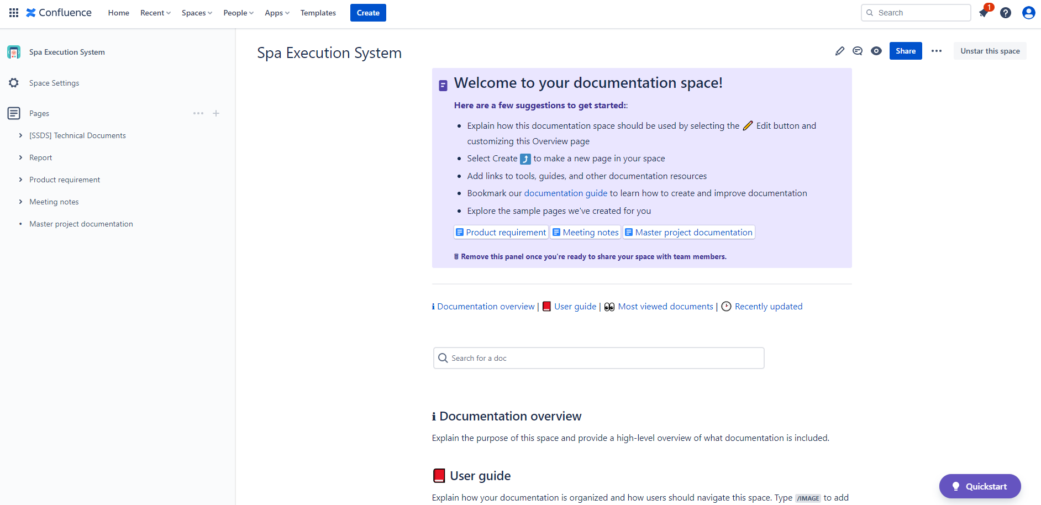

*Figure 6.1.1: Confluence Overview*

This is an example about APIs management in Confluence

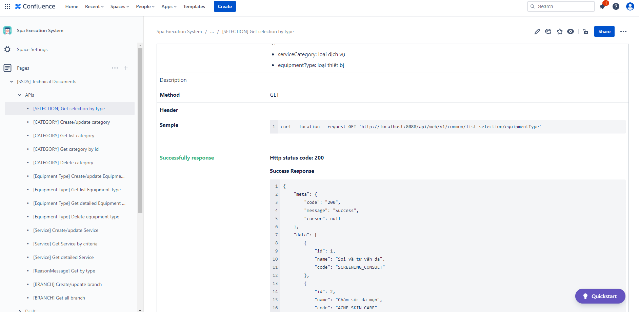

*Figure 6.1.2: APIs management in Confluence*

**- Google Drive:**



Google Drive is a [file storage](https://en.wikipedia.org/wiki/File_hosting_service) and [synchronization service](https://en.wikipedia.org/wiki/File_synchronization) developed by [Google](https://en.wikipedia.org/wiki/Google). Launched on April 24, 2012, Google Drive allows users to store files in the [cloud](https://en.wikipedia.org/wiki/Cloud_storage) (on Google's servers), synchronize files across devices, and [share files](https://en.wikipedia.org/wiki/File_sharing). In addition to a [web interface](https://en.wikipedia.org/wiki/Web_application), Google Drive offers apps with offline capabilities for [Windows](https://en.wikipedia.org/wiki/Microsoft_Windows) and [macOS](https://en.wikipedia.org/wiki/MacOS) computers, and [Android](https://en.wikipedia.org/wiki/Android_(operating_system)) and [iOS](https://en.wikipedia.org/wiki/IOS) smartphones and tablets. Google Drive encompasses [Google Docs](https://en.wikipedia.org/wiki/Google_Docs), [Google Sheets](https://en.wikipedia.org/wiki/Google_Sheets), and [Google Slides](https://en.wikipedia.org/wiki/Google_Slides), which are a part of the [Google Docs Editors](https://en.wikipedia.org/wiki/Google_Docs_Editors) [office suite](https://en.wikipedia.org/wiki/Office_suite) that permits collaborative editing of documents, spreadsheets, presentations, drawings, forms, and more. Files created and edited through the Google Docs suite are saved in Google Drive.

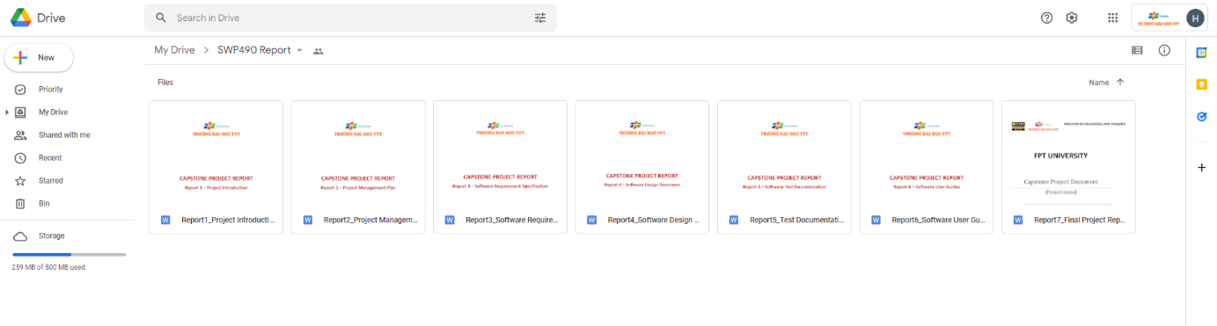

*Figure 6.1.3: Google Drive Overview*

### 6.2 Source Code Management

Our project uses GitLab to manage source code.

**- Gitlab**



GitLab helps you automate the builds, integration, and verification of your code. With SAST, DAST, code quality analysis, plus pipelines that enable concurrent testing and parallel execution, your teams get quick insights about every commit so they can deliver higher quality code faster.

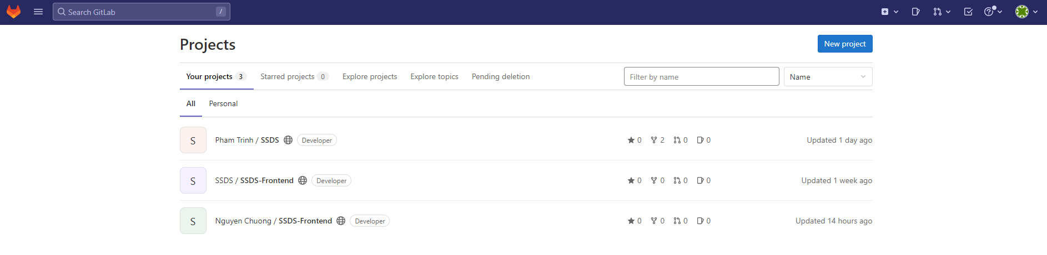

*Figure 6.2.1: Project management in GitLab*

This is a code management in GitLab.

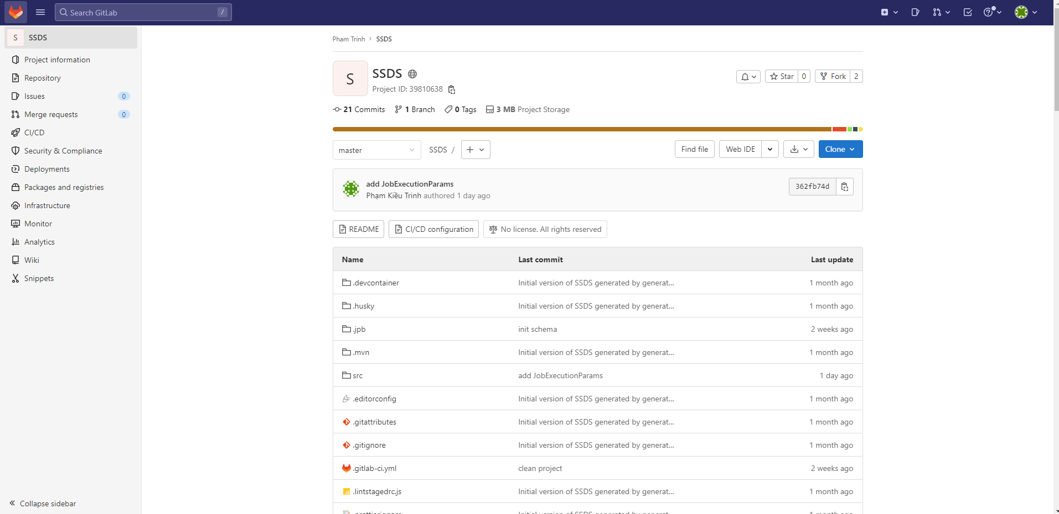

*Figure 6.2.2: Code management in GitLab*

### 6.3 Tools & Infrastructures

|  |  |
| --- | --- |
| **Category** | **Tools / Infrastructure** |
| **Technology** | ReactJS (FrontEnd), Java/SpringBoot (BackEnd), Kafka |
| **Database** | MySQL |
| **IDEs/Editors** | Visual Studio Code, IntelliJ, WebStorm |
| **Diagramming** | Figma, DrawIO |
| **Documentation** | Ms Office, Google Docs/Sheets/Slides |
| **Version Control** | GitLab (Source Codes), Confluence (Documents) |
| **Deployment server** | Amazon Web Services |
| **Third part** | Google Map Platform |
| **Project management** | Jira (Schedule, Tasks, Defects) |
| **Communication** | Messenger, Google Meet |

# III. Software Requirement Specification

## 1. Overall description

**1.1 Product Overview**

The Spa Service Providing System is a system that provide spa service for customer and system management for manager. This system is almost fully automatic, integrates many functions help users easy to use. Friendly Graphic User Interface, provide many details information about service, working order is handled smooth and reasonable. We commit that our system will overcome shorthrought of the other systems on current market and get the best performance.

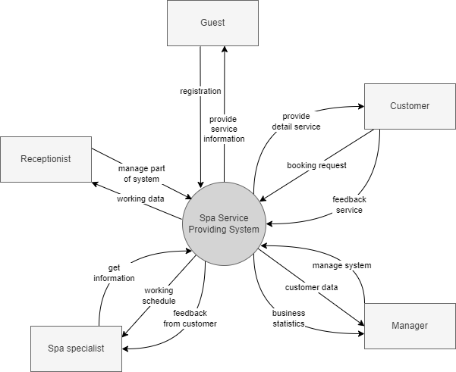

*Figure 1.1: Product Overview*

**1.2 Bussiness Rules**

|  |  |
| --- | --- |
| ID | Rule Definition |
| BR-01 | The website only active when it has been connected to the internet and server |
| BR-02 | Email must be valid |
| BR-03 | Phone number must be valid |
| BR-04 | Fullname must be at least 8 characters and contain no special characters and number |
| BR-05 | Password must be at least 8 characters, at least 1 uppercase letter, 1 number and 1 special character |
| BR-06 | Can’t register email, phone number that already registered |
| BR-07 | Can’t change registered email, phone number |
| BR-08 | User must use registered email to login |
| BR-09 | User can be one of four roles: Customer, Receptionist, Manager |
| BR-10 | The default role after register on the website is Customer |
| BR-11 | Only Manager can change role of account |
| BR-12 | Each role has different permission to access the system |
| BR-13 | After register on the website, user must validate through email |
| BR-14 | Forgot password field must contain registered email |
| BR-15 | Date of birth must be from 1-1-1922 to current day |
| BR-16 | User can select many categories |
| BR-17 | Title of the post must contain less than 255 characters |
| BR-18 | Description of the post must contain less than 1000 characters |
| BR-19 | Image size should not exceed 5mb |
| BR-20 | Deactivated function will make that relative object do not display on the website |
| BR-21 | Imported file must be excel file and in the right format |
| BR-22 | Text field must not empty |
| BR-23 | Address must contain less than 500 characters |
| BR-24 | Code must contain less than 255 characters |
| BR-25 | Name must contain less than 255 characters |
| BR-26 | Post list sorted by the latest time |
| BR-27 | Latitude and longitude must be float number |
| BR-28 | Booking appointment must follow step by step |
| BR-29 | SCA form can only be submitted if user answers all questions |
| BR-30 | User can only send feedback after using service |
| BR-31 | Rated must be picked from 1 to 5 star |
| BR-32 | User must login to chat with supporter |
| BR-33 | Notification list sorted by the latest time |
| BR-34 | Inactivated account cannot login to the system |

**2. User Requirements**

### 2.1 Actors

|  |  |  |
| --- | --- | --- |
| **#** | **Actor** | **Description** |
| 1 | Guest | Visitor who hasn’t registered |
| 2 | Customer | Has already registered an account with user role and experience the features for users on the website |
| 3 | Receptionist | Has already registered an account with receptionist role and manages posts, appointments, spa specialists, devices, FAQs. |
| 4 | Manager | Has an account in the system with admin role and responsible for managing the whole system |

### 2.2 Use Cases

#### 2.2.1 Diagram(s)

- Guest

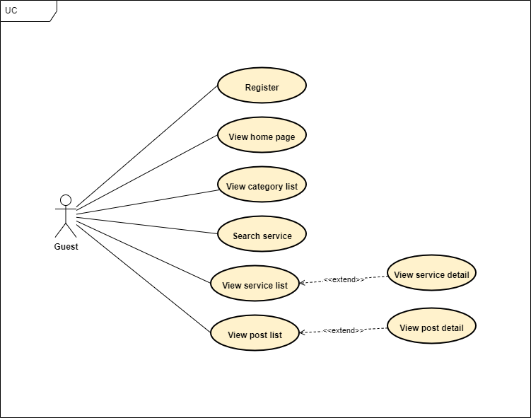

*Figure 2.2.1.1: Guest Use Case Diagram*

- Customer

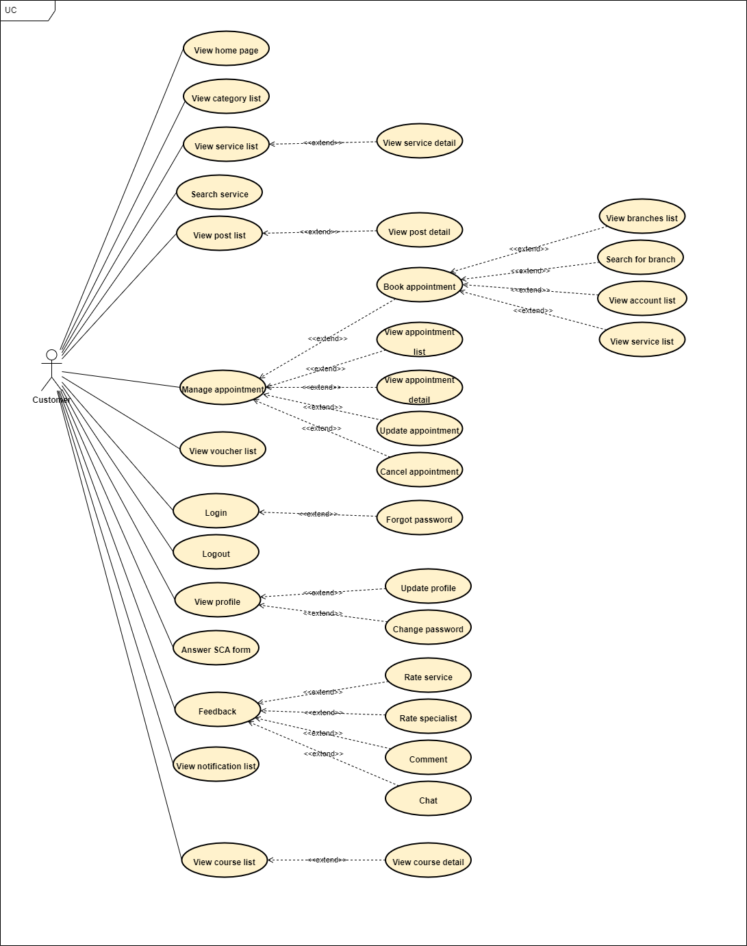

*Figure 2.2.1.2: Customer Use Case Diagram*

- Receptionist

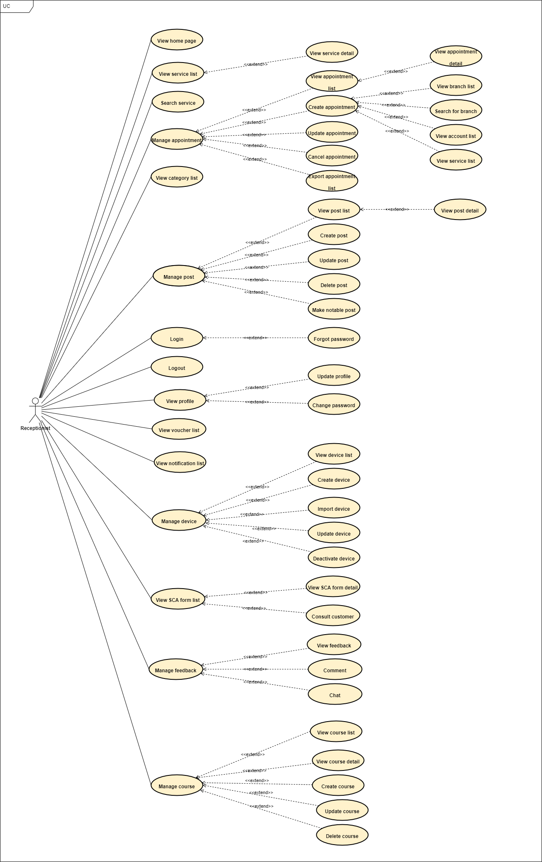

*Figure 2.2.1.4: Receptionist Use Case Diagram*

- Manager

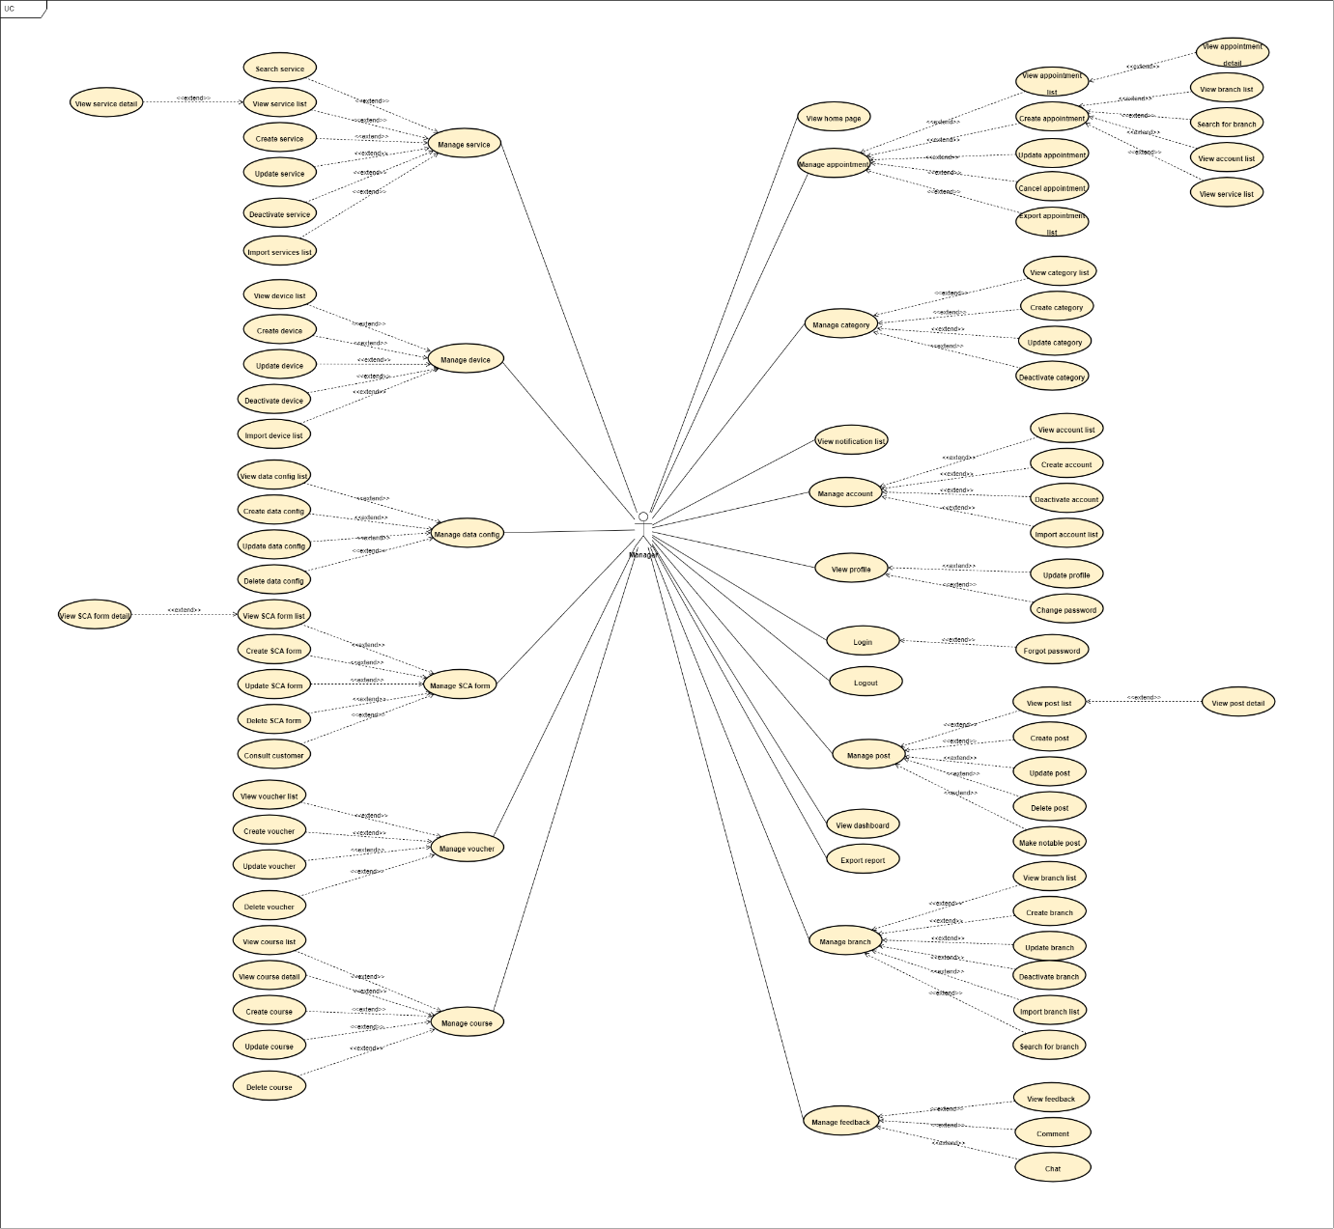

*Figure 2.2.1.5: Manager Use Case Diagram*

#### 2.2.2 Descriptions

|  |  |  |  |
| --- | --- | --- | --- |
| **Module** | **ID** | **Use Case** | **Actor** |
| Homepage | UC-01 | View homepage | Guest, Customer, Receptionist, Manager |
| Authentication | UC-02 | Register | Guest |
| UC-03 | Login | Guest, Customer, Receptionist, Manager |
| UC-04 | Forgot password | Customer, Receptionist, Manager |
| UC-05 | Logout | Customer, Receptionist, Manager |
| Manage profile | UC-06 | View profile | Customer, Receptionist, Manager |
| UC-07 | Update profile | Customer, Receptionist, Manager |
| UC-08 | Change password | Customer, Receptionist, Manager |
| Manage service | UC-09 | Search service | Guest, Customer, Receptionist, Manager |
| UC-10 | View service list | Guest, Customer, Receptionist, Manager |
| UC-11 | View service detail | Guest, Customer, Receptionist, Manager |
| UC-12 | Create service | Manager |
| UC-13 | Update service | Manager |
| UC-14 | Deactivate service | Manager |
| UC-15 | Import service list | Manager |
| Manage appointment | UC-16 | Book appointment | Customer |
| UC-17 | View appointment list | Customer, Receptionist, Manager |
| UC-18 | View appointment detail | Customer, Receptionist, Manager |
| UC-19 | Create appointment | Receptionist, Manager |
| UC-20 | Update appointment | Customer, Receptionist, Manager |
| UC-21 | Cancel appointment | Customer, Receptionist, Manager |
| Manage post | UC-22 | View post list | Guest, Customer, Receptionist, Manager |
| UC-23 | View post detail | Guest, Customer, Receptionist, Manager |
| UC-24 | Create post | Receptionist, Manager |
| UC-25 | Update post | Receptionist, Manager |
| UC-26 | Delete post | Receptionist, Manager |
| UC-27 | Make notable post | Receptionist, Manager |
| Manage branch | UC-28 | View branch list | Customer, Receptionist, Manager |
| UC-29 | Search for branch | Customer, Receptionist, Manager |
| UC-30 | Create branch | Manager |
| UC-31 | Update branch | Manager |
| UC-32 | Deactivate branch | Manager |
| UC-33 | Import branch list | Manager |
| Manage category | UC-34 | View category list | Guest, Customer, Receptionist, Manager |
| UC-35 | Create category | Manager |
| UC-36 | Update category | Manager |
| UC-37 | Delete category | Manager |
| Manage account | UC-38 | View account list | Customer, Receptionist, Manager |
| UC-39 | Create account | Manager |
| UC-40 | Update account | Manager |
| UC-41 | Deactivate account | Manager |
| UC-42 | Import account list | Manager |
| Manage course | UC-43 | View course list | Customer, Receptionist, Manager |
| UC-44 | View course detail | Customer, Receptionist, Manager |
| UC-45 | Create course | Receptionist, Manager |
| UC-46 | Update course | Receptionist, Manager |
| UC-47 | Delete course | Receptionist, Manager |
| Manage device | UC-48 | View device list | Receptionist, Manager |
| UC-49 | Create device | Receptionist, Manager |
| UC-50 | Update device | Receptionist, Manager |
| UC-51 | Delete device | Receptionist, Manager |
| UC-52 | Import device list | Receptionist, Manager |
| Manage data config | UC-53 | View data config list | Manager |
| UC-54 | Create data config | Manager |
| UC-55 | Update data config | Manager |
| UC-56 | Delete data config | Manager |
| Manage SCA form | UC-57 | View SCA form list | Receptionist, Manager |
| UC-58 | View SCA form detail | Receptionist, Manager |
| UC-59 | Create SCA form | Manager |
| UC-60 | Update SCA form | Manager |
| UC-61 | Delete SCA form | Manager |
| UC-62 | Answer SCA form | Customer |
| UC-63 | Consult customer | Receptionist |
| Manage voucher | UC-64 | View voucher list | Customer, Receptionist, Manager |
| UC-65 | Create voucher | Manager |
| UC-66 | Update voucher | Manager |
| UC-67 | Delete voucher | Manager |
| Manage feedback | UC-68 | Rate service | Customer |
| UC-69 | Rate spa specialist | Customer |
| UC-70 | Comment | Customer, Receptionist, Manager |
| UC-71 | View feedback | Customer, Receptionist, Manager |
| UC-72 | Chat | Customer, Receptionist, Manager |
| Administrator | UC-73 | View dashboard admin | Manager |
| UC-74 | Export report | Manager |
| Notification | UC-75 | View notification list | Customer, Receptionist, Manager |

#### 

#### 2.2.3 Use case specification

**UC-01. View homepage**

|  |  |  |  |
| --- | --- | --- | --- |
| **Use Case ID** | UC-01 | **Use Case Name** | View homepage |
| **Create By** | HaHM | **Created Date** | 01/10/2022 |
| **Primary Actor** | Guest, Customer, Receptionist, Manager | **Secondary Actor** | N/A |
| **Description** | User wants to view homepage | | |
| **Pre-conditions** | N/A | | |
| **Post-conditions** | N/A | | |
| **Normal Flow** | 1. User goes to link “…” | | |
| **Alternative Flow** | N/A | | |
| **Exceptions** | 1. The system cannot communicate with API server  2. Network error. | | |
| **Priority** | High | | |
| **Frequency of Use** | High | | |
| **Business Rules** | BR-01 | | |

**UC-02. Register**

|  |  |  |  |
| --- | --- | --- | --- |
| **Use Case ID** | UC-02 | **Use Case Name** | Register |
| **Create By** | HaHM | **Created Date** | 01/10/2022 |
| **Primary Actor** | Guest | **Secondary Actor** | N/A |
| **Description** | User wants to have an account on website | | |
| **Pre-conditions** | N/A | | |
| **Post-conditions** | N/A | | |
| **Normal Flow** | 1. User goes homepage.  2. User clicks on “Đăng ký” button.  3. The website displays the register screen.  4. User inputs all information needed.  5. User clicks on “Xác nhận” button. | | |
| **Alternative Flow** | User goes to link “…” | | |
| **Exceptions** | E-1: The system cannot communicate with API server  E-2: Network error. | | |
| **Priority** | High | | |
| **Frequency of Use** | High | | |
| **Business Rules** | BR-01, BR-02, BR-03, BR-04, BR-05, BR-06, BR-10, BR-13 | | |

**UC-03. Login**

|  |  |  |  |
| --- | --- | --- | --- |
| **Use Case ID** | UC-03 | **Use Case Name** | Login |
| **Create By** | HaHM | **Created Date** | 01/10/2022 |
| **Primary Actor** | Guest, Customer, Receptionist, Manager | **Secondary Actor** | N/A |
| **Description** | User wants to login to website | | |
| **Pre-conditions** | PRE-1: User already has an account. | | |
| **Post-conditions** | POST-1: User is logged in to the system.  POST-2: User is redirected to the homepage. | | |
| **Normal Flow** | 1. User goes homepage  2. User clicks on “Đăng nhập” button.  3. The website displays the login screen.  4. User inputs all information needed.  5. User clicks on “Đăng nhập” button. | | |
| **Alternative Flow** | User goes to link “…” | | |
| **Exceptions** | E-1: The system cannot communicate with API server  E-2: Network error.  E-3: Not input all fields. | | |
| **Priority** | Low | | |
| **Frequency of Use** | Low | | |
| **Business Rules** | BR-01, BR-08, BR-09, BR-12, BR-34 | | |

**UC-04. Forgot password**

|  |  |  |  |
| --- | --- | --- | --- |
| **Use Case ID** | UC-04 | **Use Case Name** | Forgot password |
| **Create By** | HaHM | **Created Date** | 01/10/2022 |
| **Primary Actor** | Customer, Receptionist, Manager | **Secondary Actor** | N/A |
| **Description** | User forgets password and want to take it back | | |
| **Pre-conditions** | PRE-1: User already has an account. | | |
| **Post-conditions** | POST-1: User gets new password by email. | | |
| **Normal Flow** | 1. User clicks on “Đăng nhập” button.  2. The website displays Login screen.  3. User clicks on “Quên mật khẩu” button.  4. The website displays Forgot password screen.  5. User inputs email or account name into field.  6. User clicks on “Gửi” button.  7. The system will send a new password to email linked to user’s account. | | |
| **Alternative Flow** | User goes to link “…” | | |
| **Exceptions** | E-1: The system cannot communicate with API server.  E-2: Network error.  E-3: User doesn’t have an account.  E-4: User inputs email or account that doesn’t exist in the system.  E-5: Not input all fields. | | |
| **Priority** | Low | | |
| **Frequency of Use** | Low | | |
| **Business Rules** | BR-01, BR-14 | | |

**UC-05. Logout**

|  |  |  |  |
| --- | --- | --- | --- |
| **Use Case ID** | UC-05 | **Use Case Name** | Logout |
| **Create By** | HaHM | **Created Date** | 01/10/2022 |
| **Primary Actor** | Customer, Receptionist, Manager | **Secondary Actor** | N/A |
| **Description** | User forgets password and want to take it back | | |
| **Pre-conditions** | PRE-1: User already has an account.  PRE-2: User has logged into the system. | | |
| **Post-conditions** | POST-1: User is logout of the system.  POST-2: User is redirected to the homepage. | | |
| **Normal Flow** | 1. User clicks on Avatar.  2. The website displays a drop-down list.  3. User clicks on “Logout” button. | | |
| **Alternative Flow** | N/A | | |
| **Exceptions** | E-1: The system cannot communicate with API server  E-2: Network error. | | |
| **Priority** | High | | |
| **Frequency of Use** | High | | |
| **Business Rules** | BR-01 | | |

**UC-06. View profile**

|  |  |  |  |
| --- | --- | --- | --- |
| **Use Case ID** | UC-06 | **Use Case Name** | View profile |
| **Create By** | HaHM | **Created Date** | 01/10/2022 |
| **Primary Actor** | Customer, Receptionist, Manager | **Secondary Actor** | N/A |
| **Description** | User wants to view detail information of his account | | |
| **Pre-conditions** | PRE-1: User already has an account.  PRE-2: User has logged into the system. | | |
| **Post-conditions** | N/A | | |
| **Normal Flow** | 1. User clicks on Avatar.  2. The website displays a drop-down list.  3. User clicks on “Tài khoản” button.  4. The website displays Profile screen. | | |
| **Alternative Flow** | N/A | | |
| **Exceptions** | E-1: The system cannot communicate with API server  E-2: Network error. | | |
| **Priority** | Medium | | |
| **Frequency of Use** | Medium | | |
| **Business Rules** | BR-01 | | |

**UC-07. Update profile**

|  |  |  |  |
| --- | --- | --- | --- |
| **Use Case ID** | UC-07 | **Use Case Name** | Update profile |
| **Create By** | HaHM | **Created Date** | 01/10/2022 |
| **Primary Actor** | Customer, Receptionist, Manager | **Secondary Actor** | N/A |
| **Description** | User wants to edit detail information of his account | | |
| **Pre-conditions** | PRE-1: User already has an account.  PRE-2: User has logged into the system. | | |
| **Post-conditions** | POST-1: User’s profile is update with new information. | | |
| **Normal Flow** | 1. User clicks on Avatar.  2. The website displays a drop-down list.  3. User clicks on “Tài khoản” button.  4. The website displays Profile screen.  5. User clicks on “Chỉnh sửa” button.  6. User inputs all information needed.  7. User clicks on “Xác nhận” button. | | |
| **Alternative Flow** | N/A | | |
| **Exceptions** | E-1: The system cannot communicate with API server  E-2: Network error.  E-3: Not input all fields. | | |
| **Priority** | Low | | |
| **Frequency of Use** | Low | | |
| **Business Rules** | BR-01, BR-07, BR-15, BR-22 | | |

**UC-08. Change password**

|  |  |  |  |
| --- | --- | --- | --- |
| **Use Case ID** | UC-08 | **Use Case Name** | Change password |
| **Create By** | HaHM | **Created Date** | 01/10/2022 |
| **Primary Actor** | Customer | **Secondary Actor** | Receptionist, Manager |
| **Description** | User wants to change password | | |
| **Pre-conditions** | PRE-1: User already has an account.  PRE-2: User has logged into the system. | | |
| **Post-conditions** | POST-1: User’s account is update with new password.  POST-2: User is redirected to View profile page. | | |
| **Normal Flow** | 1. User clicks on Avatar.  2. The website displays a drop-down list.  3. User clicks on “Tài khoản” button.  4. The website displays Profile screen.  5. User clicks on “Đổi mật khẩu” button.  6. User inputs old password, new password, confirm new password.  7. User clicks on “Xác nhận” button. | | |
| **Alternative Flow** | N/A | | |
| **Exceptions** | E-1: The system cannot communicate with API server  E-2: Network error.  E-3: Not input all fields.  E-4: Wrong old password.  E-5: New password and Confirm new password is different. | | |
| **Priority** | Medium | | |
| **Frequency of Use** | Low | | |
| **Business Rules** | BR-01, BR-05 | | |

**UC-09. Search service**

|  |  |  |  |
| --- | --- | --- | --- |
| **Use Case ID** | UC-09 | **Use Case Name** | Search service |
| **Create By** | HaHM | **Created Date** | 01/10/2022 |
| **Primary Actor** | Customer | **Secondary Actor** | Guest, Receptionist, Manager |
| **Description** | User wants to find services that he looks for. | | |
| **Pre-conditions** | N/A | | |
| **Post-conditions** | N/A | | |
| **Normal Flow** | 1. User goes to homepage.  2. User inputs into searching field.  3. User clicks on “Tìm kiếm” button.  4. The website displays result that user searchs for. | | |
| **Alternative Flow** | N/A | | |
| **Exceptions** | E-1: The system cannot communicate with API server  E-2: Network error. | | |
| **Priority** | Medium | | |
| **Frequency of Use** | High | | |
| **Business Rules** | BR-01, BR-22 | | |

**UC-10. View service list**

|  |  |  |  |
| --- | --- | --- | --- |
| **Use Case ID** | UC-10 | **Use Case Name** | View service list |
| **Create By** | HaHM | **Created Date** | 01/10/2022 |
| **Primary Actor** | Customer | **Secondary Actor** | Guest, Receptionist, Manager |
| **Description** | User wants to view all services | | |
| **Pre-conditions** | N/A | | |
| **Post-conditions** | N/A | | |
| **Normal Flow** | 1. User goes to homepage.  2. User clicks on “Dịch vụ” button.  3. The website displays “View service list” screen. | | |
| **Alternative Flow** | User goes to link “…” | | |
| **Exceptions** | E-1: The system cannot communicate with API server  E-2: Network error. | | |
| **Priority** | High | | |
| **Frequency of Use** | High | | |
| **Business Rules** | BR-01 | | |

**UC-11. View service detail**

|  |  |  |  |
| --- | --- | --- | --- |
| **Use Case ID** | UC-11 | **Use Case Name** | View service detail |
| **Create By** | HaHM | **Created Date** | 01/10/2022 |
| **Primary Actor** | Guest, Customer, Receptionist, Manager | **Secondary Actor** | N/A |
| **Description** | User wants to view detail information of service | | |
| **Pre-conditions** | N/A | | |
| **Post-conditions** | POST-1: The website displays | | |
| **Normal Flow** | 1. User goes to “View service list” page.  2. User clicks on service that he wants to view detail information. | | |
| **Alternative Flow** | User goes to link “…” | | |
| **Exceptions** | E-1: The system cannot communicate with API server  E-2: Network error. | | |
| **Priority** | High | | |
| **Frequency of Use** | High | | |
| **Business Rules** | BR-01 | | |

**UC-12. Create service**

|  |  |  |  |
| --- | --- | --- | --- |
| **Use Case ID** | UC-12 | **Use Case Name** | Create service |
| **Create By** | HaHM | **Created Date** | 01/10/2022 |
| **Primary Actor** | Manager | **Secondary Actor** | N/A |
| **Description** | User wants to create new service | | |
| **Pre-conditions** | PRE-1: User already has an account.  PRE-2: User has logged into the system by manager role. | | |
| **Post-conditions** | POST-1: New service is created and displayed in service list. | | |
| **Normal Flow** | 1. User goes to “Quản lý” page.  2. User clicks on “Quản lý dịch vụ” button.  3. The website displays “Quản lý dịch vụ” page.  4. User clicks on “Tạo mới” button.  5. User inputs all information needed into fields.  6. User clicks on “Xác nhận” button. | | |
| **Alternative Flow** | N/A | | |
| **Exceptions** | E-1: The system cannot communicate with API server  E-2: Network error.  E-3: Not input all fields. | | |
| **Priority** | Medium | | |
| **Frequency of Use** | Medium | | |
| **Business Rules** | BR-01, BR-22 | | |

**UC-13. Update service**

|  |  |  |  |
| --- | --- | --- | --- |
| **Use Case ID** | UC-13 | **Use Case Name** | Update service |
| **Create By** | HaHM | **Created Date** | 01/10/2022 |
| **Primary Actor** | Manager | **Secondary Actor** | N/A |
| **Description** | User wants to edit detail information of service | | |
| **Pre-conditions** | PRE-1: User already has an account.  PRE-2: User has logged into the system by manager role. | | |
| **Post-conditions** | POST-1: New detail information is updated for service | | |
| **Normal Flow** | 1. User goes to “Quản lý” page.  2. User clicks on “Quản lý dịch vụ” button.  3. The website displays “Quản lý dịch vụ” page.  4. User clicks on “Chỉnh sửa” button.  5. User inputs all information needed into fields.  6. User clicks on “Xác nhận” button. | | |
| **Alternative Flow** | N/A | | |
| **Exceptions** | E-1: The system cannot communicate with API server  E-2: Network error.  E-3: Not input all fields. | | |
| **Priority** | Medium | | |
| **Frequency of Use** | Medium | | |
| **Business Rules** | BR-01, BR-22 | | |

**UC-14. Deactivate service**

|  |  |  |  |
| --- | --- | --- | --- |
| **Use Case ID** | UC-14 | **Use Case Name** | Deactivate service |
| **Create By** | HaHM | **Created Date** | 01/10/2022 |
| **Primary Actor** | Manager | **Secondary Actor** | N/A |
| **Description** | User wants to deactivate service and undisplays it on customer side | | |
| **Pre-conditions** | PRE-1: User already has an account.  PRE-2: User has logged into the system by manager role. | | |
| **Post-conditions** | POST-1: Service is deactivated and undisplayed in service list. | | |
| **Normal Flow** | 1. User goes to “Quản lý” page.  2. User clicks on “Quản lý dịch vụ” button.  3. The website displays “Quản lý dịch vụ” page.  4. User clicks on “Tạm ngừng” button.  5. User clicks on “Xác nhận” button. | | |
| **Alternative Flow** | N/A | | |
| **Exceptions** | E-1: The system cannot communicate with API server  E-2: Network error. | | |
| **Priority** | Medium | | |
| **Frequency of Use** | Low | | |
| **Business Rules** | BR-01, BR-20 | | |

**UC-15. Import service list**

|  |  |  |  |
| --- | --- | --- | --- |
| **Use Case ID** | UC-15 | **Use Case Name** | Import service list |
| **Create By** | HaHM | **Created Date** | 01/10/2022 |
| **Primary Actor** | Manager | **Secondary Actor** | N/A |
| **Description** | User wants to import service list from excel file to the system. | | |
| **Pre-conditions** | PRE-1: User already has an account.  PRE-2: User has logged into the system by manager role. | | |
| **Post-conditions** | POST-1: Service list is updated from excel file. | | |
| **Normal Flow** | 1. User goes to “Quản lý” page.  2. User clicks on “Quản lý dịch vụ” button.  3. The website displays “Quản lý dịch vụ” page.  4. User clicks on “Chọn danh sách” button.  5. User selects excel file from local computer.  6. User clicks on “Xác nhận” button. | | |
| **Alternative Flow** | N/A | | |
| **Exceptions** | E-1: The system cannot communicate with API server  E-2: Network error. | | |
| **Priority** | Medium | | |
| **Frequency of Use** | Low | | |
| **Business Rules** | BR-01, BR-21 | | |

**UC-16. Book appointment**

|  |  |  |  |
| --- | --- | --- | --- |
| **Use Case ID** | UC-16 | **Use Case Name** | Book appointment |
| **Create By** | HaHM | **Created Date** | 01/10/2022 |
| **Primary Actor** | Customer | **Secondary Actor** | N/A |
| **Description** | User wants to book an appointment. | | |
| **Pre-conditions** | PRE-1: User already has an account.  PRE-2: User has logged into the system by customer role. | | |
| **Post-conditions** | POST-1: User has an appointment on the system. | | |
| **Normal Flow** | 1. User goes to homepage.  2. User clicks on “Đặt lịch” button.  3. The website displays Booking page.  4. User selects branch, spa specialist, service, datetime.  5. User clicks on “Đặt lịch” button.  6. The website displays a notification screen. | | |
| **Alternative Flow** | N/A | | |
| **Exceptions** | E-1: The system cannot communicate with API server  E-2: Network error.  E-3: User doesn’t select all information needed. | | |
| **Priority** | High | | |
| **Frequency of Use** | High | | |
| **Business Rules** | BR-01, BR-28 | | |

**UC-17. View appointment list**

|  |  |  |  |
| --- | --- | --- | --- |
| **Use Case ID** | UC-17 | **Use Case Name** | View appointment list |
| **Create By** | HaHM | **Created Date** | 01/10/2022 |
| **Primary Actor** | Customer, Receptionist, Manager | **Secondary Actor** | N/A |
| **Description** | User wants to view all appointment that he can manage. | | |
| **Pre-conditions** | PRE-1: User already has an account.  PRE-2: User has logged into the system. | | |
| **Post-conditions** | POST-1: The website displays all appointment. | | |
| **Normal Flow** | 1. User goes to “Quản lý” page.  2. User clicks on “Quản lý lịch hẹn” button.  3. The website displays “Quản lý lịch hẹn” page. | | |
| **Alternative Flow** | N/A | | |
| **Exceptions** | E-1: The system cannot communicate with API server  E-2: Network error. | | |
| **Priority** | Medium | | |
| **Frequency of Use** | High | | |
| **Business Rules** | BR-01 | | |

**UC-18. View appointment detail**

|  |  |  |  |
| --- | --- | --- | --- |
| **Use Case ID** | UC-18 | **Use Case Name** | View appointment detail |
| **Create By** | HaHM | **Created Date** | 01/10/2022 |
| **Primary Actor** | Customer, Receptionist, Manager | **Secondary Actor** | N/A |
| **Description** | User wants to view detail information of an appointment. | | |
| **Pre-conditions** | PRE-1: User already has an account.  PRE-2: User has logged into the system. | | |
| **Post-conditions** | N/A | | |
| **Normal Flow** | 1. User goes to “Quản lý” page.  2. User clicks on “Quản lý lịch hẹn” button.  3. The website displays “Quản lý lịch hẹn” page.  4. User clicks on an appointment that he wants to view detail.  5. The website displays detail information of an appointment. | | |
| **Alternative Flow** | N/A | | |
| **Exceptions** | E-1: The system cannot communicate with API server  E-2: Network error. | | |
| **Priority** | Medium | | |
| **Frequency of Use** | High | | |
| **Business Rules** | BR-01 | | |

**UC-19. Create appointment**

|  |  |  |  |
| --- | --- | --- | --- |
| **Use Case ID** | UC-19 | **Use Case Name** | Create appointment |
| **Create By** | HaHM | **Created Date** | 01/10/2022 |
| **Primary Actor** | Receptionist, Manager | **Secondary Actor** | N/A |
| **Description** | User wants to create an appointment for customer when customer doesn’t have an account to book appointment. | | |
| **Pre-conditions** | PRE-1: User already has an account.  PRE-2: User has logged into the system by Receptionist, Manager role. | | |
| **Post-conditions** | POST-1: New appointment is created in the system. | | |
| **Normal Flow** | 1. User goes to “Quản lý” page.  2. User clicks on “Quản lý lịch hẹn” button.  3. The website displays “Quản lý lịch hẹn” page.  4. User clicks on “Tạo lịch hẹn” button.  5. User inputs branch, spa specialist, service, datetime, customer’s name, phone number into field.  6. User clicks on “Xác nhận” button. | | |
| **Alternative Flow** | N/A | | |
| **Exceptions** | E-1: The system cannot communicate with API server  E-2: Network error.  E-3: Not inputs all fields. | | |
| **Priority** | Medium | | |
| **Frequency of Use** | Medium | | |
| **Business Rules** | BR-01 | | |

**UC-20. Update appointment**

|  |  |  |  |
| --- | --- | --- | --- |
| **Use Case ID** | UC-20 | **Use Case Name** | Update appointment |
| **Create By** | HaHM | **Created Date** | 01/10/2022 |
| **Primary Actor** | Customer, Receptionist, Manager | **Secondary Actor** | N/A |
| **Description** | User wants to update appointment that he booked. | | |
| **Pre-conditions** | PRE-1: User already has an account.  PRE-2: User has logged into the system. | | |
| **Post-conditions** | POST-1: An appointment is updated on the system. | | |
| **Normal Flow** | 1. User goes to “Quản lý” page.  2. User clicks on “Quản lý lịch hẹn” button.  3. The website displays “Quản lý lịch hẹn” page.  4. User clicks on “Chỉnh sửa” button.  5. User inputs new information into field.  6. User clicks on “Xác nhận” button. | | |
| **Alternative Flow** | N/A | | |
| **Exceptions** | E-1: The system cannot communicate with API server  E-2: Network error.  E-3: Not inputs all fields. | | |
| **Priority** | High | | |
| **Frequency of Use** | Medium | | |
| **Business Rules** | BR-01, BR-22 | | |

**UC-21. Cancel appointment**

|  |  |  |  |
| --- | --- | --- | --- |
| **Use Case ID** | UC-21 | **Use Case Name** | Cancel appointment |
| **Create By** | HaHM | **Created Date** | 01/10/2022 |
| **Primary Actor** | Customer, Receptionist, Manager | **Secondary Actor** | N/A |
| **Description** | User wants to cancel appointment that he booked. | | |
| **Pre-conditions** | PRE-1: User already has an account.  PRE-2: User has logged into the system.  PRE-3: User has booked an appointment. | | |
| **Post-conditions** | POST-1: An appointment is updated on the system. | | |
| **Normal Flow** | 1. User goes to “Quản lý” page.  2. User clicks on “Quản lý lịch hẹn” button.  3. The website displays “Quản lý lịch hẹn” page.  4. User clicks on “Chỉnh sửa” button.  5. User inputs new information into field.  6. User clicks on “Xác nhận” button. | | |
| **Alternative Flow** | N/A | | |
| **Exceptions** | E-1: The system cannot communicate with API server  E-2: Network error.  E-3: Not inputs all fields. | | |
| **Priority** | High | | |
| **Frequency of Use** | Medium | | |
| **Business Rules** | BR-01 | | |

**UC-22. View post list**

|  |  |  |  |
| --- | --- | --- | --- |
| **Use Case ID** | UC-22 | **Use Case Name** | View post list |
| **Create By** | HaHM | **Created Date** | 01/10/2022 |
| **Primary Actor** | Guest, Customer, Receptionist, Manager | **Secondary Actor** | N/A |
| **Description** | User wants to view all posts in the system. | | |
| **Pre-conditions** | N/A | | |
| **Post-conditions** | N/A | | |
| **Normal Flow** | 1. User goes to homepage.  2. User clicks on “Kinh nghiệm” button.  3. The website displays “Kinh nghiệm” page. | | |
| **Alternative Flow** | N/A | | |
| **Exceptions** | E-1: The system cannot communicate with API server  E-2: Network error.  E-3: Not inputs all fields. | | |
| **Priority** | High | | |
| **Frequency of Use** | Medium | | |
| **Business Rules** | BR-01, BR-26 | | |

**UC-23. View post detail**

|  |  |  |  |
| --- | --- | --- | --- |
| **Use Case ID** | UC-23 | **Use Case Name** | View post detail |
| **Create By** | HaHM | **Created Date** | 01/10/2022 |
| **Primary Actor** | Guest, Customer, Receptionist, Manager | **Secondary Actor** | N/A |
| **Description** | User wants to view detail information of a post | | |
| **Pre-conditions** | N/A | | |
| **Post-conditions** | N/A | | |
| **Normal Flow** | 1. User goes to homepage.  2. User clicks on “Kinh nghiệm” button.  3. The website displays “Kinh nghiệm” page.  4. User clicks on a post he wants to view detail.  5. The website displays a detail information of a post. | | |
| **Alternative Flow** | N/A | | |
| **Exceptions** | E-1: The system cannot communicate with API server  E-2: Network error. | | |
| **Priority** | High | | |
| **Frequency of Use** | High | | |
| **Business Rules** | BR-01 | | |

**UC-24. Create post**

|  |  |  |  |
| --- | --- | --- | --- |
| **Use Case ID** | UC-24 | **Use Case Name** | Create post |
| **Create By** | HaHM | **Created Date** | 01/10/2022 |
| **Primary Actor** | Receptionist, Manager | **Secondary Actor** | N/A |
| **Description** | User wants to create new post in the system | | |
| **Pre-conditions** | PRE-1: User already has an account.  PRE-2: User has logged into the system by Receptionist, Manager role. | | |
| **Post-conditions** | POST-1: New post is created on the system. | | |
| **Normal Flow** | 1. User goes to “Quản lý” page.  2. User clicks on “Quản lý bài viết” button.  3. The website displays “Quản lý bài viết” page.  4. User clicks on “Tạo bài viết” button.  5. User inputs title, datetime, image, description into field.  6. User clicks on “Xác nhận” button. | | |
| **Alternative Flow** | N/A | | |
| **Exceptions** | E-1: The system cannot communicate with API server  E-2: Network error. | | |
| **Priority** | High | | |
| **Frequency of Use** | High | | |
| **Business Rules** | BR-01, BR-17, BR-18, BR-19, BR-22 | | |

**UC-25. Update post**

|  |  |  |  |
| --- | --- | --- | --- |
| **Use Case ID** | UC-25 | **Use Case Name** | Update post |
| **Create By** | HaHM | **Created Date** | 01/10/2022 |
| **Primary Actor** | Receptionist, Manager | **Secondary Actor** | N/A |
| **Description** | User wants to edit a post in the system | | |
| **Pre-conditions** | PRE-1: User already has an account.  PRE-2: User has logged into the system by Receptionist, Manager role. | | |
| **Post-conditions** | POST-1: A post is updated in the system. | | |
| **Normal Flow** | 1. User goes to “Quản lý” page.  2. User clicks on “Quản lý bài viết” button.  3. The website displays “Quản lý bài viết” page.  4. User clicks on “Chỉnh sửa” button.  5. User inputs title, datetime, image, description into field.  6. User clicks on “Xác nhận” button. | | |
| **Alternative Flow** | N/A | | |
| **Exceptions** | E-1: The system cannot communicate with API server  E-2: Network error.  E-3: Not input all fields. | | |
| **Priority** | High | | |
| **Frequency of Use** | High | | |
| **Business Rules** | BR-01, BR-17, BR-18, BR-19, BR-22 | | |

**UC-26. Delete post**

|  |  |  |  |
| --- | --- | --- | --- |
| **Use Case ID** | UC-26 | **Use Case Name** | Delete post |
| **Create By** | HaHM | **Created Date** | 01/10/2022 |
| **Primary Actor** | Receptionist, Manager | **Secondary Actor** | N/A |
| **Description** | User wants to edit a post in the system | | |
| **Pre-conditions** | PRE-1: User already has an account.  PRE-2: User has logged into the system by Receptionist, Manager role. | | |
| **Post-conditions** | POST-1: A post is deleted in the system. | | |
| **Normal Flow** | 1. User goes to “Quản lý” page.  2. User clicks on “Quản lý bài viết” button.  3. The website displays “Quản lý bài viết” page.  4. User clicks on “Xóa” button.  5. The website displays confirm screen.  6. User clicks on “Xác nhận” button. | | |
| **Alternative Flow** | N/A | | |
| **Exceptions** | E-1: The system cannot communicate with API server  E-2: Network error.  E-3: Not input all fields. | | |
| **Priority** | High | | |
| **Frequency of Use** | High | | |
| **Business Rules** | BR-01 | | |

**UC-27. Make notable post**

|  |  |  |  |
| --- | --- | --- | --- |
| **Use Case ID** | UC-27 | **Use Case Name** | Make notable post |
| **Create By** | HaHM | **Created Date** | 01/10/2022 |
| **Primary Actor** | Receptionist, Manager | **Secondary Actor** | N/A |
| **Description** | User wants to make notable post to display at homepage | | |
| **Pre-conditions** | PRE-1: User already has an account.  PRE-2: User has logged into the system by Receptionist, Manager role. | | |
| **Post-conditions** | POST-1: A notable post is updated in the system. | | |
| **Normal Flow** | 1. User goes to “Quản lý” page.  2. User clicks on “Quản lý bài viết” button.  3. The website displays “Quản lý bài viết” page.  4. User selects three posts and clicks on “Nổi bật” button. | | |
| **Alternative Flow** | N/A | | |
| **Exceptions** | E-1: The system cannot communicate with API server  E-2: Network error. | | |
| **Priority** | High | | |
| **Frequency of Use** | Medium | | |
| **Business Rules** | BR-01 | | |

**UC-28. View branch list**

|  |  |  |  |
| --- | --- | --- | --- |
| **Use Case ID** | UC-28 | **Use Case Name** | View branch list |
| **Create By** | HaHM | **Created Date** | 01/10/2022 |
| **Primary Actor** | Customer, Receptionist, Manager | **Secondary Actor** | N/A |
| **Description** | User wants to view all branches in the system. | | |
| **Pre-conditions** | PRE-1: User already has an account.  PRE-2: User has logged into the system. | | |
| **Post-conditions** | N/A | | |
| **Normal Flow** | - On customer side:  1. User goes to “Đặt lịch” page.  2. The website displays “Đặt lịch” page, first screen is “Chọn cơ sở”.  3. The website displays all branches for customer to select.  - On manager side:  1. User goes to “Quản lý” page.  2. User clicks on “Quản lý cơ sở” button.  3. The website displays “Quản lý cơ sở” page. | | |
| **Alternative Flow** | N/A | | |
| **Exceptions** | E-1: The system cannot communicate with API server  E-2: Network error. | | |
| **Priority** | High | | |
| **Frequency of Use** | High | | |
| **Business Rules** | BR-01 | | |

**UC-29. Search for branch**

|  |  |  |  |
| --- | --- | --- | --- |
| **Use Case ID** | UC-29 | **Use Case Name** | Search for branch |
| **Create By** | HaHM | **Created Date** | 01/10/2022 |
| **Primary Actor** | Customer, Receptionist, Manager | **Secondary Actor** | N/A |
| **Description** | User wants to search for a branch. | | |
| **Pre-conditions** | PRE-1: User already has an account.  PRE-2: User has logged into the system. | | |
| **Post-conditions** | N/A | | |
| **Normal Flow** | - On customer side:  1. User goes to “Đặt lịch” page.  2. The website displays “Đặt lịch” page, first screen is “Chọn cơ sở”.  3. User inputs branch name on search bar.  4. The website displays all branches that related to searching keyword.  - On manager side:  1. User goes to “Quản lý” page.  2. User clicks on “Quản lý cơ sở” button.  3. The website displays “Quản lý cơ sở” page.  4. User inputs branch name on search bar.  5. The website displays all branches that related to searching keyword. | | |
| **Alternative Flow** | N/A | | |
| **Exceptions** | E-1: The system cannot communicate with API server  E-2: Network error.  E-3: Input nothing on field. | | |
| **Priority** | High | | |
| **Frequency of Use** | High | | |
| **Business Rules** | BR-01 | | |

**UC-30. Create branch**

|  |  |  |  |
| --- | --- | --- | --- |
| **Use Case ID** | UC-30 | **Use Case Name** | Create branch |
| **Create By** | HaHM | **Created Date** | 01/10/2022 |
| **Primary Actor** | Manager | **Secondary Actor** | N/A |
| **Description** | User wants to create new branch in the system. | | |
| **Pre-conditions** | PRE-1: User already has an account.  PRE-2: User has logged into the system by Manager role. | | |
| **Post-conditions** | POST-1: A new branch is created in the system. | | |
| **Normal Flow** | 1. User goes to “Quản lý” page.  2. User clicks on “Quản lý cơ sở” button.  3. The website displays “Quản lý cơ sở” page.  4. User clicks on “Tạo cơ sở” button.  5. The website displays “Tạo cơ sở” page.  6. User inputs branch’s name, address, phone number, image into fields.  7. User clicks on “Xác nhận” button. | | |
| **Alternative Flow** | N/A | | |
| **Exceptions** | E-1: The system cannot communicate with API server  E-2: Network error.  E-3: Not input all fields. | | |
| **Priority** | High | | |
| **Frequency of Use** | Low | | |
| **Business Rules** | BR-01, BR-22, BR-23, BR-24, BR-25 | | |

**UC-31. Update branch**

|  |  |  |  |
| --- | --- | --- | --- |
| **Use Case ID** | UC-31 | **Use Case Name** | Create branch |
| **Create By** | HaHM | **Created Date** | 01/10/2022 |
| **Primary Actor** | Manager | **Secondary Actor** | N/A |
| **Description** | User wants to edit detail information of a branch | | |
| **Pre-conditions** | PRE-1: User already has an account.  PRE-2: User has logged into the system by Manager role. | | |
| **Post-conditions** | POST-1: A branch is updated in the system. | | |
| **Normal Flow** | 1. User goes to “Quản lý” page.  2. User clicks on “Quản lý cơ sở” button.  3. The website displays “Quản lý cơ sở” page.  4. User clicks on “Chỉnh sửa” button.  5. The website displays “Cập nhật thông tin cơ sở” page.  6. User inputs branch’s name, address, phone number, image into fields.  7. User clicks on “Xác nhận” button. | | |
| **Alternative Flow** | N/A | | |
| **Exceptions** | E-1: The system cannot communicate with API server  E-2: Network error.  E-3: Not input all fields. | | |
| **Priority** | High | | |
| **Frequency of Use** | Low | | |
| **Business Rules** | BR-01, BR-22, BR-23, BR-24, BR-25 | | |

**UC-32. Deactivate branch**

|  |  |  |  |
| --- | --- | --- | --- |
| **Use Case ID** | UC-32 | **Use Case Name** | Deactivate branch |
| **Create By** | HaHM | **Created Date** | 01/10/2022 |
| **Primary Actor** | Manager | **Secondary Actor** | N/A |
| **Description** | User wants to deactivate a branch in the system | | |
| **Pre-conditions** | PRE-1: User already has an account.  PRE-2: User has logged into the system by Manager role. | | |
| **Post-conditions** | POST-1: A branch is not displayed on the system. | | |
| **Normal Flow** | 1. User goes to “Quản lý” page.  2. User clicks on “Quản lý cơ sở” button.  3. The website displays “Quản lý cơ sở” page.  4. User clicks on “Vô hiệu hóa” button. | | |
| **Alternative Flow** | N/A | | |
| **Exceptions** | E-1: The system cannot communicate with API server  E-2: Network error.  E-3: Not input all fields. | | |
| **Priority** | High | | |
| **Frequency of Use** | Low | | |
| **Business Rules** | BR-01, BR-20 | | |

**UC-33. Import branch list**

|  |  |  |  |
| --- | --- | --- | --- |
| **Use Case ID** | UC-33 | **Use Case Name** | Import branch list |
| **Create By** | HaHM | **Created Date** | 01/10/2022 |
| **Primary Actor** | Manager | **Secondary Actor** | N/A |
| **Description** | User wants to import branch list from excel file to the system | | |
| **Pre-conditions** | PRE-1: User already has an account.  PRE-2: User has logged into the system by Manager role. | | |
| **Post-conditions** | POST-1: A branch list is updated from excel file | | |
| **Normal Flow** | 1. User goes to “Quản lý” page.  2. User clicks on “Quản lý cơ sở” button.  3. The website displays “Quản lý cơ sở” page.  4. User clicks on “Chọn danh sách” button.  5. User selects excel file from local computer.  6. The website displays confirm screen.  7. User clicks on “Xác nhận” button. | | |
| **Alternative Flow** | N/A | | |
| **Exceptions** | E-1: The system cannot communicate with API server  E-2: Network error.  E-3: User selects malformed file. | | |
| **Priority** | High | | |
| **Frequency of Use** | Low | | |
| **Business Rules** | BR-01, BR-21 | | |

**UC-34: View category list**

|  |  |  |  |
| --- | --- | --- | --- |
| **Use Case ID** | UC-34 | **Use Case Name** | View category list |
| **Create By** | HaHM | **Created Date** | 01/10/2022 |
| **Primary Actor** | Manager | **Secondary Actor** | N/A |
| **Description** | User wants to view all categories | | |
| **Pre-conditions** | *\*Guest, Customer, Receptionist role has no pre-conditions*  PRE-1: User already has an account.  PRE-2: User has logged into the system by Manager role. | | |
| **Post-conditions** | N/A | | |
| **Normal Flow** | - On Guest, Customer, Receptionist side:  1. User can view categories at any pages of the website.  - On Manager side:  1. User goes to “Quản lý” page.  2. User clicks on “Quản lý thể loại” button.  3. The website displays “Quản lý thể loại” page. | | |
| **Alternative Flow** | N/A | | |
| **Exceptions** | E-1: The system cannot communicate with API server  E-2: Network error.  E-3: User selects malformed file. | | |
| **Priority** | High | | |
| **Frequency of Use** | Low | | |
| **Business Rules** | BR-01, BR-16 | | |

**UC-35: Create category**

|  |  |  |  |
| --- | --- | --- | --- |
| **Use Case ID** | UC-35 | **Use Case Name** | Create category |
| **Create By** | HaHM | **Created Date** | 01/10/2022 |
| **Primary Actor** | Manager | **Secondary Actor** | N/A |
| **Description** | User wants to create a new category | | |
| **Pre-conditions** | PRE-1: User already has an account.  PRE-2: User has logged into the system by Manager role. | | |
| **Post-conditions** | POST-1: A new category is created in the system. | | |
| **Normal Flow** | 1. User goes to “Quản lý” page.  2. User clicks on “Quản lý thể loại” button.  3. The website displays “Quản lý thể loại” page.  4. User clicks on “Tạo mới” button.  5. User inputs all information needed.  6. User clicks on “Xác nhận” button. | | |
| **Alternative Flow** | N/A | | |
| **Exceptions** | E-1: The system cannot communicate with API server  E-2: Network error.  E-3: Not input all fields. | | |
| **Priority** | High | | |
| **Frequency of Use** | Low | | |
| **Business Rules** | BR-01, BR-22 | | |

**UC-36: Update category**

|  |  |  |  |
| --- | --- | --- | --- |
| **Use Case ID** | UC-36 | **Use Case Name** | Update category |
| **Create By** | HaHM | **Created Date** | 01/10/2022 |
| **Primary Actor** | Manager | **Secondary Actor** | N/A |
| **Description** | User wants to edit detail information of a category | | |
| **Pre-conditions** | PRE-1: User already has an account.  PRE-2: User has logged into the system by Manager role. | | |
| **Post-conditions** | POST-1: A category is updated in the system. | | |
| **Normal Flow** | 1. User goes to “Quản lý” page.  2. User clicks on “Quản lý thể loại” button.  3. The website displays “Quản lý thể loại” page.  4. User clicks on “Chỉnh sửa” button.  5. User inputs all information needed.  6. User clicks on “Xác nhận” button. | | |
| **Alternative Flow** | N/A | | |
| **Exceptions** | E-1: The system cannot communicate with API server  E-2: Network error.  E-3: Not input all fields. | | |
| **Priority** | High | | |
| **Frequency of Use** | Low | | |
| **Business Rules** | BR-01, BR-22 | | |

**UC-37: Delete category**

|  |  |  |  |
| --- | --- | --- | --- |
| **Use Case ID** | UC-37 | **Use Case Name** | Delete category |
| **Create By** | HaHM | **Created Date** | 01/10/2022 |
| **Primary Actor** | Manager | **Secondary Actor** | N/A |
| **Description** | User wants to deactivate a category | | |
| **Pre-conditions** | PRE-1: User already has an account.  PRE-2: User has logged into the system by Manager role. | | |
| **Post-conditions** | POST-1: A category is not displayed on the website | | |
| **Normal Flow** | 1. User goes to “Quản lý” page.  2. User clicks on “Quản lý thể loại” button.  3. The website displays “Quản lý thể loại” page.  4. User clicks on “Vô hiệu hóa” button. | | |
| **Alternative Flow** | N/A | | |
| **Exceptions** | E-1: The system cannot communicate with API server  E-2: Network error. | | |
| **Priority** | High | | |
| **Frequency of Use** | Low | | |
| **Business Rules** | BR-01 | | |

**UC-38. View account list**

|  |  |  |  |
| --- | --- | --- | --- |
| **Use Case ID** | UC-38 | **Use Case Name** | View account list |
| **Create By** | HaHM | **Created Date** | 01/10/2022 |
| **Primary Actor** | Customer, Receptionist, Manager | **Secondary Actor** | N/A |
| **Description** | User wants to view all accounts | | |
| **Pre-conditions** | PRE-1: User already has an account.  PRE-2: User has logged into the system by Manager role. | | |
| **Post-conditions** | POST-1: A category is not displayed on the website | | |
| **Normal Flow** | - On customer side:  1. User goes to “Đặt lịch” page.  2. The website displays “Đặt lịch” page which includes “Danh sách nhân viên” screen.  3. User views all spa specialists.  - On Receptionist, Manager side:  1. User goes to “Quản lý” page.  2. User clicks on “Quản lý tài khoản” button.  3. The website displays “Quản lý tài khoản” page. | | |
| **Alternative Flow** | N/A | | |
| **Exceptions** | E-1: The system cannot communicate with API server  E-2: Network error. | | |
| **Priority** | High | | |
| **Frequency of Use** | Low | | |
| **Business Rules** | BR-01, BR-22 | | |

**UC-39. Create account**

|  |  |  |  |
| --- | --- | --- | --- |
| **Use Case ID** | UC-39 | **Use Case Name** | Create account |
| **Create By** | HaHM | **Created Date** | 01/10/2022 |
| **Primary Actor** | Manager | **Secondary Actor** | N/A |
| **Description** | User wants to create a new account | | |
| **Pre-conditions** | PRE-1: User already has an account.  PRE-2: User has logged into the system by Manager role. | | |
| **Post-conditions** | POST-1: A new account is created in the system. | | |
| **Normal Flow** | 1. User goes to “Quản lý” page.  2. User clicks on “Quản lý tài khoản” button.  3. The website displays “Quản lý tài khoản” page.  4. User clicks on “Tạo mới” button.  5. The website displays “Tạo mới” page.  6. User inputs all information needed into fields.  7. User clicks on “Xác nhận” button. | | |
| **Alternative Flow** | N/A | | |
| **Exceptions** | E-1: The system cannot communicate with API server  E-2: Network error.  E-3: Not input all fields. | | |
| **Priority** | High | | |
| **Frequency of Use** | Low | | |
| **Business Rules** | BR-01, BR-22 | | |

**UC-40. Update account**

|  |  |  |  |
| --- | --- | --- | --- |
| **Use Case ID** | UC-40 | **Use Case Name** | Update account |
| **Create By** | HaHM | **Created Date** | 01/10/2022 |
| **Primary Actor** | Manager | **Secondary Actor** | N/A |
| **Description** | User wants to edit detail information of an account | | |
| **Pre-conditions** | PRE-1: User already has an account.  PRE-2: User has logged into the system by Manager role. | | |
| **Post-conditions** | POST-1: An account is updated in the system. | | |
| **Normal Flow** | 1. User goes to “Quản lý” page.  2. User clicks on “Quản lý tài khoản” button.  3. The website displays “Quản lý tài khoản” page.  4. User clicks on “Chỉnh sửa” button.  5. The website displays “Chỉnh sửa” page.  6. User inputs all information needed into fields.  7. User clicks on “Xác nhận” button. | | |
| **Alternative Flow** | N/A | | |
| **Exceptions** | E-1: The system cannot communicate with API server  E-2: Network error.  E-3: Not input all fields. | | |
| **Priority** | High | | |
| **Frequency of Use** | Low | | |
| **Business Rules** | BR-01, BR-22 | | |

**UC-41. Deactivate account**

|  |  |  |  |
| --- | --- | --- | --- |
| **Use Case ID** | UC-41 | **Use Case Name** | Deactivate account |
| **Create By** | HaHM | **Created Date** | 01/10/2022 |
| **Primary Actor** | Manager | **Secondary Actor** | N/A |
| **Description** | User wants to deactivate an account in the system | | |
| **Pre-conditions** | PRE-1: User already has an account.  PRE-2: User has logged into the system by Manager role. | | |
| **Post-conditions** | POST-1: An account is deactivated in the system. | | |
| **Normal Flow** | 1. User goes to “Quản lý” page.  2. User clicks on “Quản lý tài khoản” button.  3. The website displays “Quản lý tài khoản” page.  4. User clicks on “Vô hiệu hóa” button. | | |
| **Alternative Flow** | N/A | | |
| **Exceptions** | E-1: The system cannot communicate with API server  E-2: Network error. | | |
| **Priority** | High | | |
| **Frequency of Use** | Low | | |
| **Business Rules** | BR-01, BR-34 | | |

**UC-42. Import account list**

|  |  |  |  |
| --- | --- | --- | --- |
| **Use Case ID** | UC-42 | **Use Case Name** | Import account list |
| **Create By** | HaHM | **Created Date** | 01/10/2022 |
| **Primary Actor** | Manager | **Secondary Actor** | N/A |
| **Description** | User wants to import account list from excel file to the system | | |
| **Pre-conditions** | PRE-1: User already has an account.  PRE-2: User has logged into the system by Manager role. | | |
| **Post-conditions** | POST-1: An account list is updated from excel file | | |
| **Normal Flow** | 1. User goes to “Quản lý” page.  2. User clicks on “Quản lý tài khoản” button.  3. The website displays “Quản lý tài khoản” page.  4. User clicks on “Chọn danh sách” button.  5. User selects excel file from local computer.  6. User clicks on “Xác nhận” button. | | |
| **Alternative Flow** | N/A | | |
| **Exceptions** | E-1: The system cannot communicate with API server  E-2: Network error.  E-3: User selects malformed file. | | |
| **Priority** | High | | |
| **Frequency of Use** | Low | | |
| **Business Rules** | BR-01, BR-21 | | |

**UC-43. View course list**

|  |  |  |  |
| --- | --- | --- | --- |
| **Use Case ID** | UC-43 | **Use Case Name** | View course list |
| **Create By** | HaHM | **Created Date** | 01/10/2022 |
| **Primary Actor** | Customer, Receptionist, Manager | **Secondary Actor** | N/A |
| **Description** | User wants to view all courses | | |
| **Pre-conditions** | PRE-1: User already has an account.  PRE-2: User has logged into the system. | | |
| **Post-conditions** | N/A | | |
| **Normal Flow** | - On customer side:  1. User goes to homepage.  2. User clicks on Avatar.  3. The website displays a drop-down list that have “Liệu trình” button.  4. User clicks on “Liệu trình” button.  5. The website displays “Liệu trình” page.  - On receptionist, manager side:  1. User goes to “Quản lý” page.  2. User clicks on “Quản lý liệu trình” button.  3. The website displays “Quản lý liệu trình” page. | | |
| **Alternative Flow** | N/A | | |
| **Exceptions** | E-1: The system cannot communicate with API server  E-2: Network error. | | |
| **Priority** | High | | |
| **Frequency of Use** | Medium | | |
| **Business Rules** | BR-01 | | |

**UC-44. View course detail**

|  |  |  |  |
| --- | --- | --- | --- |
| **Use Case ID** | UC-44 | **Use Case Name** | View course detail |
| **Create By** | HaHM | **Created Date** | 01/10/2022 |
| **Primary Actor** | Customer, Receptionist, Manager | **Secondary Actor** | N/A |
| **Description** | User wants to view all courses | | |
| **Pre-conditions** | PRE-1: User already has an account.  PRE-2: User has logged into the system. | | |
| **Post-conditions** | N/A | | |
| **Normal Flow** | - On customer side:  1. User goes to homepage.  2. User clicks on Avatar.  3. The website displays a drop-down list that have “Liệu trình” button.  4. User clicks on “Liệu trình” button.  5. The website displays “Liệu trình” page.  - On receptionist, manager side:  1. User goes to “Quản lý” page.  2. User clicks on “Quản lý liệu trình” button.  3. The website displays “Quản lý liệu trình” page. | | |
| **Alternative Flow** | N/A | | |
| **Exceptions** | E-1: The system cannot communicate with API server  E-2: Network error. | | |
| **Priority** | High | | |
| **Frequency of Use** | Medium | | |
| **Business Rules** | BR-01 | | |

**UC-45. Create course**

|  |  |  |  |
| --- | --- | --- | --- |
| **Use Case ID** | UC-45 | **Use Case Name** | Create course |
| **Create By** | HaHM | **Created Date** | 01/10/2022 |
| **Primary Actor** | Receptionist, Manager | **Secondary Actor** | N/A |
| **Description** | User wants to create a new course | | |
| **Pre-conditions** | PRE-1: User already has an account.  PRE-2: User has logged into the system. | | |
| **Post-conditions** | N/A | | |
| **Normal Flow** | 1. User goes to “Quản lý” page.  2. User clicks on “Quản lý liệu trình” button.  3. The website displays “Quản lý liệu trình” page.  4. User clicks on “Tạo mới” button.  5. User input all information needed into fields.  6. User clicks on “Xác nhận” button. | | |
| **Alternative Flow** | N/A | | |
| **Exceptions** | E-1: The system cannot communicate with API server  E-2: Network error.  E-3: Not input all fields. | | |
| **Priority** | High | | |
| **Frequency of Use** | Medium | | |
| **Business Rules** | BR-01, BR-22 | | |

**UC-46. Update course**

|  |  |  |  |
| --- | --- | --- | --- |
| **Use Case ID** | UC-46 | **Use Case Name** | Update course |
| **Create By** | HaHM | **Created Date** | 01/10/2022 |
| **Primary Actor** | Receptionist, Manager | **Secondary Actor** | N/A |
| **Description** | User wants to edit detail information of a course | | |
| **Pre-conditions** | PRE-1: User already has an account.  PRE-2: User has logged into the system. | | |
| **Post-conditions** | POST-1: A course is updated in the system. | | |
| **Normal Flow** | 1. User goes to “Quản lý” page.  2. User clicks on “Quản lý liệu trình” button.  3. The website displays “Quản lý liệu trình” page.  4. User clicks on “Chỉnh sửa” button.  5. User input all information needed into fields.  6. User clicks on “Xác nhận” button. | | |
| **Alternative Flow** | N/A | | |
| **Exceptions** | E-1: The system cannot communicate with API server  E-2: Network error.  E-3: Not input all fields. | | |
| **Priority** | High | | |
| **Frequency of Use** | Medium | | |
| **Business Rules** | BR-01, BR-22 | | |

**UC-47. Delete course**

|  |  |  |  |
| --- | --- | --- | --- |
| **Use Case ID** | UC-47 | **Use Case Name** | Delete course |
| **Create By** | HaHM | **Created Date** | 01/10/2022 |
| **Primary Actor** | Receptionist, Manager | **Secondary Actor** | N/A |
| **Description** | User wants to delete a course from the system | | |
| **Pre-conditions** | PRE-1: User already has an account.  PRE-2: User has logged into the system. | | |
| **Post-conditions** | POST-1: A course is updated in the system. | | |
| **Normal Flow** | 1. User goes to “Quản lý” page.  2. User clicks on “Quản lý liệu trình” button.  3. The website displays “Quản lý liệu trình” page.  4. User clicks on “Xóa” button.  5. The website displays confirm screen.  6. User clicks on “Xác nhận” button. | | |
| **Alternative Flow** | N/A | | |
| **Exceptions** | E-1: The system cannot communicate with API server  E-2: Network error. | | |
| **Priority** | High | | |
| **Frequency of Use** | Medium | | |
| **Business Rules** | BR-01 | | |

**UC-48. View device list**

|  |  |  |  |
| --- | --- | --- | --- |
| **Use Case ID** | UC-48 | **Use Case Name** | View device list |
| **Create By** | HaHM | **Created Date** | 01/10/2022 |
| **Primary Actor** | Receptionist, Manager | **Secondary Actor** | N/A |
| **Description** | User wants to view all devices in the system | | |
| **Pre-conditions** | PRE-1: User already has an account.  PRE-2: User has logged into the system by Receptionist, Manger role. | | |
| **Post-conditions** | N/A | | |
| **Normal Flow** | 1. User goes to “Quản lý” page.  2. User clicks on “Quản lý thiết bị” button.  3. The website displays “Quản lý thiết bị” page. | | |
| **Alternative Flow** | N/A | | |
| **Exceptions** | E-1: The system cannot communicate with API server  E-2: Network error. | | |
| **Priority** | High | | |
| **Frequency of Use** | Medium | | |
| **Business Rules** | BR-01 | | |

**UC-49. Create device**

|  |  |  |  |
| --- | --- | --- | --- |
| **Use Case ID** | UC-49 | **Use Case Name** | Create device |
| **Create By** | HaHM | **Created Date** | 01/10/2022 |
| **Primary Actor** | Receptionist, Manager | **Secondary Actor** | N/A |
| **Description** | User wants to create a new device | | |
| **Pre-conditions** | PRE-1: User already has an account.  PRE-2: User has logged into the system by Receptionist, Manger role. | | |
| **Post-conditions** | POST-1: A new device is created in the system | | |
| **Normal Flow** | 1. User goes to “Quản lý” page.  2. User clicks on “Quản lý thiết bị” button.  3. The website displays “Quản lý thiết bị” page.  4. User clicks on “Tạo mới” button.  5. The website displays “Tạo mới thiết bị” page.  6. User inputs all information needed into fields.  7. User clicks on “Xác nhận” button. | | |
| **Alternative Flow** | N/A | | |
| **Exceptions** | E-1: The system cannot communicate with API server  E-2: Network error.  E-3: Not input all fields. | | |
| **Priority** | High | | |
| **Frequency of Use** | Medium | | |
| **Business Rules** | BR-01, BR-22, BR-24, BR-25 | | |

**UC-50. Update device**

|  |  |  |  |
| --- | --- | --- | --- |
| **Use Case ID** | UC-50 | **Use Case Name** | Update device |
| **Create By** | HaHM | **Created Date** | 01/10/2022 |
| **Primary Actor** | Receptionist, Manager | **Secondary Actor** | N/A |
| **Description** | User wants to view all devices in the system | | |
| **Pre-conditions** | PRE-1: User already has an account.  PRE-2: User has logged into the system by Receptionist, Manger role. | | |
| **Post-conditions** | N/A | | |
| **Normal Flow** | 1. User goes to “Quản lý” page.  2. User clicks on “Quản lý thiết bị” button.  3. The website displays “Quản lý thiết bị” page.  4. User clicks on “Chỉnh sửa” button.  5. The website displays “Chỉnh sửa thiết bị” page.  6. User inputs all information needed into fields.  7. User clicks on “Xác nhận” button. | | |
| **Alternative Flow** | N/A | | |
| **Exceptions** | E-1: The system cannot communicate with API server  E-2: Network error.  E-3: Not input all fields. | | |
| **Priority** | High | | |
| **Frequency of Use** | Medium | | |
| **Business Rules** | BR-01, BR-22, BR-24, BR-25 | | |

**UC-51. Delete device**

|  |  |  |  |
| --- | --- | --- | --- |
| **Use Case ID** | UC-51 | **Use Case Name** | Delete device |
| **Create By** | HaHM | **Created Date** | 01/10/2022 |
| **Primary Actor** | Receptionist, Manager | **Secondary Actor** | N/A |
| **Description** | User wants to deactivate a device | | |
| **Pre-conditions** | PRE-1: User already has an account.  PRE-2: User has logged into the system by Receptionist, Manger role. | | |
| **Post-conditions** | POST-1: A device is deactivated in the system | | |
| **Normal Flow** | 1. User goes to “Quản lý” page.  2. User clicks on “Quản lý thiết bị” button.  3. The website displays “Quản lý thiết bị” page.  4. User clicks on “Vô hiệu hóa” button. | | |
| **Alternative Flow** | N/A | | |
| **Exceptions** | E-1: The system cannot communicate with API server  E-2: Network error. | | |
| **Priority** | High | | |
| **Frequency of Use** | Medium | | |
| **Business Rules** | BR-01 | | |

**UC-52. Import device list**

|  |  |  |  |
| --- | --- | --- | --- |
| **Use Case ID** | UC-52 | **Use Case Name** | Deactivate device |
| **Create By** | HaHM | **Created Date** | 01/10/2022 |
| **Primary Actor** | Receptionist, Manager | **Secondary Actor** | N/A |
| **Description** | User wants to import device list from excel file | | |
| **Pre-conditions** | PRE-1: User already has an account.  PRE-2: User has logged into the system by Receptionist, Manger role. | | |
| **Post-conditions** | POST-1: A device list is updated from excel file | | |
| **Normal Flow** | 1. User goes to “Quản lý” page.  2. User clicks on “Quản lý thiết bị” button.  3. The website displays “Quản lý thiết bị” page.  4. User clicks on “Chọn danh sách” button.  5. User selects excel file from local computer.  6. User clicks on “Xác nhận” button. | | |
| **Alternative Flow** | N/A | | |
| **Exceptions** | E-1: The system cannot communicate with API server  E-2: Network error. | | |
| **Priority** | High | | |
| **Frequency of Use** | Medium | | |
| **Business Rules** | BR-01, BR-21 | | |

**UC-53. View data config list**

|  |  |  |  |
| --- | --- | --- | --- |
| **Use Case ID** | UC-53 | **Use Case Name** | View data config list |
| **Create By** | HaHM | **Created Date** | 01/10/2022 |
| **Primary Actor** | Receptionist, Manager | **Secondary Actor** | N/A |
| **Description** | User wants to view all data configs | | |
| **Pre-conditions** | PRE-1: User already has an account.  PRE-2: User has logged into the system by Manger role. | | |
| **Post-conditions** | N/A | | |
| **Normal Flow** | 1. User goes to “Quản lý” page.  2. User clicks on “Quản lý liệu trình” button.  3. The website displays “Quản lý liệu trình” page.  4. User clicks on “Tạo mới” button.  5. User input all information needed into fields.  6. User clicks on “Xác nhận” button. | | |
| **Alternative Flow** | N/A | | |
| **Exceptions** | E-1: The system cannot communicate with API server  E-2: Network error. | | |
| **Priority** | High | | |
| **Frequency of Use** | Medium | | |
| **Business Rules** | BR-01 | | |

**UC-54. Create data config**

|  |  |  |  |
| --- | --- | --- | --- |
| **Use Case ID** | UC-54 | **Use Case Name** | Create data config |
| **Create By** | HaHM | **Created Date** | 01/10/2022 |
| **Primary Actor** | Manager | **Secondary Actor** | N/A |
| **Description** | User wants to create a new data config | | |
| **Pre-conditions** | PRE-1: User already has an account.  PRE-2: User has logged into the system by Manger role. | | |
| **Post-conditions** | POST-1: A new data config is created in the system | | |
| **Normal Flow** | 1. User goes to “Quản lý” page.  2. User clicks on “Quản lý cấu hình” button.  3. The website displays “Quản lý cấu hình” page.  4. User clicks on “Tạo mới” button.  5. User input all information needed into fields.  6. User clicks on “Xác nhận” button. | | |
| **Alternative Flow** | N/A | | |
| **Exceptions** | E-1: The system cannot communicate with API server  E-2: Network error.  E-3: Not input all fields. | | |
| **Priority** | High | | |
| **Frequency of Use** | Medium | | |
| **Business Rules** | BR-01, BR-22 | | |

**UC-55. Update data config**

|  |  |  |  |
| --- | --- | --- | --- |
| **Use Case ID** | UC-55 | **Use Case Name** | Update data config |
| **Create By** | HaHM | **Created Date** | 01/10/2022 |
| **Primary Actor** | Manager | **Secondary Actor** | N/A |
| **Description** | User wants to update data config | | |
| **Pre-conditions** | PRE-1: User already has an account.  PRE-2: User has logged into the system by Manger role. | | |
| **Post-conditions** | POST-1: A data config is updated in the system | | |
| **Normal Flow** | 1. User goes to “Quản lý” page.  2. User clicks on “Quản lý cấu hình” button.  3. The website displays “Quản lý cấu hình” page.  4. User clicks on “Chỉnh sửa” button.  5. The website displays “Chỉnh sửa cấu hình” page.  6. User input all information needed into fields.  7. User clicks on “Xác nhận” button. | | |
| **Alternative Flow** | N/A | | |
| **Exceptions** | E-1: The system cannot communicate with API server  E-2: Network error.  E-3: Not input all fields. | | |
| **Priority** | High | | |
| **Frequency of Use** | Medium | | |
| **Business Rules** | BR-01, BR-22 | | |

**UC-56. Delete data config**

|  |  |  |  |
| --- | --- | --- | --- |
| **Use Case ID** | UC-56 | **Use Case Name** | Delete data config |
| **Create By** | HaHM | **Created Date** | 01/10/2022 |
| **Primary Actor** | Manager | **Secondary Actor** | N/A |
| **Description** | User wants to delete a new data config | | |
| **Pre-conditions** | PRE-1: User already has an account.  PRE-2: User has logged into the system by Manger role. | | |
| **Post-conditions** | POST-1: A data config is deleted from the system | | |
| **Normal Flow** | 1. User goes to “Quản lý” page.  2. User clicks on “Quản lý cấu hình” button.  3. The website displays “Quản lý cấu hình” page.  4. User clicks on “Xóa” button.  5. The website display confirm screen.  6. User clicks on “Xác nhận” button. | | |
| **Alternative Flow** | N/A | | |
| **Exceptions** | E-1: The system cannot communicate with API server  E-2: Network error. | | |
| **Priority** | High | | |
| **Frequency of Use** | Medium | | |
| **Business Rules** | BR-01 | | |

**UC-57. View SCA form list**

|  |  |  |  |
| --- | --- | --- | --- |
| **Use Case ID** | UC-57 | **Use Case Name** | View SCA form list |
| **Create By** | HaHM | **Created Date** | 01/10/2022 |
| **Primary Actor** | Receptionist, Manager | **Secondary Actor** | N/A |
| **Description** | User wants to view all SCA forms | | |
| **Pre-conditions** | PRE-1: User already has an account.  PRE-2: User has logged into the system by Receptionist, Manger role. | | |
| **Post-conditions** | N/A | | |
| **Normal Flow** | 1. User goes to “Quản lý” page.  2. User clicks on “Quản lý bộ câu hỏi” button.  3. The website displays “Quản lý bộ câu hỏi” page. | | |
| **Alternative Flow** | N/A | | |
| **Exceptions** | E-1: The system cannot communicate with API server  E-2: Network error. | | |
| **Priority** | High | | |
| **Frequency of Use** | Medium | | |
| **Business Rules** | BR-01 | | |

**UC-58. View SCA form detail**

|  |  |  |  |
| --- | --- | --- | --- |
| **Use Case ID** | UC-58 | **Use Case Name** | View SCA form detail |
| **Create By** | HaHM | **Created Date** | 01/10/2022 |
| **Primary Actor** | Receptionist, Manager | **Secondary Actor** | N/A |
| **Description** | User wants to view detail information of a SCA form | | |
| **Pre-conditions** | PRE-1: User already has an account.  PRE-2: User has logged into the system. | | |
| **Post-conditions** | N/A | | |
| **Normal Flow** | 1. User goes to “Quản lý” page.  2. User clicks on “Quản lý bộ câu hỏi” button.  3. The website displays “Quản lý bộ câu hỏi” page.  4. User clicks on SCA form that he wants to view detail.  5. The website displays detail information of SCA form. | | |
| **Alternative Flow** | N/A | | |
| **Exceptions** | E-1: The system cannot communicate with API server  E-2: Network error. | | |
| **Priority** | High | | |
| **Frequency of Use** | Medium | | |
| **Business Rules** | BR-01 | | |

**UC-59. Create SCA form**

|  |  |  |  |
| --- | --- | --- | --- |
| **Use Case ID** | UC-59 | **Use Case Name** | Create SCA form |
| **Create By** | HaHM | **Created Date** | 01/10/2022 |
| **Primary Actor** | Manager | **Secondary Actor** | N/A |
| **Description** | User wants to create a new SCA form | | |
| **Pre-conditions** | PRE-1: User already has an account.  PRE-2: User has logged into the system by Manger role. | | |
| **Post-conditions** | POST-1: A new SCA form is created in the system | | |
| **Normal Flow** | 1. User goes to “Quản lý” page.  2. User clicks on “Quản lý bộ câu hỏi” button.  3. The website displays “Quản lý bộ câu hỏi” page.  4. User clicks on “Tạo mới” button.  5. The website displays “Tạo mới bộ câu hỏi” page.  6. User inputs all information needed into fields.  7. User clicks on “Xác nhận” button. | | |
| **Alternative Flow** | N/A | | |
| **Exceptions** | E-1: The system cannot communicate with API server  E-2: Network error.  E-3: Not input all fields. | | |
| **Priority** | High | | |
| **Frequency of Use** | Low | | |
| **Business Rules** | BR-01, BR-22 | | |

**UC-60. Update SCA form**

|  |  |  |  |
| --- | --- | --- | --- |
| **Use Case ID** | UC-60 | **Use Case Name** | Update SCA form |
| **Create By** | HaHM | **Created Date** | 01/10/2022 |
| **Primary Actor** | Manager | **Secondary Actor** | N/A |
| **Description** | User wants to update a SCA form | | |
| **Pre-conditions** | PRE-1: User already has an account.  PRE-2: User has logged into the system by Manger role. | | |
| **Post-conditions** | POST-1: A SCA form is updated in the system | | |
| **Normal Flow** | 1. User goes to “Quản lý” page.  2. User clicks on “Quản lý bộ câu hỏi” button.  3. The website displays “Quản lý bộ câu hỏi” page.  4. User clicks on “Chỉnh sửa” button.  5. The website displays “Chỉnh sửa bộ câu hỏi” page.  6. User inputs all information needed into fields.  7. User clicks on “Xác nhận” button. | | |
| **Alternative Flow** | N/A | | |
| **Exceptions** | E-1: The system cannot communicate with API server  E-2: Network error.  E-3: Not input all fields. | | |
| **Priority** | High | | |
| **Frequency of Use** | Low | | |
| **Business Rules** | BR-01, BR-22 | | |

**UC-61. Delete SCA form**

|  |  |  |  |
| --- | --- | --- | --- |
| **Use Case ID** | UC-61 | **Use Case Name** | Delete SCA form |
| **Create By** | HaHM | **Created Date** | 01/10/2022 |
| **Primary Actor** | Manager | **Secondary Actor** | N/A |
| **Description** | User wants to delete a SCA form | | |
| **Pre-conditions** | PRE-1: User already has an account.  PRE-2: User has logged into the system by Manger role. | | |
| **Post-conditions** | POST-1: A SCA form is deleted from the system | | |
| **Normal Flow** | 1. User goes to “Quản lý” page.  2. User clicks on “Quản lý bộ câu hỏi” button.  3. The website displays “Quản lý bộ câu hỏi” page.  4. User clicks on “Xóa” button.  5. The website displays confirm screen.  6. User clicks on “Xác nhận” button. | | |
| **Alternative Flow** | N/A | | |
| **Exceptions** | E-1: The system cannot communicate with API server  E-2: Network error. | | |
| **Priority** | High | | |
| **Frequency of Use** | Low | | |
| **Business Rules** | BR-01 | | |

**UC-62. Answer SCA form**

|  |  |  |  |
| --- | --- | --- | --- |
| **Use Case ID** | UC-62 | **Use Case Name** | Answer SCA form |
| **Create By** | HaHM | **Created Date** | 01/10/2022 |
| **Primary Actor** | Customer | **Secondary Actor** | N/A |
| **Description** | User wants to answer a SCA form | | |
| **Pre-conditions** | PRE-1: User already has an account.  PRE-2: User has logged into the system by Customer role. | | |
| **Post-conditions** | POST-1: A SCA form is created in SCA form list | | |
| **Normal Flow** | 1. User goes to homepage.  2. User clicks on “Bộ câu hỏi” button.  3. The website displays “Bộ câu hỏi” page.  4. User answers a SCA form step by step.  5. After finish, user clicks on “Gửi” button. | | |
| **Alternative Flow** | N/A | | |
| **Exceptions** | E-1: The system cannot communicate with API server  E-2: Network error. | | |
| **Priority** | High | | |
| **Frequency of Use** | Low | | |
| **Business Rules** | BR-01, BR-22, BR-29 | | |

**UC-63. Consult customer**

|  |  |  |  |
| --- | --- | --- | --- |
| **Use Case ID** | UC-63 | **Use Case Name** | Consult customer |
| **Create By** | HaHM | **Created Date** | 01/10/2022 |
| **Primary Actor** | Receptionist | **Secondary Actor** | N/A |
| **Description** | User wants to consult customer after receiving a SCA form from them | | |
| **Pre-conditions** | PRE-1: User already has an account.  PRE-2: User has logged into the system by Receptionist role. | | |
| **Post-conditions** | POST-1: A notification is sent to customer announce that they have a consulting from receptionist | | |
| **Normal Flow** | 1. User goes to “Quản lý” page.  2. User clicks on “Quản lý bộ câu hỏi” button.  3. The website displays “Quản lý bộ câu hỏi” page.  4. User clicks on “Trả lời” button.  5. The website displays “Trả lời bộ câu hỏi” page.  6. User inputs all information needed into fields.  6. User clicks on “Xác nhận” button. | | |
| **Alternative Flow** | N/A | | |
| **Exceptions** | E-1: The system cannot communicate with API server  E-2: Network error.  E-3: Not input all fields. | | |
| **Priority** | High | | |
| **Frequency of Use** | Low | | |
| **Business Rules** | BR-01 | | |

**UC-64. View voucher list**

|  |  |  |  |
| --- | --- | --- | --- |
| **Use Case ID** | UC-63 | **Use Case Name** | View voucher list |
| **Create By** | HaHM | **Created Date** | 01/10/2022 |
| **Primary Actor** | Customer, Receptionist, Manager | **Secondary Actor** | N/A |
| **Description** | User wants to view all vouchers | | |
| **Pre-conditions** | PRE-1: User already has an account.  PRE-2: User has logged into the system. | | |
| **Post-conditions** | N/A | | |
| **Normal Flow** | - On customer side:  1. User goes to homepage.  2. User clicks on Avater.  3. The website displays a drop-down list that have “Phiếu giảm giá” button.  4. User clicks on “Phiếu giảm giá” button.  5. The website displays “Phiếu giảm giá” page.  - On receptionist, manager side:  1. User goes to “Quản lý” page.  2. User clicks on “Quản lý phiếu giảm giá” button.  3. The website displays “Quản lý phiếu giảm giá” page. | | |
| **Alternative Flow** | N/A | | |
| **Exceptions** | E-1: The system cannot communicate with API server  E-2: Network error. | | |
| **Priority** | High | | |
| **Frequency of Use** | Low | | |
| **Business Rules** | BR-01 | | |

**UC-65. Create voucher**

|  |  |  |  |
| --- | --- | --- | --- |
| **Use Case ID** | UC-65 | **Use Case Name** | Create voucher |
| **Create By** | HaHM | **Created Date** | 01/10/2022 |
| **Primary Actor** | Manager | **Secondary Actor** | N/A |
| **Description** | User wants to create a new voucher | | |
| **Pre-conditions** | PRE-1: User already has an account.  PRE-2: User has logged into the system by Manager role. | | |
| **Post-conditions** | POST-1: A new voucher is created in the system. | | |
| **Normal Flow** | 1. User goes to “Quản lý” page.  2. User clicks on “Quản lý phiếu giảm giá” button.  3. The website displays “Quản lý phiếu giảm giá” page.  4. User clicks on “Tạo mới” button.  5. The website displays “Tạo mới phiếu giảm giá” page.  6. User inputs all information needed into fields.  7. User clicks on “Xác nhận” button. | | |
| **Alternative Flow** | N/A | | |
| **Exceptions** | E-1: The system cannot communicate with API server  E-2: Network error.  E-3: Not input all fields. | | |
| **Priority** | High | | |
| **Frequency of Use** | Low | | |
| **Business Rules** | BR-01, BR-22 | | |

**UC-66. Update voucher**

|  |  |  |  |
| --- | --- | --- | --- |
| **Use Case ID** | UC-65 | **Use Case Name** | Update voucher |
| **Create By** | HaHM | **Created Date** | 01/10/2022 |
| **Primary Actor** | Manager | **Secondary Actor** | N/A |
| **Description** | User wants to update a new voucher | | |
| **Pre-conditions** | PRE-1: User already has an account.  PRE-2: User has logged into the system by Manager role. | | |
| **Post-conditions** | POST-1: A voucher is updated in the system | | |
| **Normal Flow** | 1. User goes to “Quản lý” page.  2. User clicks on “Quản lý phiếu giảm giá” button.  3. The website displays “Quản lý phiếu giảm giá” page.  4. User clicks on “Chỉnh sửa” button.  5. The website displays “Chỉnh sửa phiếu giảm giá” page.  6. User inputs all information needed into fields.  7. User clicks on “Xác nhận” button. | | |
| **Alternative Flow** | N/A | | |
| **Exceptions** | E-1: The system cannot communicate with API server  E-2: Network error.  E-3: Not input all fields. | | |
| **Priority** | High | | |
| **Frequency of Use** | Low | | |
| **Business Rules** | BR-01, BR-22 | | |

**UC-67. Delete voucher**

|  |  |  |  |
| --- | --- | --- | --- |
| **Use Case ID** | UC-67 | **Use Case Name** | Delete voucher |
| **Create By** | HaHM | **Created Date** | 01/10/2022 |
| **Primary Actor** | Manager | **Secondary Actor** | N/A |
| **Description** | User wants to delete a voucher | | |
| **Pre-conditions** | PRE-1: User already has an account.  PRE-2: User has logged into the system by Manager role. | | |
| **Post-conditions** | POST-1: A voucher is deleted from the system | | |
| **Normal Flow** | 1. User goes to “Quản lý” page.  2. User clicks on “Quản lý phiếu giảm giá” button.  3. The website displays “Quản lý phiếu giảm giá” page.  4. User clicks on “Xóa” button.  5. The website displays confirm screen.  6. User clicks on “Xác nhận” button. | | |
| **Alternative Flow** | N/A | | |
| **Exceptions** | E-1: The system cannot communicate with API server  E-2: Network error. | | |
| **Priority** | High | | |
| **Frequency of Use** | Low | | |
| **Business Rules** | BR-01 | | |

**UC-68. Rate service**

|  |  |  |  |
| --- | --- | --- | --- |
| **Use Case ID** | UC-68 | **Use Case Name** | Rate service |
| **Create By** | HaHM | **Created Date** | 01/10/2022 |
| **Primary Actor** | Customer | **Secondary Actor** | N/A |
| **Description** | User wants to feedback a quality of the service | | |
| **Pre-conditions** | PRE-1: User already has an account.  PRE-2: User has logged into the system. | | |
| **Post-conditions** | POST-1: A feedback is created in the system. | | |
| **Normal Flow** | 1. User goes to “Đánh giá” page.  2. User selects a service that he used to review.  3. User selects number of stars.  4. User can write comment about a service.  5. User clicks on “Gửi” button. | | |
| **Alternative Flow** | N/A | | |
| **Exceptions** | E-1: The system cannot communicate with API server  E-2: Network error.  E-3: Not select star. | | |
| **Priority** | High | | |
| **Frequency of Use** | Low | | |
| **Business Rules** | BR-01, BR-30, BR-31 | | |

**UC-69. Rate spa specialist**

|  |  |  |  |
| --- | --- | --- | --- |
| **Use Case ID** | UC-69 | **Use Case Name** | Rate spa specialist |
| **Create By** | HaHM | **Created Date** | 01/10/2022 |
| **Primary Actor** | Customer | **Secondary Actor** | N/A |
| **Description** | User wants to rate a quality of a spa specialist | | |
| **Pre-conditions** | PRE-1: User already has an account.  PRE-2: User has logged into the system. | | |
| **Post-conditions** | POST-1: A feedback is created in the system | | |
| **Normal Flow** | 1. User goes to “Đánh giá” page.  2. User selects a spa specialist that he selected to review.  3. User selects number of stars.  4. User can write comment about a spa specialist.  5. User clicks on “Gửi” button. | | |
| **Alternative Flow** | N/A | | |
| **Exceptions** | E-1: The system cannot communicate with API server  E-2: Network error.  E-3: Not select star. | | |
| **Priority** | High | | |
| **Frequency of Use** | Low | | |
| **Business Rules** | BR-01, BR-30, BR-31 | | |

**UC-70. Comment**

|  |  |  |  |
| --- | --- | --- | --- |
| **Use Case ID** | UC-70 | **Use Case Name** | Comment |
| **Create By** | HaHM | **Created Date** | 01/10/2022 |
| **Primary Actor** | Customer | **Secondary Actor** | N/A |
| **Description** | User wants to rate a quality of a spa specialist | | |
| **Pre-conditions** | PRE-1: User already has an account.  PRE-2: User has logged into the system. | | |
| **Post-conditions** | POST-1: A feedback is created in the system | | |
| **Normal Flow** | 1. User goes to “Đánh giá” page.  2. User selects a spa specialist that he selected to review.  3. User selects number of stars.  4. User can write comment about a spa specialist.  5. User clicks on “Gửi” button. | | |
| **Alternative Flow** | N/A | | |
| **Exceptions** | E-1: The system cannot communicate with API server  E-2: Network error.  E-3: Not select star. | | |
| **Priority** | High | | |
| **Frequency of Use** | Low | | |
| **Business Rules** | BR-01, BR-22 | | |

**UC-71. View feedback**

|  |  |  |  |
| --- | --- | --- | --- |
| **Use Case ID** | UC-71 | **Use Case Name** | View feedback |
| **Create By** | HaHM | **Created Date** | 01/10/2022 |
| **Primary Actor** | Customer | **Secondary Actor** | N/A |
| **Description** | User wants to view feedback list | | |
| **Pre-conditions** | PRE-1: User already has an account.  PRE-2: User has logged into the system. | | |
| **Post-conditions** | N/A | | |
| **Normal Flow** | 1. User goes to “Quản lý” page.  2. User clicks on “Quản lý đánh giá” button.  3. The website displays “Quản lý đánh giá” page. | | |
| **Alternative Flow** | N/A | | |
| **Exceptions** | E-1: The system cannot communicate with API server  E-2: Network error. | | |
| **Priority** | High | | |
| **Frequency of Use** | Low | | |
| **Business Rules** | BR-01 | | |

**UC-72. Chat**

|  |  |  |  |
| --- | --- | --- | --- |
| **Use Case ID** | UC-72 | **Use Case Name** | Chat |
| **Create By** | HaHM | **Created Date** | 01/10/2022 |
| **Primary Actor** | Customer | **Secondary Actor** | N/A |
| **Description** | User wants to rate a quality of a spa specialist | | |
| **Pre-conditions** | PRE-1: User already has an account.  PRE-2: User has logged into the system. | | |
| **Post-conditions** | N/A | | |
| **Normal Flow** | 1. User goes to homepage.  2. User clicks on “Chat” button.  3. The website displays “Chat” screen. | | |
| **Alternative Flow** | N/A | | |
| **Exceptions** | E-1: The system cannot communicate with API server  E-2: Network error. | | |
| **Priority** | High | | |
| **Frequency of Use** | Low | | |
| **Business Rules** | BR-01, BR-32 | | |

**UC-73. View dashboard admin**

|  |  |  |  |
| --- | --- | --- | --- |
| **Use Case ID** | UC-73 | **Use Case Name** | View dashboard admin |
| **Create By** | HaHM | **Created Date** | 01/10/2022 |
| **Primary Actor** | Manager | **Secondary Actor** | N/A |
| **Description** | User wants to view dashboard | | |
| **Pre-conditions** | PRE-1: User already has an account.  PRE-2: User has logged into the system by Manager role. | | |
| **Post-conditions** | N/A | | |
| **Normal Flow** | 1. User goes to “Quản lý” page.  2. The website displays “Dashboard” screen. | | |
| **Alternative Flow** | N/A | | |
| **Exceptions** | E-1: The system cannot communicate with API server  E-2: Network error. | | |
| **Priority** | High | | |
| **Frequency of Use** | Low | | |
| **Business Rules** | BR-01 | | |

**UC-74. Export report**

|  |  |  |  |
| --- | --- | --- | --- |
| **Use Case ID** | UC-74 | **Use Case Name** | Export report |
| **Create By** | HaHM | **Created Date** | 01/10/2022 |
| **Primary Actor** | Manager | **Secondary Actor** | N/A |
| **Description** | User wants to export report from the system | | |
| **Pre-conditions** | PRE-1: User already has an account.  PRE-2: User has logged into the system. | | |
| **Post-conditions** | POST-1: A report is exported from the system | | |
| **Normal Flow** | 1. User goes to “Quản lý” page.  2. User clicks on “Xuất thông tin” button.  3. The website displays confirm screen.  4. User clicks on “Xác nhận” button. | | |
| **Alternative Flow** | N/A | | |
| **Exceptions** | E-1: The system cannot communicate with API server  E-2: Network error. | | |
| **Priority** | High | | |
| **Frequency of Use** | Low | | |
| **Business Rules** | BR-01 | | |

**UC-75. View notification list**

|  |  |  |  |
| --- | --- | --- | --- |
| **Use Case ID** | UC-75 | **Use Case Name** | View notification list |
| **Create By** | HaHM | **Created Date** | 01/10/2022 |
| **Primary Actor** | Customer | **Secondary Actor** | N/A |
| **Description** | User wants to view notification list | | |
| **Pre-conditions** | PRE-1: User already has an account.  PRE-2: User has logged into the system. | | |
| **Post-conditions** | N/A | | |
| **Normal Flow** | 1. User goes to homepage.  2. User clicks on “Thông báo” button.  3. The website displays a drop-down “Thông báo” screen. | | |
| **Alternative Flow** | N/A | | |
| **Exceptions** | E-1: The system cannot communicate with API server  E-2: Network error. | | |
| **Priority** | High | | |
| **Frequency of Use** | Low | | |
| **Business Rules** | BR-33 | | |

## 3. Functional Requirements

### 3.1 System Functional Overview

#### 3.1.1 Screens Flow

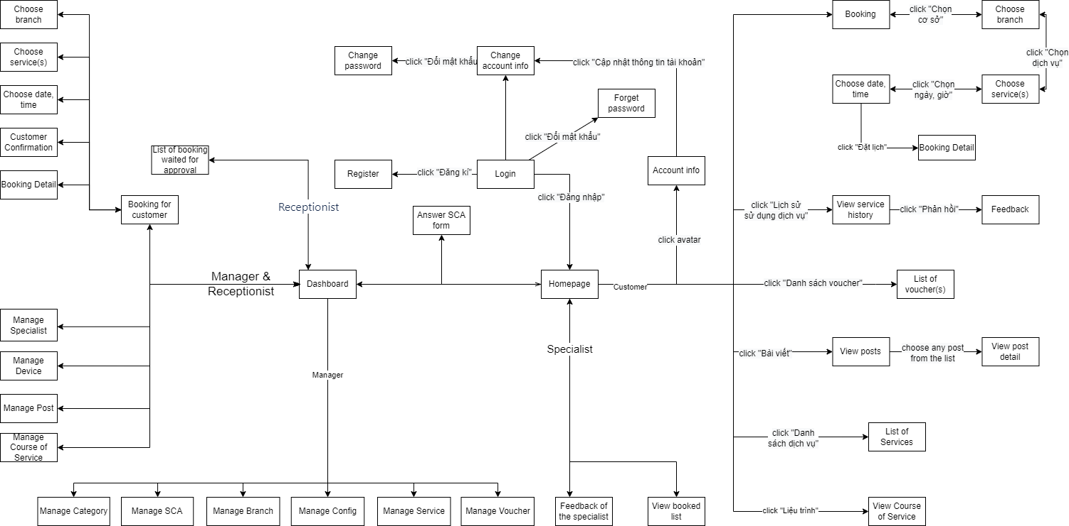

*Figure 3.1.1.1: Screens flow*

#### 3.1.2 Screen Descriptions

|  |  |  |  |
| --- | --- | --- | --- |
| **#** | **Feature** | **Screen** | **Description** |
| 1 | View homepage | Homepage | User goes to homepage |
| 2 | Login | Login | User already has an account and sign into the system |
| 3 | Register | Register | Users don’t have an account yet and create new accounts |
| 4 | Forgot password | Forgot password | User forgot password and want to reset password |
| 5 | Book appointment | Booking | User books an appointment |
| 6 | Choose branch | User selects a branch |
| 7 | Choose service | User selects a service |
| 8 | Choose datetime | User selects date and time |
| 9 | Booking detail | User views booking detail and confirms information after successfully booked |
| 10 | View service history | View service history | User views service history list that user has used |
| 11 | Feedback | Feedback | User rates and comments service, spa specialist that user has used |
| 12 | View vourcher list | List of vouchers | User views all voucher that user has |
| 13 | View post list | View posts | User views all post on the website |
| 14 | View post detail | View post detail | User views detail information of a post |
| 15 | View service list | List of services | User views all service on the website |
| 16 | View course list | View course of service | User views course of service that user has used |
| 17 | Manage profile | Account info | User views account information |
| 18 | Change account info | User edits detail information of account |
| 19 | Change password | User changes new password |
| 20 | View feedback | Feedback of customer | User views feedback of customer |
| 21 | View appointment list | View booked list | User views booked appoitment list |
| 22 | Answer SCA form | Answer SCA form | User answers set of questions and sends it to the system |
| 23 | Dashboard Admin | Dashboard | User views statistics |
| 24 | Manage category | Manage category | User can create, update, delete category |
| 25 | Manage SCA form | Manage SCA | User can create, update, delete SCA form |
| 26 | Manage branch | Manage branch | User can create, update, deactivate branch |
| 27 | Manage config | Manage config | User can create, update, delete data config |
| 28 | Manage service | Manage service | User can create, update, deactivate service |
| 29 | Manage voucher | Manage voucher | User can create, update, delete voucher |
| 30 | Manage account | Manage account | User can create, update, deactivate account |
| 31 | Manage device | Manage device | User can create, update, deactivate device |
| 32 | Manage post | Manage post | User can create, update, delete post |
| 33 | Manage course of service | Manage course of service | User can create, update, delete course of service |
| 34 | Booking for customer | Booking for customer | User books an appointment for customer in case they don’t have account |
| 35 | List of booking waited for approval | List of booking waited for approval | User views list of booking waited for approval |

#### 3.1.3 Screen Authorization

|  |  |  |  |  |
| --- | --- | --- | --- | --- |
| **Screen** | **Guest** | **Customer** | **Receptionist** | **Manager** |
| Homepage | X | X | X | X |
| Login |  | X | X | X |
| Register | X |  |  |  |
| Forgot password |  | X | X | X |
| Booking |  | X |  |  |
| Choose branch |  | X | X | X |
| Choose service |  | X | X | X |
| Choose datetime |  | X | X | X |
| Booking detail |  | X | X | X |
| View service history |  | X |  |  |
| Feedback |  | X |  |  |
| List of vouchers |  | X | X | X |
| View posts | X | X | X | X |
| View post detail | X | x | X | X |
| List of services | X | X | X | X |
| View course of service |  | X |  |  |
| Account info |  | X |  |  |
| Change account info |  | X |  |  |
| Change password |  | X |  |  |
| Feedback of the specialist |  | X |  |  |
| View booked list |  | X |  |  |
| Answer SCA form |  | X |  |  |
| Dashboard |  |  | X | X |
| Manage category |  |  |  | X |
| Manage SCA |  |  | X | X |
| Manage branch |  |  |  | X |
| Manage config |  |  |  | X |
| Manage service |  |  |  | X |
| Manage voucher |  |  |  | X |
| Manage account |  |  | X | X |
| Manage device |  |  | X | X |
| Manage post |  |  | X | X |
| Manage course of service |  |  | X | X |
| Booking for customer |  |  | X | X |
| List of booking waited for approval |  |  | X | X |

#### 3.1.4 Non-Screen Functions

|  |  |  |  |
| --- | --- | --- | --- |
| **#** | **Feature** | **System Function** | **Description** |
| 1 | Send email | Confirm email | The system will send a confirmation mail to email linked to user’s account. |
| 2 | Forgot password | The system will send a new password to email linked to user’s account. |
| 3 | Notify booking status | Every booking of user, the system sends a notification about detail information status to customer. |

#### 3.1.5 Entity Relationship Diagram

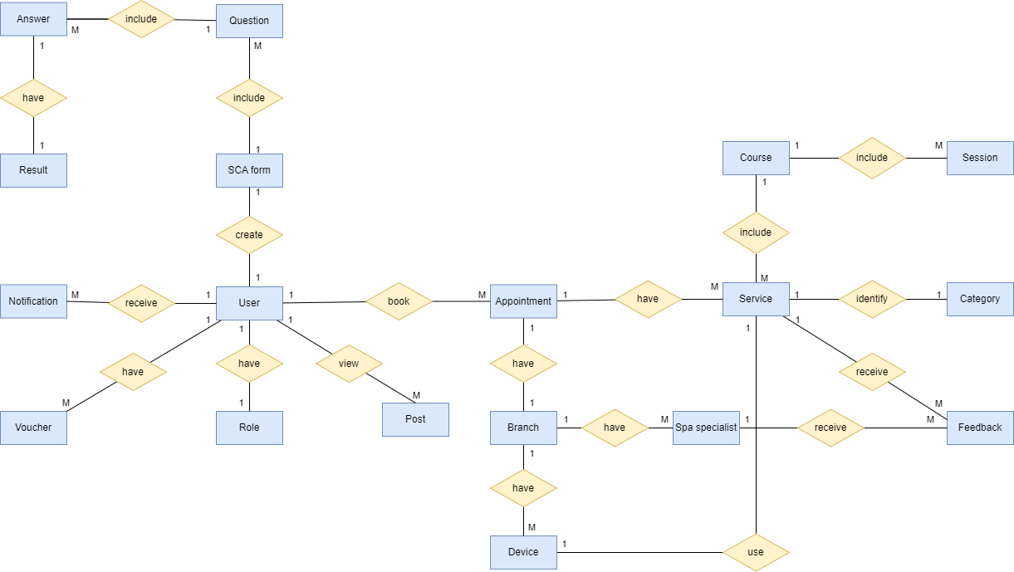

*Figure 3.1.5.1: Entity Relationship Diagram*

**Entities Description**

|  |  |  |
| --- | --- | --- |
| **#** | **Entity** | **Description** |
| 1 | User | Who has permission to access the system. |
| 2 | Role | Identify permission of each role.  This entity has relationship with User **(“One-to-One”).** |
| 3 | Voucher | Vorcher for discount.  This entity has relationship with User **(“Many-to-One”).** |
| 4 | Notification | Notification about different activities in the system.  This entity has relationship with User **(“Many-to-One”).** |
| 5 | Post | Experience sharing articles.  This entity has relationship with User **(“Many-to-One”).** |
| 6 | SCA form | Questionnaire for new customers  This entity has relationship with Question **(“One-to-Many”).** |
| 7 | Question | Question about customer’s health status.  This entity has relationship with Answer **(“One-to-Many”).** |
| 8 | Answer | Multiple choice type answer.  This entity has relationship with Post **(“Many-to-One”).** |
| 9 | Result | Result based on the answer.  This entity has relationship with Post **(“One-to-One”).** |
| 10 | Appointment | Booking service.  This entity has relationship with User **(“One-to-Many”).** |
| 11 | Branch | Branch.  This entity has relationship with Appointment **(“One-to-One”).** |
| 12 | Spa specialist | Staff.  This entity has relationship with Branch **(“One-to-One”).** |
| 13 | Device | Device.  This entity has relationship with Branch **(“Many-to-One”).**  This entity has relationship with Service **(“One-to-One”).** |
| 14 | Service | Spa Service.  This entity has relationship with Appointment **(“Many-to-One”).** |
| 15 | Course | Course of service.  This entity has relationship with Service **(“One-to-Many”).** |
| 16 | Session | Session of course.  This entity has relationship with Course **(“Many-to-One”).** |
| 17 | Category | Identify different type of service.  This entity has relationship with Service **(“One-to-One”).** |
| 18 | Feedback | Feedback of customer.  This entity has relationship with Service, Spa Specialist **(“Many-to-One”).** |

## 

## 4. Non-Functional Requirements

### 4.1 External Interfaces

#### 4.1.1 User Interfaces

UI-1: The application has a friendly user interface and is easy to use.

UI-2: The page layout of the screen is streamlined, clearly, easy to operate, and implement for the user.

UI-3: Have a responsive layout for Desktop, Mobile screen.

UI-4: Buttons have distinctive features and colors, based on the standard of UI layout.

UI-5: Active button or link direction when user is on a screen or function, sync with the interface.

UI-6: Notifications displayed based on events the user has done on the screen have a banner outlining the content for the user.

UI-7: Use icons to provide visual insights to users.

#### 4.1.2 Software Interfaces

Web User Interface: Require Web Browsers.

SI-1:   Require Web Browsers that have HTML5 / CSS3 / Javascript supported

|  |  |
| --- | --- |
| **Web / Mobile Browser** | **Infrastructure Classic Console and Applications Console** |
| Microsoft Internet Explorer | 11 or later |
| Mozilla Firefox | 52 or later |
| Google Chrome | 63 or later |
| Apple Safari | 10 or later |
| Microsoft Edge | 35 or later |
| Safari, Chrome, Firefox on iOS (iPad and iPhone) | Latest |
| Chrome, Firefox on Android (Phone and Tablet) | Latest |

#### 4.1.3 Hardware Interfaces

HI-1: To use an application, a smart device such as a phone, computer, laptop, or tablet is required.

HI-2: Because the application runs on the Internet, the device must connect to the Internet.

#### 4.1.4 Communications Interfaces

CI-1: The communication architecture must follow the client-server model.

### 4.2 Quality Attributes

#### 4.2.1 Usability

* Main languages: Vietnamese
* User interfaces are friendly, easy to use and should be elegant.
* All the titles or names of features, function should be easy to understand and reflect the purpose of the function.
* Error messages should be clearly and detailed.
* Direction or links are easily recognizable and can be clickable.
* Buttons, checkboxes, dropdowns, etc are easily clickable.
* The Front-end web application should support almost all Web Browsers.

#### 4.2.2 Reliability

* Availability:
* MTBF (Mean Time Between Failures): 1 month
  + **MTBF = # of operational hours ÷ # of failures**
* MTTR (Mean Time To Repair): 30 minutes (It includes both the repair time and any testing time)
* Accuracy:
* Maximum Bugs: 10% (No fatal, user interfaces or server error, only automatically recoverable)
* Bugs Rate or Defect Rate:
  + Minor: Error in back-end that rarely happen and automatically recoverable
  + Significant: Error that usually happen but automatically recoverable
  + Critical: Error that leads to data loss, system down.

#### 4.2.3 Performance

* Response time for a transaction:
  + **Average**: 3s
  + **Maximum**: 5s
* The number of customers visiting the system can accommodate: 200 users.
* The application’s action should feel snappy, responsive and needs to be light-weighted and not use much memory or resources.

## 5. Requirement Appendix

### 5.3 Application Messages List

|  |  |  |  |  |
| --- | --- | --- | --- | --- |
| **#** | **Message code** | **Message Type** | **Context** | **Content** |
| 1 | MSG01 | In line | There is not any search result | *No search results.* |
| 2 | MSG02 | In red, under the text box | Input-required fields are empty | *The * field is required.* |
| 3 | MSG03 | Toast message | Updating asset(s) information successfully | *Update asset(s) successfully.* |
| 4 | MSG04 | Toast message | Adding new asset successfully | *Add asset successfully.* |
| 5 | MSG05 | Toast message | Confirming email of asset hand-over is sent successfully | *A confirmation email has been sent to {email_address}.* |
| 6 | MSG06 | Toast message | Resetting asset information successfully | *Return asset(s) successfully.* |
| 7 | MSG07 | Toast message | Deleting asset information successfully | *Delete asset(s) successfully.* |
| 8 | MSG08 | In red, under the text box | Input value length > max length | *Exceed max length of {max_length}.* |
| 9 | MSG09 | In line | Username or password is not correct when clicking sign-in | *Incorrrect user name or password. Please check again.* |

# IV. Software Design Description

## 1. System Design

### 1.1 System Architecture

#### 1.1.1 Diagram

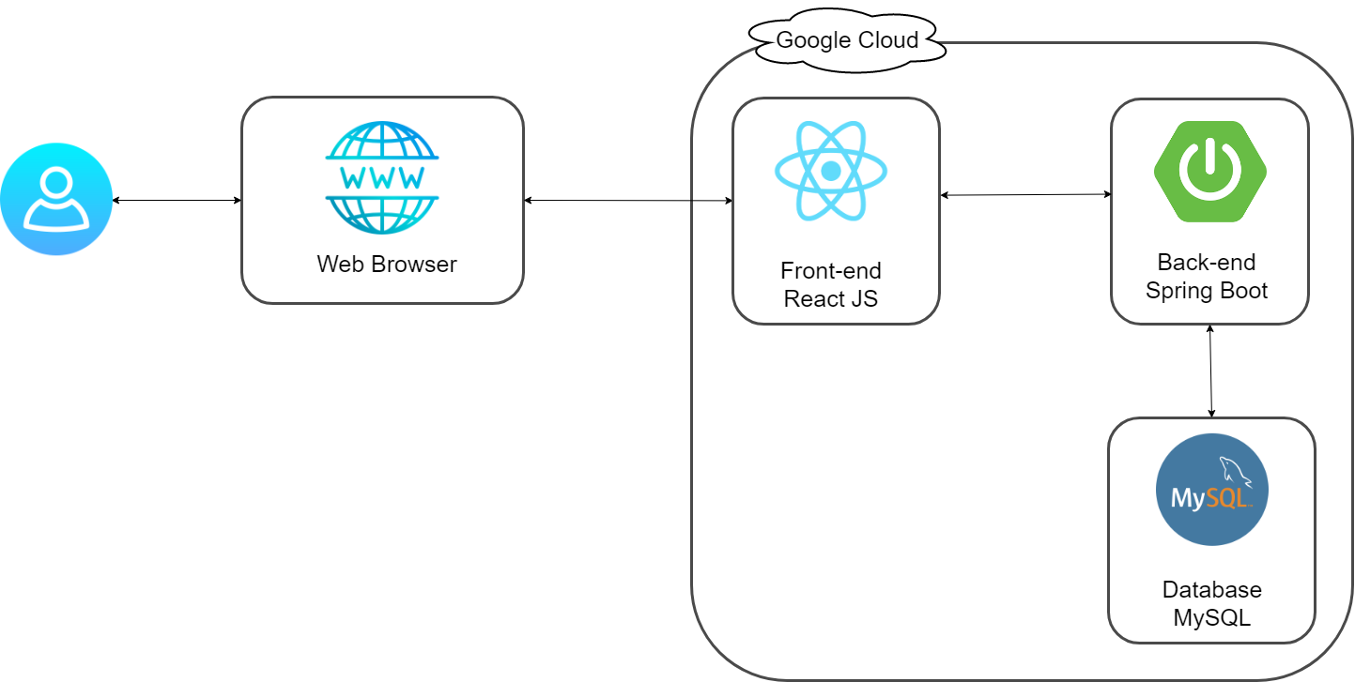

HTTPS

HTTPS

#### 1.1.2 Component Explanation

##### *1.1.2.1 Spring Boot*



In the project, the team uses Spring Boot libraries to implement the backend system for this project. The project uses the startup libraries provided by Spring Boot and uses the Spring Security library to generate JWT Tokens to authenticate and authorize requests sent to the system.

##### *1.1.2.2 ReactJS*



ReactJS is a JavaScript library used to create reusable person interface factors. The definition of React is as follows: React is a library for creating composable person interfaces. It promotes the development of reusable UI additives that show constantly changing statistics.

React takes away the DOM from you, resulting in a greater honest programming fashion and stepped forward velocity. React can also energy local apps with React local and also render at the server the use of Node. React makes use of one-manner reactive records flow, that's less boilerplate and easier to apprehend than traditional records binding.

##### *1.1.2.3 MySQL*



My team is final student and we looking for a free or low-cost database management system, several are available from which to choose: MySQL, PostgreSQL, SQLite, one of the free-but-unsupported engines from commercial vendors, and so forth. When we compare MySQL with other database systems, think about what's most important to us. Performance, support, features (such as SQL conformance or extensions), licensing conditions and restrictions, and price all are factors to take into account. Given these considerations, MySQL has many attractive features to offer:

* **Speed**: MySQL is fast. Its developers contend that MySQL is about the fastest database system can get.
* **Ease of use:** MySQL is a high-performance but relatively simple database system and is much less complex to set up and administer than larger systems.
* **Query language support:** MySQL understands SQL, the standard language of choice for all modern database systems.
* **Capability:** The MySQL server is multi-threaded, so many clients can connect to it at the same time. Each client can use multiple databases simultaneously.

##### *1.1.2.4 Google Cloud Platform*



In the project, the team uses many typical Google Cloud platform services such as the Google Map API service to use for locating the hostel and giving directions to the hostel right on the interface of the website. In addition, the team also deploys the project on a virtual machine of Google Cloud with Ubuntu operating system and running Nginx server.

##### *1.1.2.5 Google Map API*



Google Maps is a Web-based service that provides detailed information about geographical regions and sites around the world. In addition to conventional road maps, Google Maps offers aerial and satellite views of many places. In some cities, Google Maps offers street views compromising photographs taken from vehicles. It offers satellite imagery, aerial photography, street maps, 360° interactive panoramic views of streets (Street View), real-time traffic conditions

### 1.2 Package Diagram

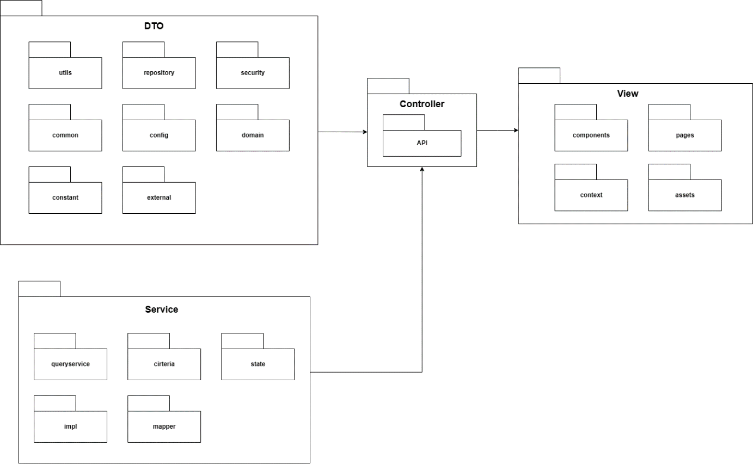

***Package Descriptions***

|  |  |  |
| --- | --- | --- |
| **No** | **Package** | **Description** |
| 01 | DTO | Carries data between processes |
| 02 | Service | Contains classes for display data to the view and, handle logic, modify, convert from model to DTO |
| 03 | Controller | Communicate between Backend and Frontend |
| 04 | View | Contains the UI and UX of the website |

## 2. Database Design

**2.1 Database Diagram**

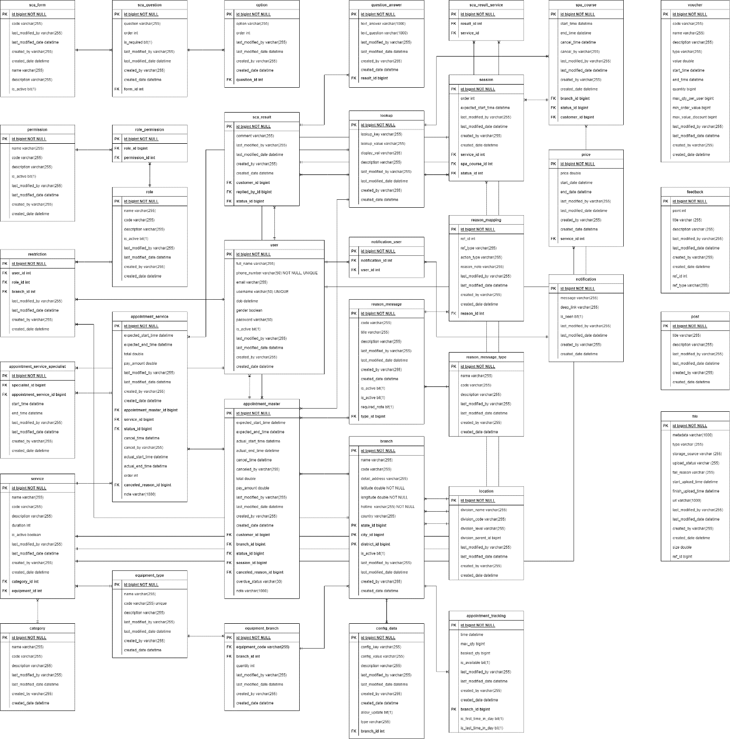

*Figure 2.1.1: Database Diagram*

**2.2 Table Descriptions**

**2.2.1 Sca_form**

|  |  |  |  |  |  |
| --- | --- | --- | --- | --- | --- |
| **No** | **Field name** | **Type** | **PK/FK** | **Not null** | **Notes** |
| 01 | id | int | PK | x |  |
| 02 | code | varchar(255) |  |  |  |
| 03 | name | varchar(255) |  |  |  |
| 04 | description | varchar(255) |  |  |  |
| 05 | last_modified_by | varchar(255) |  |  |  |
| 06 | last_modified_date | datetime |  |  |  |
| 07 | created_by | varchar(255) |  |  |  |
| 08 | created_date | datetime |  |  |  |

**2.2.2 Sca_question**

|  |  |  |  |  |  |
| --- | --- | --- | --- | --- | --- |
| **No** | **Field name** | **Type** | **PK/FK** | **Not null** | **Notes** |
| 01 | id | int | PK | x |  |
| 02 | question | varchar(255) |  |  |  |
| 03 | order | int |  |  |  |
| 04 | is_required | bit(1) |  |  |  |
| 05 | last_modified_by | varchar(255) |  |  |  |
| 06 | last_modified_date | datetime |  |  |  |
| 07 | created_by | varchar(255) |  |  |  |
| 08 | created_date | datetime |  |  |  |
| 09 | form_id | int | FK |  |  |

**2.2.3 Option**

|  |  |  |  |  |  |
| --- | --- | --- | --- | --- | --- |
| **No** | **Field name** | **Type** | **PK/FK** | **Not null** | **Notes** |
| 01 | id | int | PK | x |  |
| 02 | question_id | varchar(255) | FK |  |  |
| 03 | option | varchar(1000) |  |  |  |
| 04 | order | int |  |  |  |
| 05 | last_modified_by | varchar(255) |  |  |  |
| 06 | last_modified_date | datetime |  |  |  |
| 07 | created_by | varchar(255) |  |  |  |
| 08 | created_date | datetime |  |  |  |

**2.2.4 Question_answer**

|  |  |  |  |  |  |
| --- | --- | --- | --- | --- | --- |
| **No** | **Field name** | **Type** | **PK/FK** | **Not null** | **Notes** |
| 01 | id | int | PK | x |  |
| 02 | question_id | varchar(255) | FK |  |  |
| 03 | option_id | int | FK |  |  |
| 04 | result_id | int | FK |  |  |
| 05 | text_answer | varchar(1000) |  |  |  |
| 06 | last_modified_by | varchar(255) |  |  |  |
| 07 | last_modified_date | datetime |  |  |  |
| 08 | created_by | varchar(255) |  |  |  |
| 09 | created_date | datetime |  |  |  |

**2.2.5 Sca_result**

|  |  |  |  |  |  |
| --- | --- | --- | --- | --- | --- |
| **No** | **Field name** | **Type** | **PK/FK** | **Not null** | **Notes** |
| 01 | id | int | PK | x |  |
| 02 | customer_id | int | FK |  |  |
| 03 | receptionist_id | int | FK |  |  |
| 04 | status_id | int | FK |  |  |
| 05 | comment | varchar(1000) |  |  |  |
| 06 | last_modified_by | varchar(255) |  |  |  |
| 07 | last_modified_date | datetime |  |  |  |
| 08 | created_by | varchar(255) |  |  |  |
| 09 | created_date | datetime |  |  |  |

**2.2.6 Sca_result_service**

|  |  |  |  |  |  |
| --- | --- | --- | --- | --- | --- |
| **No** | **Field name** | **Type** | **PK/FK** | **Not null** | **Notes** |
| 01 | id | int | PK | x |  |
| 02 | result_id | int | FK |  |  |
| 03 | service_id | int | FK |  |  |

**2.2.7 Lookup**

|  |  |  |  |  |  |
| --- | --- | --- | --- | --- | --- |
| **No** | **Field name** | **Type** | **PK/FK** | **Not null** | **Notes** |
| 01 | id | int | PK | x |  |
| 02 | lookup_key | varchar(255) |  |  |  |
| 03 | lookup_val | varchar(255) |  |  |  |
| 04 | display_val | varchar(255) |  |  |  |
| 05 | description | varchar(255) |  |  |  |
| 06 | last_modified_by | varchar(255) |  |  |  |
| 07 | last_modified_date | datetime |  |  |  |
| 08 | created_by | varchar(255) |  |  |  |
| 09 | created_date | datetime |  |  |  |

**2.2.8 Session**

|  |  |  |  |  |  |
| --- | --- | --- | --- | --- | --- |
| **No** | **Field name** | **Type** | **PK/FK** | **Not null** | **Notes** |
| 01 | id | int | PK | x |  |
| 02 | service_id | varchar(255) | FK |  |  |
| 03 | spa_course_id | varchar(255) | FK |  |  |
| 04 | status_id | varchar(255) | FK |  |  |
| 05 | expected_start_date | varchar(255) |  |  |  |
| 06 | order | int |  |  |  |
| 07 | last_modified_by | varchar(255) |  |  |  |
| 08 | last_modified_date | datetime |  |  |  |
| 09 | created_by | varchar(255) |  |  |  |
| 10 | created_date | datetime |  |  |  |

**2.2.9 Spa_course**

|  |  |  |  |  |  |
| --- | --- | --- | --- | --- | --- |
| **No** | **Field name** | **Type** | **PK/FK** | **Not null** | **Notes** |
| 01 | id | int | PK | x |  |
| 02 | service_id | int | FK |  |  |
| 03 | spa_course_id | int | FK |  |  |
| 04 | status_id | int | FK |  |  |
| 05 | start_time | int |  |  |  |
| 06 | end_time | int |  |  |  |
| 07 | cancelled_time | datetime |  |  |  |
| 08 | cancelled_by | varchar(255) |  |  |  |
| 09 | last_modified_by | varchar(255) |  |  |  |
| 10 | last_modified_date | datetime |  |  |  |
| 11 | created_by | varchar(255) |  |  |  |
| 12 | created_date | datetime |  |  |  |

**2.2.10 Branch**

|  |  |  |  |  |  |
| --- | --- | --- | --- | --- | --- |
| **No** | **Field name** | **Type** | **PK/FK** | **Not null** | **Notes** |
| 01 | id | int | PK | x |  |
| 02 | service_id | int | FK |  |  |
| 03 | spa_course_id | int | FK |  |  |
| 04 | status_id | int | FK |  |  |
| 05 | name | varchar(255) |  |  |  |
| 06 | code | varchar(255) |  |  |  |
| 07 | detail_address | varchar(500) |  |  |  |
| 08 | hotline | varchar(50) |  | x |  |
| 09 | latitude | varchar(255) |  | x |  |
| 10 | longitude | varchar(255) |  | x |  |
| 11 | last_modified_by | varchar(255) |  |  |  |
| 12 | last_modified_date | datetime |  |  |  |
| 13 | created_by | varchar(255) |  |  |  |
| 14 | created_date | datetime |  |  |  |

**2.2.11 Config_data**

|  |  |  |  |  |  |
| --- | --- | --- | --- | --- | --- |
| **No** | **Field name** | **Type** | **PK/FK** | **Not null** | **Notes** |
| 01 | id | int | PK | x |  |
| 02 | branch_id | int | FK |  |  |
| 03 | config_key | varchar(255) | FK |  |  |
| 04 | config_value | varchar(255) | FK |  |  |
| 05 | description | varchar(255) |  |  |  |
| 06 | last_modified_by | varchar(255) |  |  |  |
| 07 | last_modified_date | datetime |  |  |  |
| 08 | created_by | varchar(255) |  |  |  |
| 09 | created_date | datetime |  |  |  |

**2.2.12 Branch_service**

|  |  |  |  |  |  |
| --- | --- | --- | --- | --- | --- |
| **No** | **Field name** | **Type** | **PK/FK** | **Not null** | **Notes** |
| 01 | id | int | PK | x |  |
| 02 | branch_id | int | FK |  |  |
| 03 | service_id | int | FK |  |  |

**2.2.13 Service**

|  |  |  |  |  |  |
| --- | --- | --- | --- | --- | --- |
| **No** | **Field name** | **Type** | **PK/FK** | **Not null** | **Notes** |
| 01 | id | int | PK | x |  |
| 02 | category_id | int | FK |  |  |
| 03 | equipment_id | int | FK |  |  |
| 04 | name | varchar(255) |  |  |  |
| 05 | code | varchar(255) |  |  |  |
| 06 | description | varchar(255) |  |  |  |
| 07 | duration | int |  |  |  |
| 08 | is_active | boolean |  |  |  |
| 09 | last_modified_by | varchar(255) |  |  |  |
| 10 | last_modified_date | datetime |  |  |  |
| 11 | created_by | varchar(255) |  |  |  |
| 12 | created_date | datetime |  |  |  |

**2.2.14 Price**

|  |  |  |  |  |  |
| --- | --- | --- | --- | --- | --- |
| **No** | **Field name** | **Type** | **PK/FK** | **Not null** | **Notes** |
| 01 | id | int | PK | x |  |
| 02 | service_id | int | FK |  |  |
| 03 | price | float |  |  |  |
| 04 | start_date | datetime |  |  |  |
| 05 | end_date | datetime |  |  |  |
| 06 | last_modified_by | varchar(255) |  |  |  |
| 07 | last_modified_date | datetime |  |  |  |
| 08 | created_by | varchar(255) |  |  |  |
| 09 | created_date | datetime |  |  |  |

**2.2.15 Service_category**

|  |  |  |  |  |  |
| --- | --- | --- | --- | --- | --- |
| **No** | **Field name** | **Type** | **PK/FK** | **Not null** | **Notes** |
| 01 | id | int | PK | x |  |
| 02 | name | varchar(255) |  |  |  |
| 03 | code | varchar(255) |  |  |  |
| 04 | description | varchar(255) |  |  |  |
| 06 | last_modified_by | varchar(255) |  |  |  |
| 07 | last_modified_date | datetime |  |  |  |
| 08 | created_by | varchar(255) |  |  |  |
| 09 | created_date | datetime |  |  |  |

**2.2.16 Equipment_type**

|  |  |  |  |  |  |
| --- | --- | --- | --- | --- | --- |
| **No** | **Field name** | **Type** | **PK/FK** | **Not null** | **Notes** |
| 01 | id | int | PK | x |  |
| 02 | name | varchar(255) |  |  |  |
| 03 | code | varchar(255) |  |  | UNIQUE |
| 04 | description | varchar(255) |  |  |  |
| 05 | last_modified_by | varchar(255) |  |  |  |
| 06 | last_modified_date | datetime |  |  |  |
| 07 | created_by | varchar(255) |  |  |  |
| 08 | created_date | datetime |  |  |  |

**2.2.17 Equipment_branch**

|  |  |  |  |  |  |
| --- | --- | --- | --- | --- | --- |
| **No** | **Field name** | **Type** | **PK/FK** | **Not null** | **Notes** |
| 01 | id | int | PK | x |  |
| 02 | equipment_code | varchar(255) | FK |  |  |
| 03 | branch_id | int | FK |  |  |
| 04 | quantity | int |  |  |  |
| 05 | last_modified_by | varchar(255) |  |  |  |
| 06 | last_modified_date | datetime |  |  |  |
| 07 | created_by | varchar(255) |  |  |  |
| 08 | created_date | datetime |  |  |  |

**2.2.18 Retriction**

|  |  |  |  |  |  |
| --- | --- | --- | --- | --- | --- |
| **No** | **Field name** | **Type** | **PK/FK** | **Not null** | **Notes** |
| 01 | id | int | PK | x |  |
| 02 | user_id | int | FK |  |  |
| 03 | branch_id | int | FK |  |  |
| 04 | role_id | int | FK |  |  |
| 05 | last_modified_by | varchar(255) |  |  |  |
| 06 | last_modified_date | datetime |  |  |  |
| 07 | created_by | varchar(255) |  |  |  |
| 08 | created_date | datetime |  |  |  |

**2.2.19 Role**

|  |  |  |  |  |  |
| --- | --- | --- | --- | --- | --- |
| **No** | **Field name** | **Type** | **PK/FK** | **Not null** | **Notes** |
| 01 | id | int | PK | x |  |
| 02 | user_id | int | FK |  |  |
| 03 | branch_id | int | FK |  |  |
| 04 | role_id | int | FK |  |  |
| 05 | name | varchar(255) |  |  |  |
| 06 | code | varchar(255) |  |  |  |
| 07 | description | varchar(255) |  |  |  |
| 08 | is_active | boolean |  |  |  |
| 09 | last_modified_by | varchar(255) |  |  |  |
| 10 | last_modified_date | datetime |  |  |  |
| 11 | created_by | varchar(255) |  |  |  |
| 12 | created_date | datetime |  |  |  |

**2.2.20 Permission_role**

|  |  |  |  |  |  |
| --- | --- | --- | --- | --- | --- |
| **No** | **Field name** | **Type** | **PK/FK** | **Not null** | **Notes** |
| 01 | id | int | PK | x |  |
| 02 | role_id | int | FK |  |  |
| 03 | permission_id | int | FK |  |  |

**2.2.21 Permission**

|  |  |  |  |  |  |
| --- | --- | --- | --- | --- | --- |
| **No** | **Field name** | **Type** | **PK/FK** | **Not null** | **Notes** |
| 01 | id | int | PK | x |  |
| 02 | name | varchar(255) |  |  |  |
| 03 | code | varchar(255) |  |  |  |
| 04 | description | varchar(255) |  |  |  |
| 05 | last_modified_by | varchar(255) |  |  |  |
| 06 | last_modified_date | datetime |  |  |  |
| 07 | created_by | varchar(255) |  |  |  |
| 08 | created_date | datetime |  |  |  |

**2.2.22 Notification**

|  |  |  |  |  |  |
| --- | --- | --- | --- | --- | --- |
| **No** | **Field name** | **Type** | **PK/FK** | **Not null** | **Notes** |
| 01 | id | int | PK | x |  |
| 02 | message | varchar(1000) | FK |  |  |
| 03 | deep_link | varchar(1000) | FK |  |  |
| 04 | is_seen | bit(1) | FK |  |  |
| 05 | last_modified_by | varchar(255) |  |  |  |
| 06 | last_modified_date | datetime |  |  |  |
| 07 | created_by | varchar(255) |  |  |  |
| 08 | created_date | datetime |  |  |  |

**2.2.23 Notification_user**

|  |  |  |  |  |  |
| --- | --- | --- | --- | --- | --- |
| **No** | **Field name** | **Type** | **PK/FK** | **Not null** | **Notes** |
| 01 | id | int | PK | x |  |
| 02 | notification_id | int | FK |  |  |
| 03 | user_id | int | FK |  |  |

**2.2.24 User**

|  |  |  |  |  |  |
| --- | --- | --- | --- | --- | --- |
| **No** | **Field name** | **Type** | **PK/FK** | **Not null** | **Notes** |
| 01 | id | int | PK | x |  |
| 02 | full_name | varchar(255) |  |  |  |
| 03 | phone_number | varchar(50) |  |  | UNIQUE |
| 04 | email | varchar(255) |  |  |  |
| 05 | username | varchar(255) |  |  | UNIQUE |
| 06 | dob | datetime |  |  |  |
| 07 | gender | varchar(255) |  |  |  |
| 08 | password | varchar(50) |  |  |  |
| 09 | is_active | bit(1) |  |  |  |
| 10 | last_modified_by | varchar(255) |  |  |  |
| 11 | last_modified_date | datetime |  |  |  |
| 12 | created_by | varchar(255) |  |  |  |
| 13 | created_date | datetime |  |  |  |

**2.2.25 Apointment_master**

|  |  |  |  |  |  |
| --- | --- | --- | --- | --- | --- |
| **No** | **Field name** | **Type** | **PK/FK** | **Not null** | **Notes** |
| 01 | id | int | PK | x |  |
| 02 | customer_id | int | FK |  |  |
| 03 | branch_id | int | FK |  |  |
| 04 | status_id | int | FK |  |  |
| 05 | session_id | int | FK |  |  |
| 06 | expected_start_time | datetime |  |  |  |
| 07 | expected_end_time | datetime |  |  |  |
| 08 | actual_start_time | datetime |  |  |  |
| 09 | actual_end_time | datetime |  |  |  |
| 10 | cancel_time | datetime |  |  |  |
| 11 | total | float |  |  |  |
| 12 | pay_amount | float |  |  |  |
| 13 | last_modified_by | varchar(255) |  |  |  |
| 14 | last_modified_date | datetime |  |  |  |
| 15 | created_by | varchar(255) |  |  |  |
| 16 | created_date | datetime |  |  |  |

**2.2.26 Apointment_service**

|  |  |  |  |  |  |
| --- | --- | --- | --- | --- | --- |
| **No** | **Field name** | **Type** | **PK/FK** | **Not null** | **Notes** |
| 01 | id | int | PK | x |  |
| 02 | appointment_master_id | int | FK |  |  |
| 03 | service_id | int | FK |  |  |
| 04 | status_id | int | FK |  |  |  |
| 05 | expected_start_time | datetime |  |  |  |  |
| 06 | expected_end_time | datetime |  |  |  |  |
| 07 | cancel_time | datetime |  |  |  |  |
| 08 | total | float |  |  |  |  |
| 09 | pay_amount | float |  |  |  |  |
| 10 | cancelled_by | varchar(255) |  |  |  |  |
| 11 | last_modified_by | varchar(255) |  |  |  |  |
| 12 | last_modified_date | datetime |  |  |  |  |
| 13 | created_by | varchar(255) |  |  |  |  |
| 14 | created_date | datetime |  |  |  |  |

**2.2.27 Apointment_service_specialist**

|  |  |  |  |  |  |
| --- | --- | --- | --- | --- | --- |
| **No** | **Field name** | **Type** | **PK/FK** | **Not null** | **Notes** |
| 01 | id | int | PK | x |  |
| 02 | specialist_id | int | FK |  |  |
| 03 | appointment_service_id | int | FK |  |  |
| 04 | start_time | datetime |  |  |  |
| 05 | end_time | datetime |  |  |  |
| 06 | last_modified_by | varchar(255) |  |  |  |
| 07 | last_modified_date | datetime |  |  |  |
| 08 | created_by | varchar(255) |  |  |  |
| 09 | created_date | datetime |  |  |  |

**2.2.28 Voucher_usage**

|  |  |  |  |  |  |
| --- | --- | --- | --- | --- | --- |
| **No** | **Field name** | **Type** | **PK/FK** | **Not null** | **Notes** |
| 01 | id | int | PK | x |  |
| 02 | user_id | int | FK |  |  |
| 03 | voucher_id | int | FK |  |  |
| 04 | appointment_service_id | int | FK |  |  |

**2.2.29 Voucher**

|  |  |  |  |  |  |
| --- | --- | --- | --- | --- | --- |
| **No** | **Field name** | **Type** | **PK/FK** | **Not null** | **Notes** |
| 01 | id | int | PK | x |  |
| 02 | specialist_id | int | FK |  |  |
| 03 | appointment_service_id | int | FK |  |  |
| 04 | code | varchar(255) |  |  |  |
| 05 | name | varchar(255) |  |  |  |
| 06 | description | varchar(255) |  |  |  |
| 07 | type | varchar(255) |  |  |  |
| 08 | value | double |  |  |  |
| 09 | start_time | datetime |  |  |  |
| 10 | end_time | datetime |  |  |  |
| 11 | quantity | int |  |  |  |
| 12 | max_qty_per_user | int |  |  |  |
| 13 | min_order_value | int |  |  |  |
| 14 | max_value_discount | int |  |  |  |
| 15 | last_modified_by | varchar(255) |  |  |  |
| 16 | last_modified_date | datetime |  |  |  |
| 17 | created_by | varchar(255) |  |  |  |
| 18 | created_date | datetime |  |  |  |

**2.2.30 Reason_mapping**

|  |  |  |  |  |  |
| --- | --- | --- | --- | --- | --- |
| **No** | **Field name** | **Type** | **PK/FK** | **Not null** | **Notes** |
| 01 | id | int | PK | x |  |
| 02 | reason_id | int | FK |  |  |
| 03 | code | varchar(255) |  |  |  |
| 04 | ref_type | varchar(255) |  |  |  |
| 05 | action_type | varchar(255) |  |  |  |
| 06 | reason_note | varchar(255) |  |  |  |
| 07 | last_modified_by | varchar(255) |  |  |  |
| 08 | last_modified_date | datetime |  |  |  |
| 09 | created_by | varchar(255) |  |  |  |
| 10 | created_date | datetime |  |  |  |

**2.2.31 Reason_message**

|  |  |  |  |  |  |
| --- | --- | --- | --- | --- | --- |
| **No** | **Field name** | **Type** | **PK/FK** | **Not null** | **Notes** |
| 01 | id | int | PK | x |  |
| 02 | reason_message_type_id | int | FK |  |  |
| 03 | code | varchar(255) |  |  |  |
| 04 | name | varchar(255) |  |  |  |
| 05 | description | varchar(255) |  |  |  |
| 06 | is_active | bit(1) |  |  |  |
| 07 | required_note | bit(1) |  |  |  |
| 08 | last_modified_by | varchar(255) |  |  |  |
| 09 | last_modified_date | datetime |  |  |  |
| 10 | created_by | varchar(255) |  |  |  |
| 11 | created_date | datetime |  |  |  |

**2.2.32 Post**

|  |  |  |  |  |  |
| --- | --- | --- | --- | --- | --- |
| **No** | **Field name** | **Type** | **PK/FK** | **Not null** | **Notes** |
| 01 | id | int | PK | x |  |
| 02 | title | varchar(255) |  |  |  |
| 03 | description | varchar(1000) |  |  |  |
| 04 | last_modified_by | varchar(255) |  |  |  |
| 05 | last_modified_date | datetime |  |  |  |
| 06 | created_by | varchar(255) |  |  |  |
| 07 | created_date | datetime |  |  |  |

**2.2.33 File**

|  |  |  |  |  |  |
| --- | --- | --- | --- | --- | --- |
| **No** | **Field name** | **Type** | **PK/FK** | **Not null** | **Notes** |
| 01 | id | int | PK | x |  |
| 02 | metadata | varchar(1000) |  |  |  |
| 03 | type | varchar(1000) |  |  |  |
| 04 | storage_source | varchar(255) |  |  |  |
| 05 | upload_status | varchar(255) |  |  |  |
| 06 | fail_reason | varchar(255) |  |  |  |
| 07 | start_upload_time | datetime |  |  |  |
| 08 | finish_upload_time | datetime |  |  |  |
| 09 | url | varchar(1000) |  |  |  |
| 10 | last_modified_by | varchar(255) |  |  |  |
| 11 | last_modified_date | datetime |  |  |  |
| 12 | created_by | varchar(255) |  |  |  |
| 13 | created_date | datetime |  |  |  |

**2.2.34 Feedback**

|  |  |  |  |  |  |
| --- | --- | --- | --- | --- | --- |
| **No** | **Field name** | **Type** | **PK/FK** | **Not null** | **Notes** |
| 01 | id | int | PK | x |  |
| 02 | point | int |  |  |  |
| 03 | title | varchar(255) |  |  |  |
| 04 | description | varchar(1000) |  |  |  |
| 05 | ref_id | int |  |  |  |
| 06 | ref_type | varchar(255) |  |  |  |
| 07 | last_modified_by | varchar(255) |  |  |  |
| 08 | last_modified_date | datetime |  |  |  |
| 09 | created_by | varchar(255) |  |  |  |
| 10 | created_date | datetime |  |  |  |

**2.2.35 Apointment_tracking**

|  |  |  |  |  |  |
| --- | --- | --- | --- | --- | --- |
| **No** | **Field name** | **Type** | **PK/FK** | **Not null** | **Notes** |
| 01 | id | int | PK | x |  |
| 02 | time | datetime |  |  |  |
| 03 | max_qty | int |  |  |  |
| 04 | booked_qty | int |  |  |  |
| 05 | is_available | bit(1) |  |  |  |
| 06 | last_modified_by | varchar(255) |  |  |  |
| 07 | last_modified_date | datetime |  |  |  |
| 08 | created_by | varchar(255) |  |  |  |
| 09 | created_date | datetime |  |  |  |

**2.2.36 Job_execution_params**

|  |  |  |  |  |  |
| --- | --- | --- | --- | --- | --- |
| **No** | **Field name** | **Type** | **PK/FK** | **Not null** | **Notes** |
| 01 | id | int | PK | x |  |
| 02 | param_key | varchar(255) |  |  |  |
| 03 | param_value | varchar(255) |  |  |  |
| 04 | last_modified_by | varchar(255) |  |  |  |
| 05 | last_modified_date | datetime |  |  |  |
| 06 | created_by | varchar(255) |  |  |  |
| 07 | created_date | datetime |  |  |  |

## 3. Detailed Design

### 3.1 Manage Category

#### 3.1.1 Class Diagram

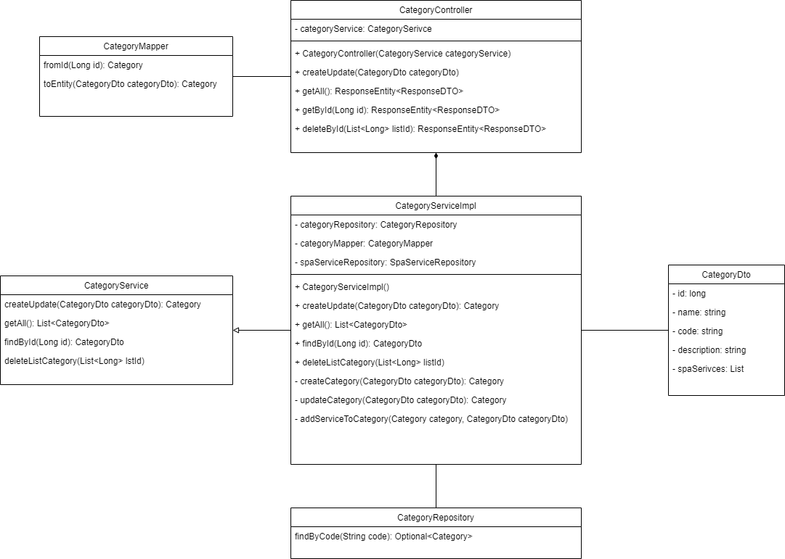

*Figure 3.1.1: Category’s Class Diagram*

***3.1.2 Sequence Diagram***

- View category list

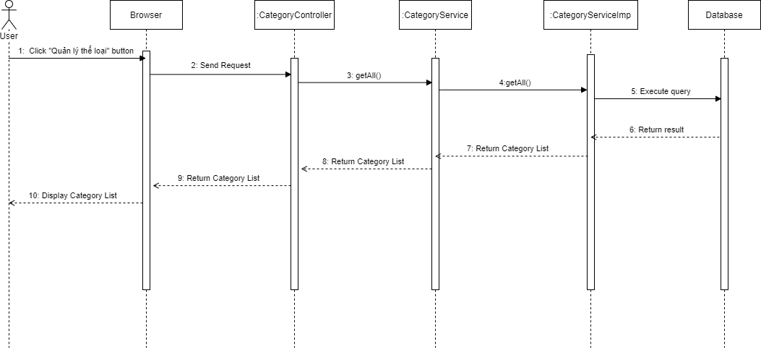

- Create category

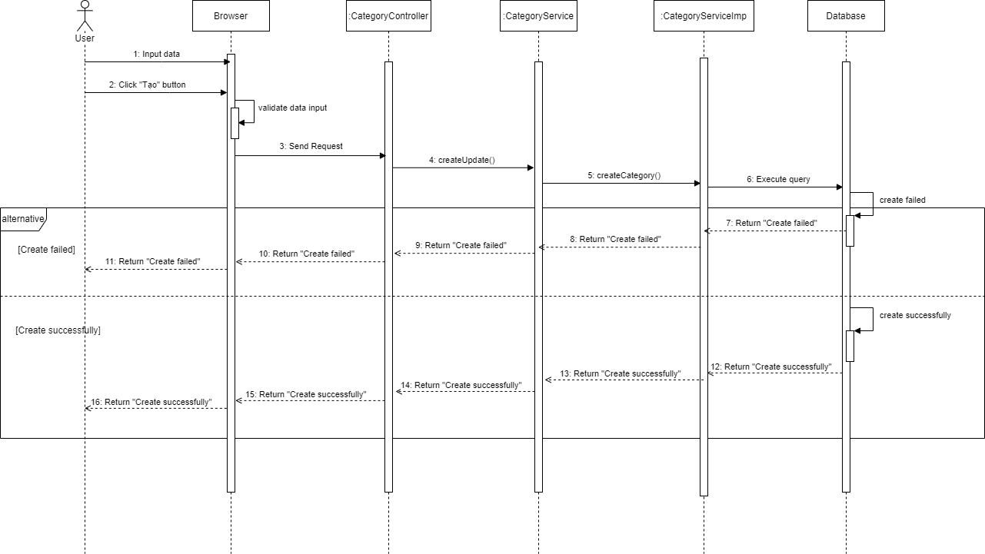

- Update category

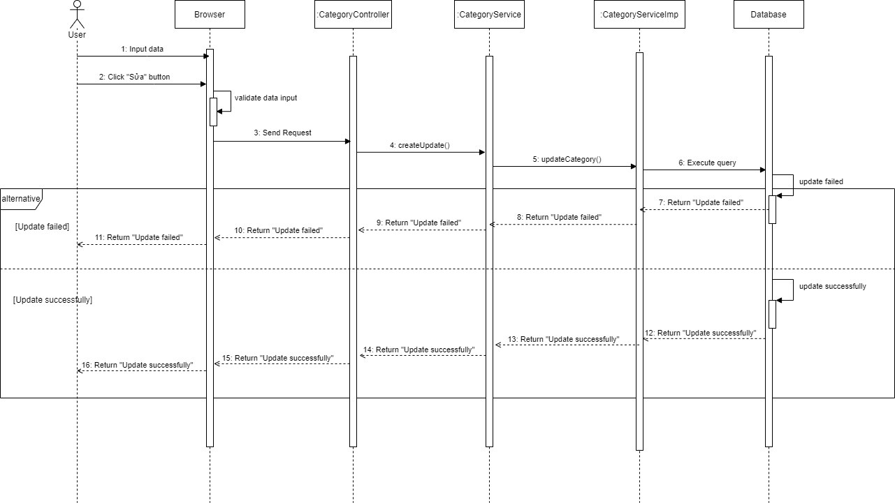

- Delete category

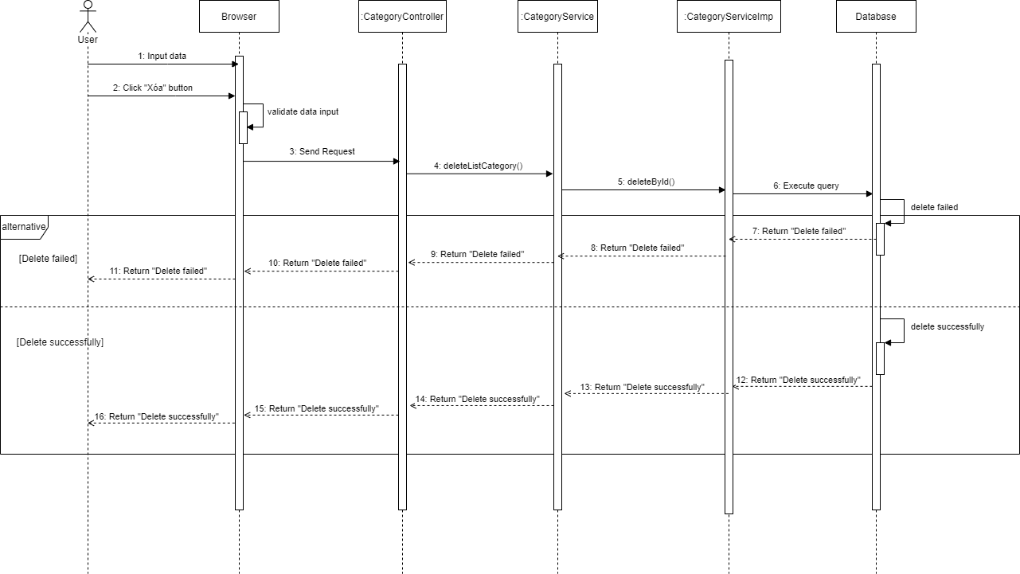

### 3.2 Manage Post

***3.2.1 Class Diagram***

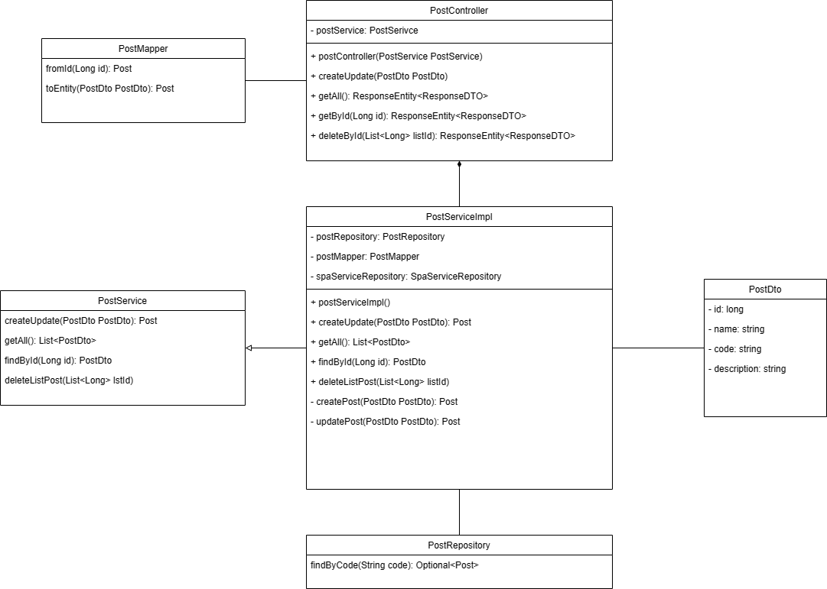

***3.2.2 Sequence Diagram***

- View post list

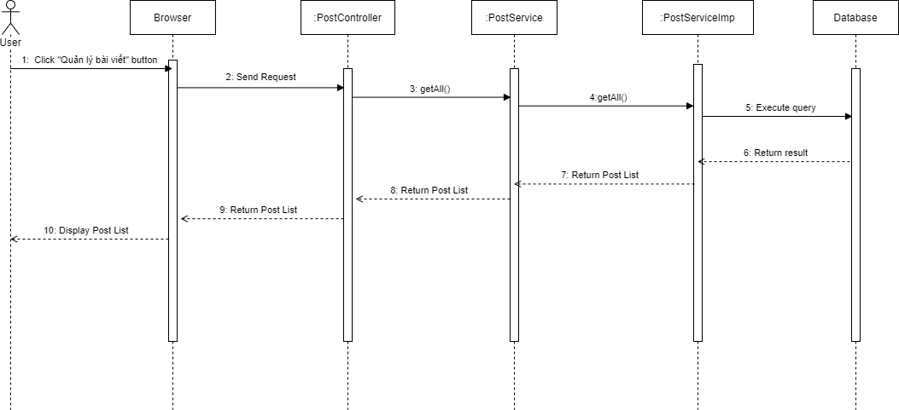

- View post detail

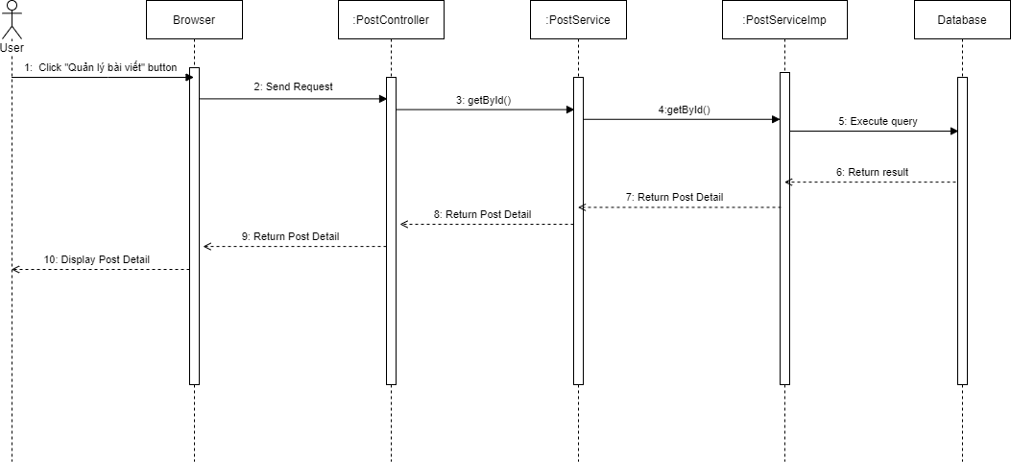

- Create post

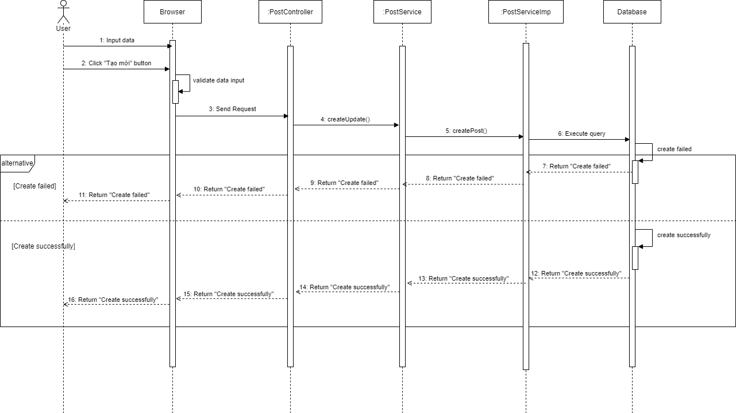

- Update post

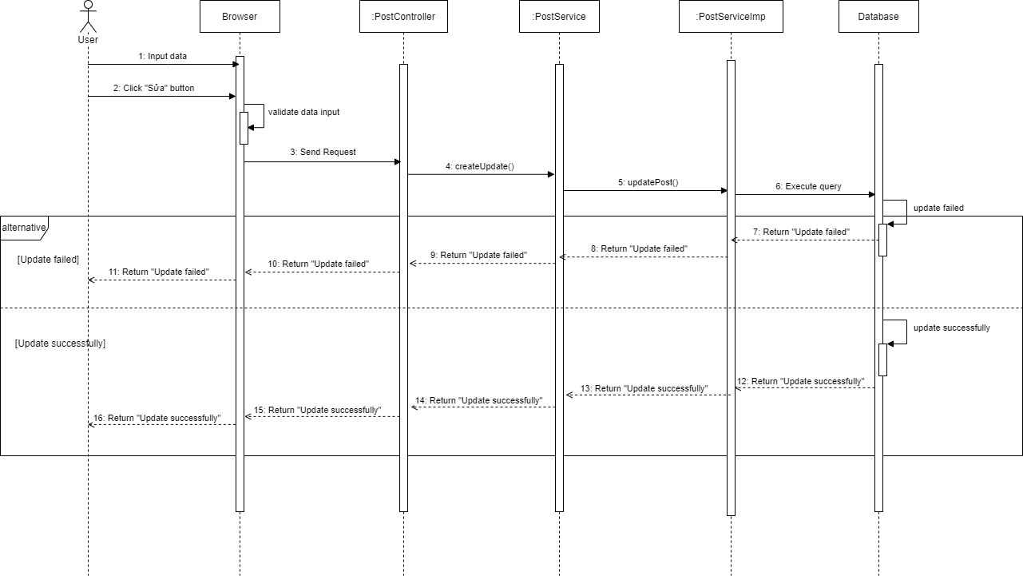

- Delete post

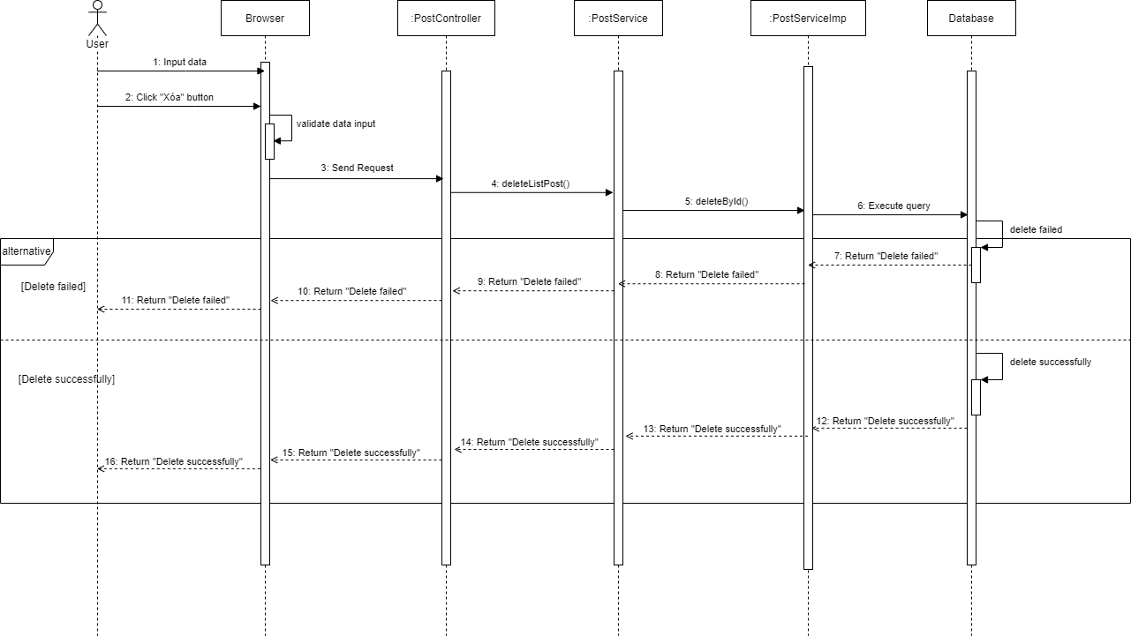

### 3.3 Manage Service

***3.3.1 Class Diagram***

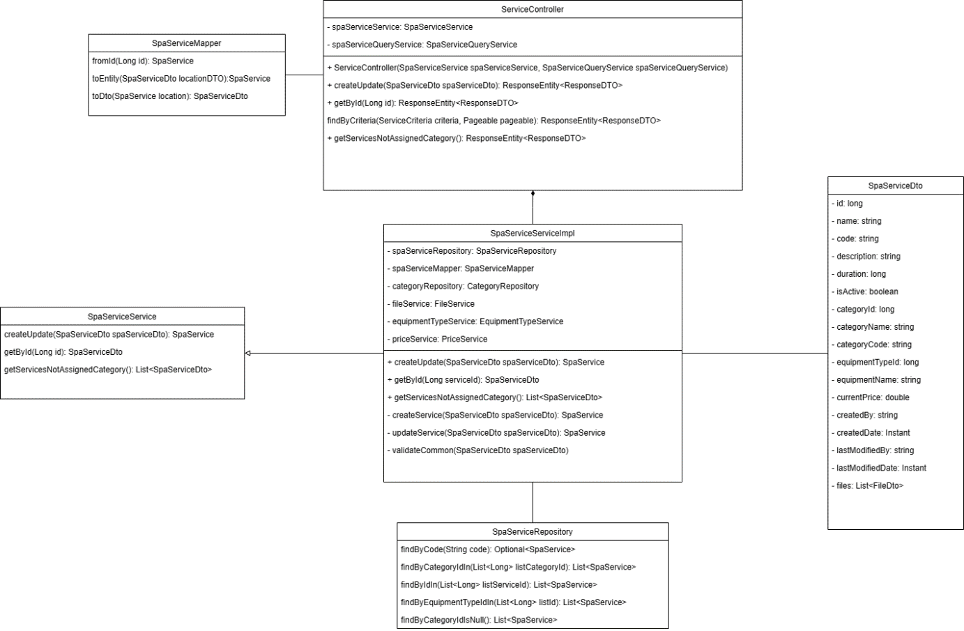

***3.3.2 Sequence Diagram***

- View service list

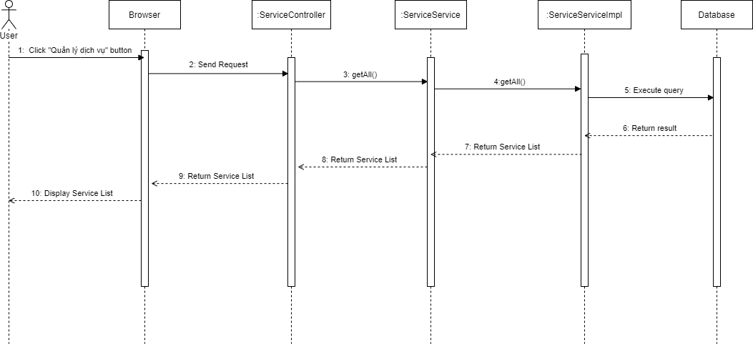

- View service detail

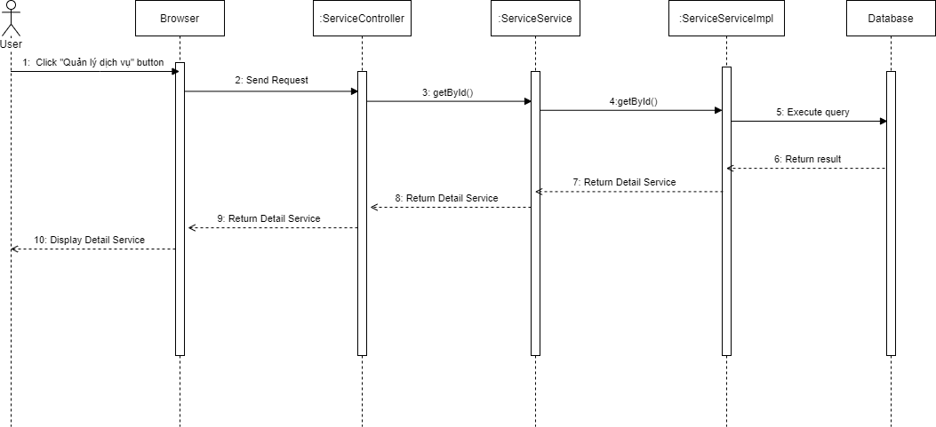

- Create service

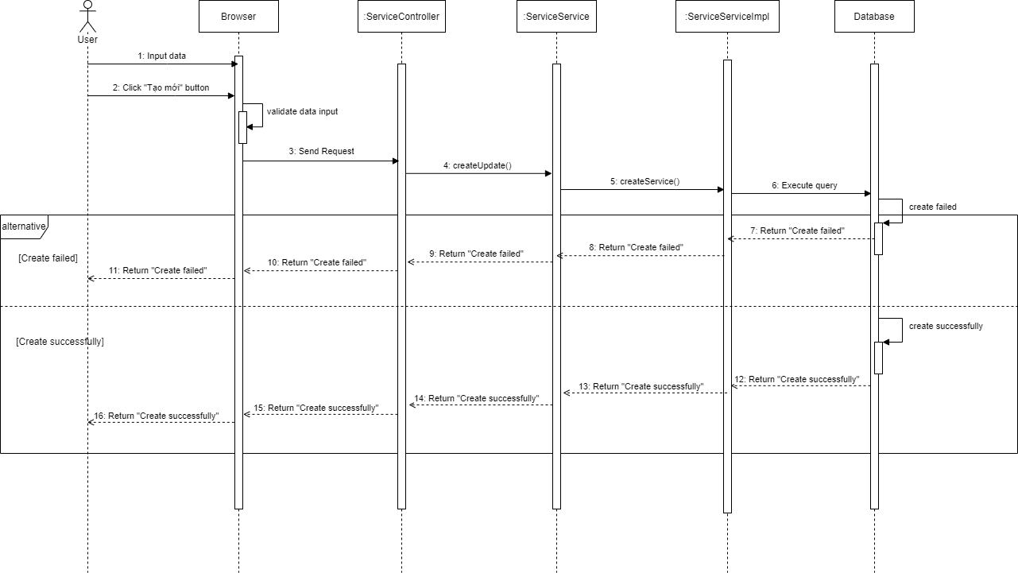

- Update service

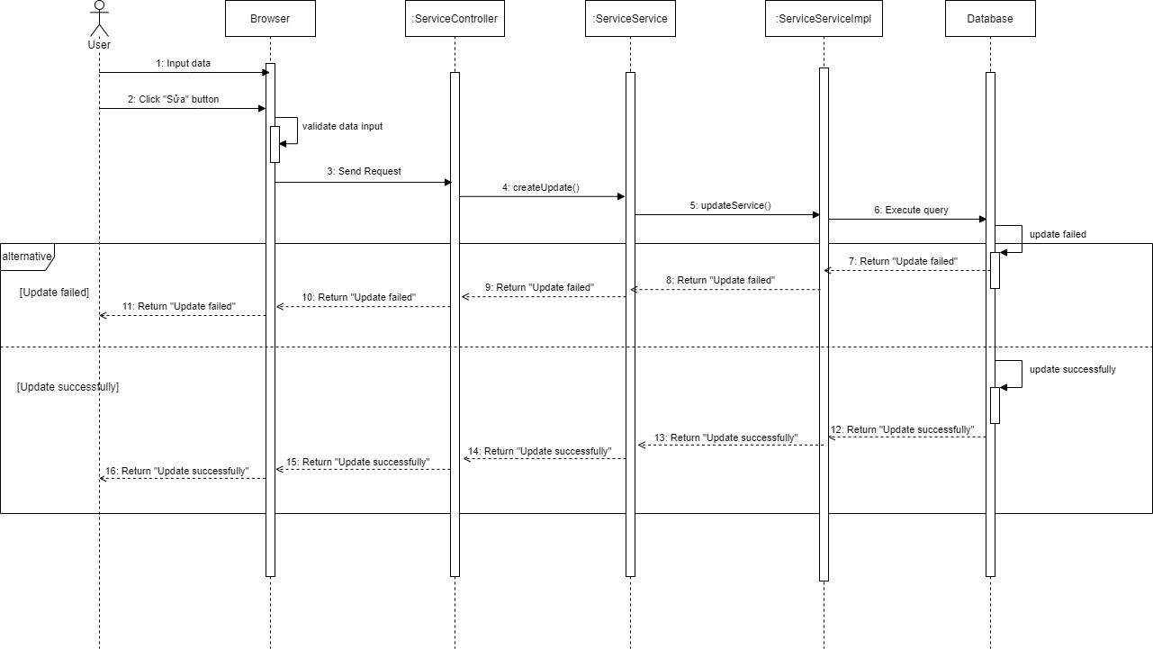

- Delete service

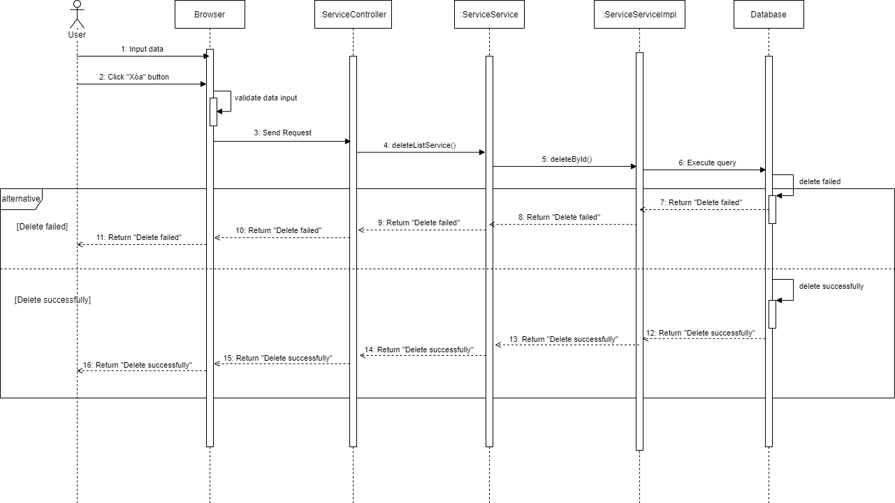

### 3.4 Manage Branch

***3.4.1 Class Diagram***

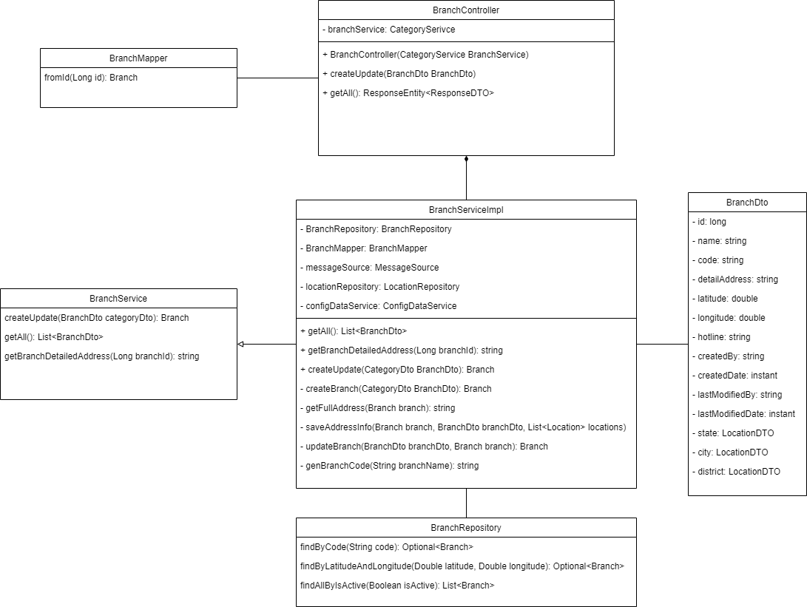

*Figure 3.4.1: Branch’s Class Diagram*

***3.4.2 Sequence Diagram***

- View branch list

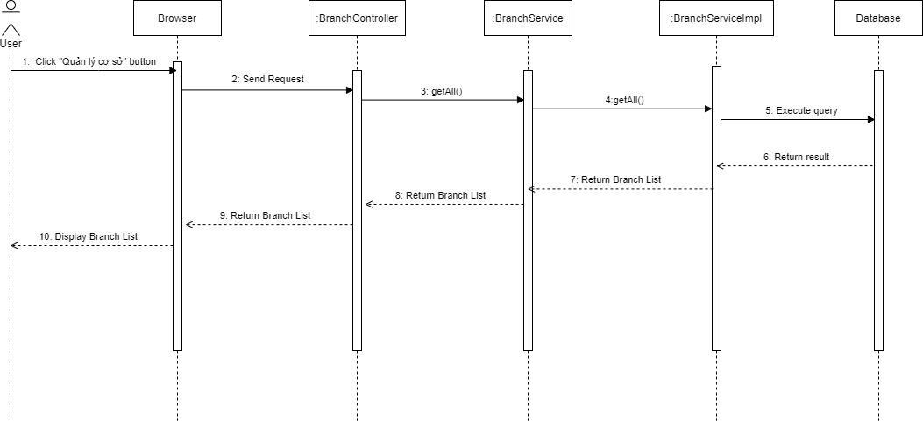

- Create branch

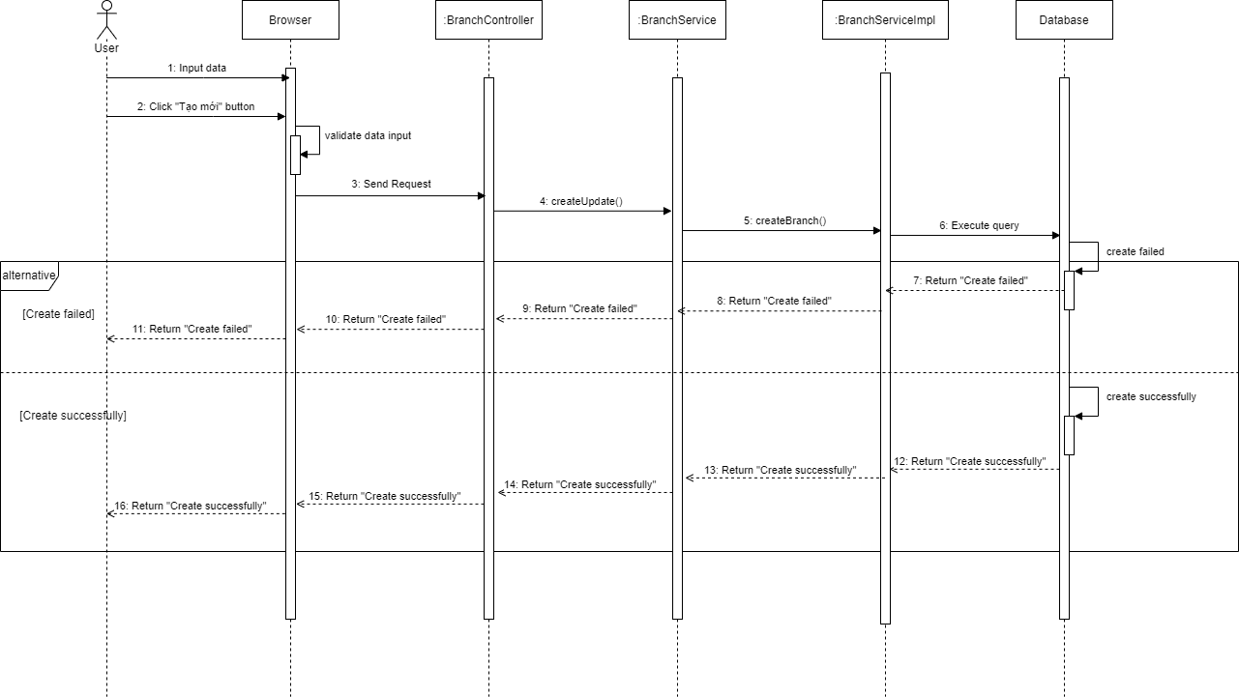

- Update branch

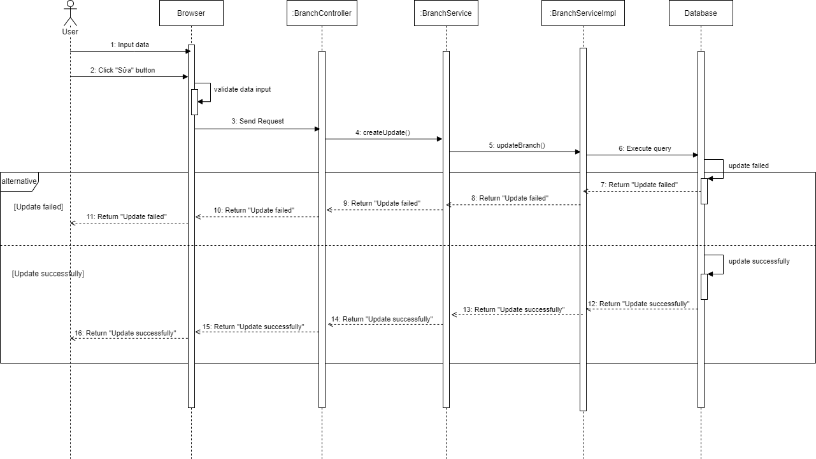

- Delete branch

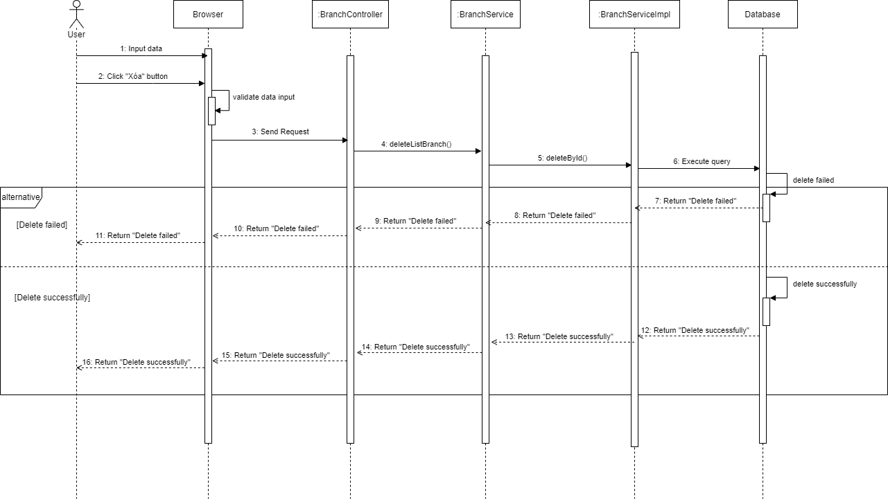

### 3.5 Manage Data Config

***3.5.1 Class Diagram***

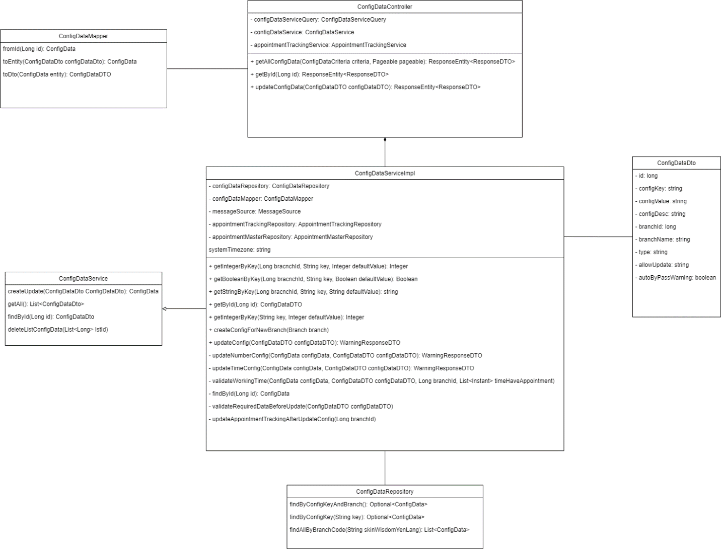

*Figure 3.5.1: Data config’s Class Diagram*

***3.5.2 Sequence Diagram***

- View data config list

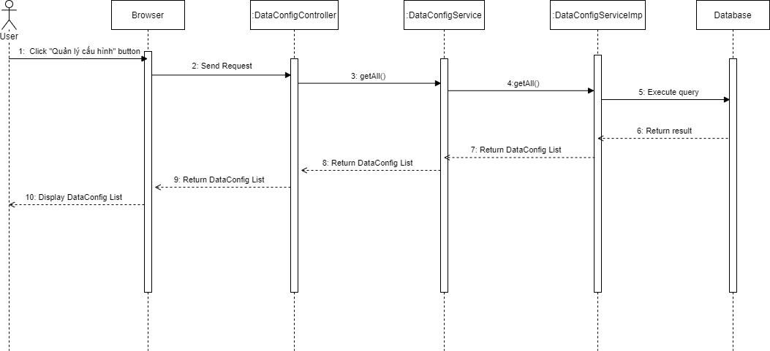

- Create data config

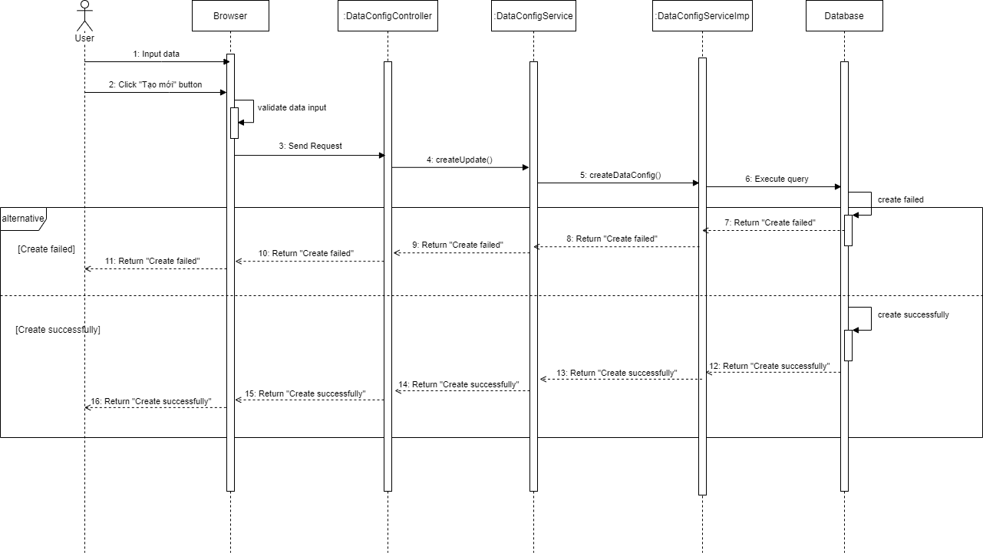

- Update data config

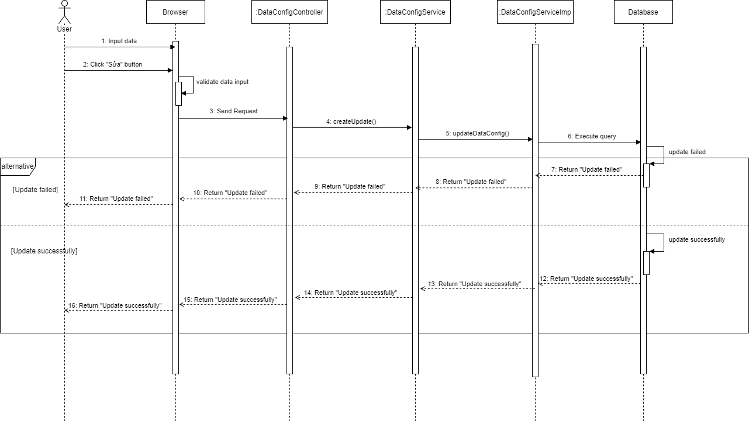

- Delete data config

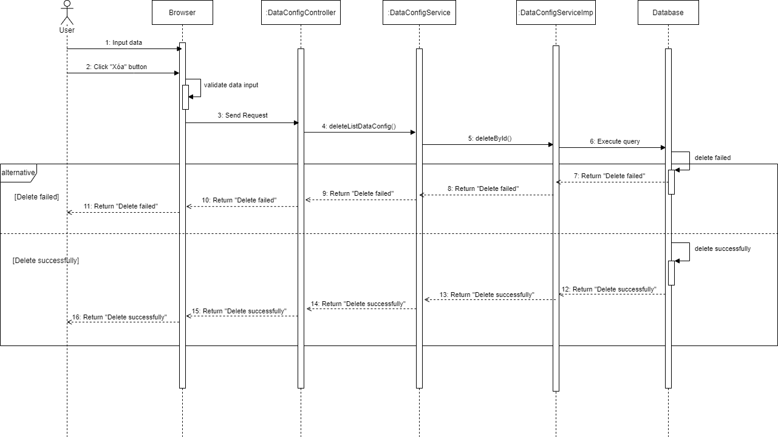

### 3.6 Manage Course

***3.6.1 Class Diagram***

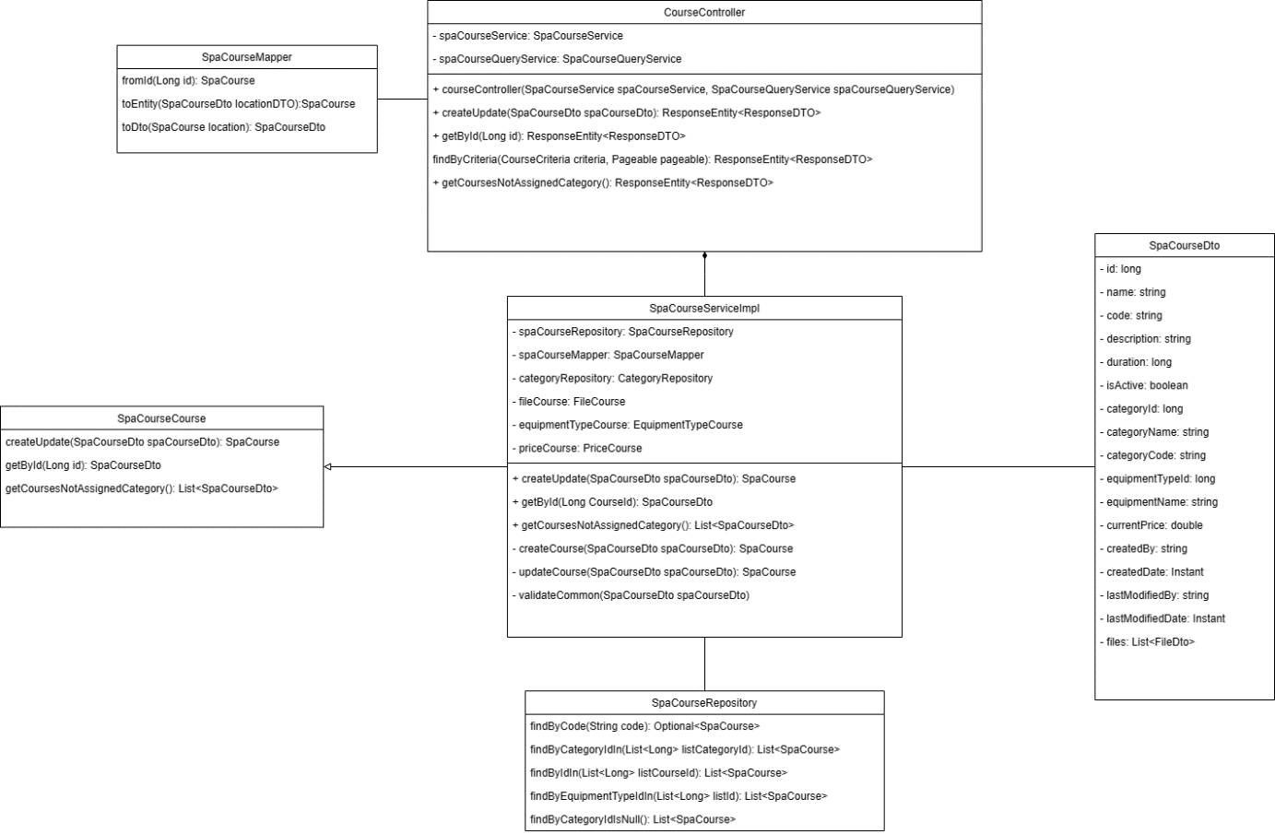

***3.6.2 Sequence Diagram***

- View course list

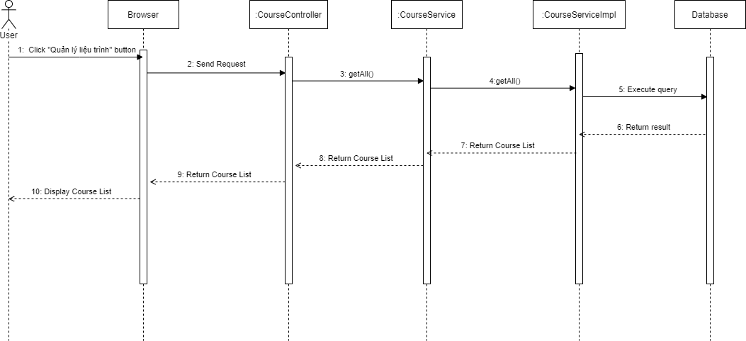

- View course detail

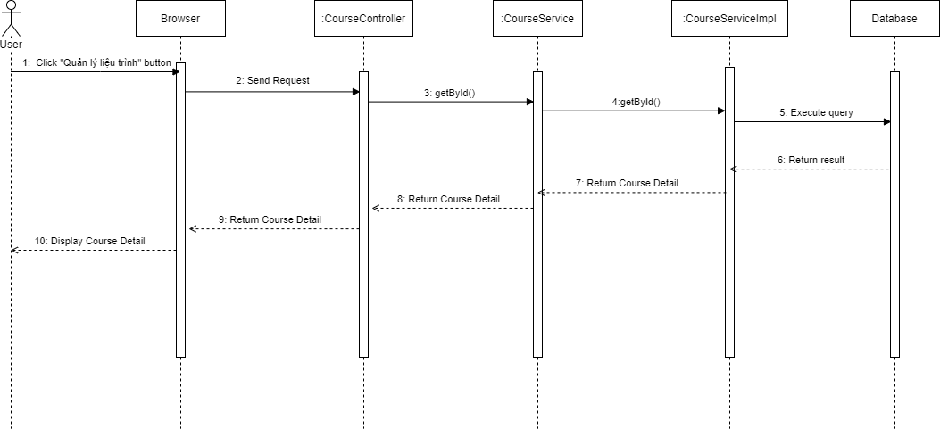

- Create course

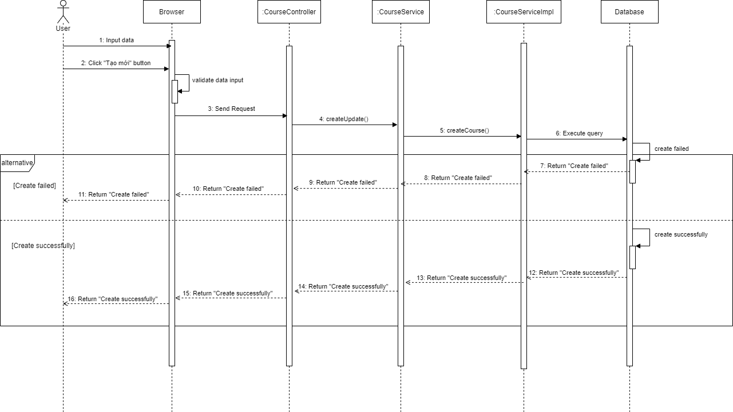

- Update course

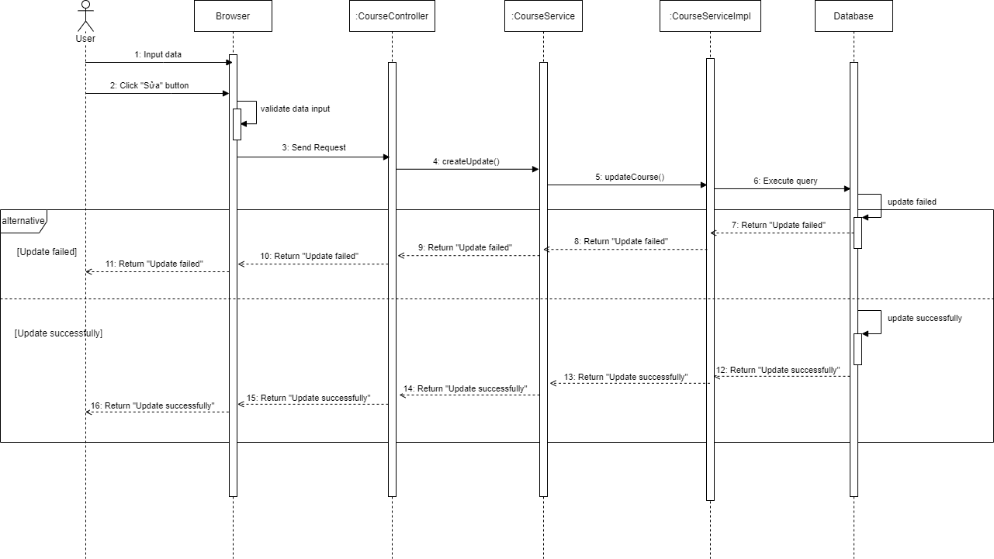

- Delete course

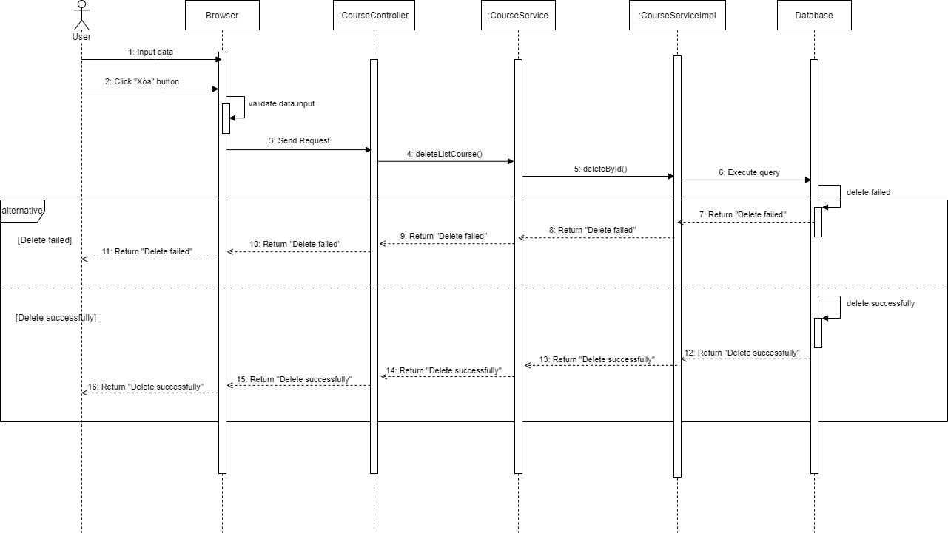

### 3.7 Manage Device

***3.7.1 Class Diagram***

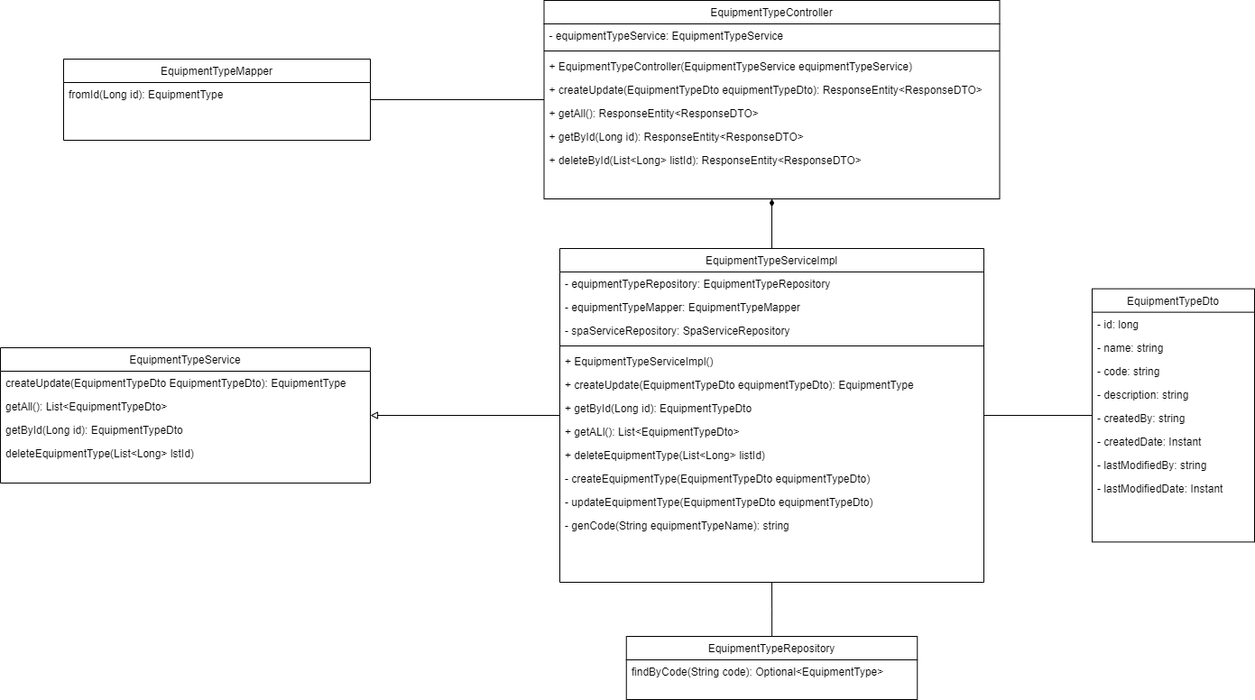

*Figure 3.7.1: Device’s Class Diagram*

***3.7.2 Sequence Diagram***

- View device list

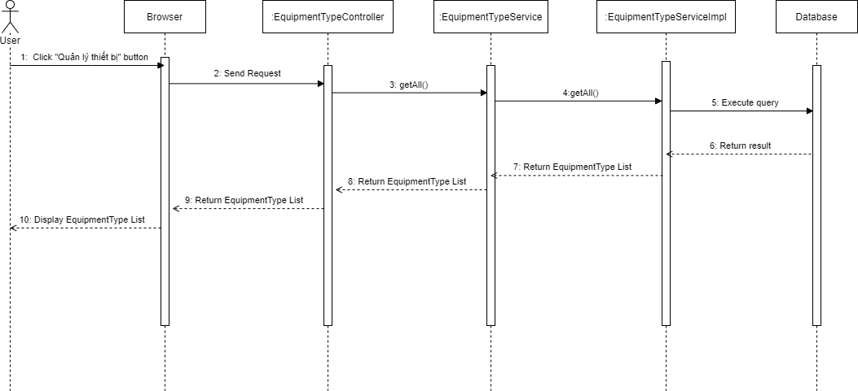

- Create device

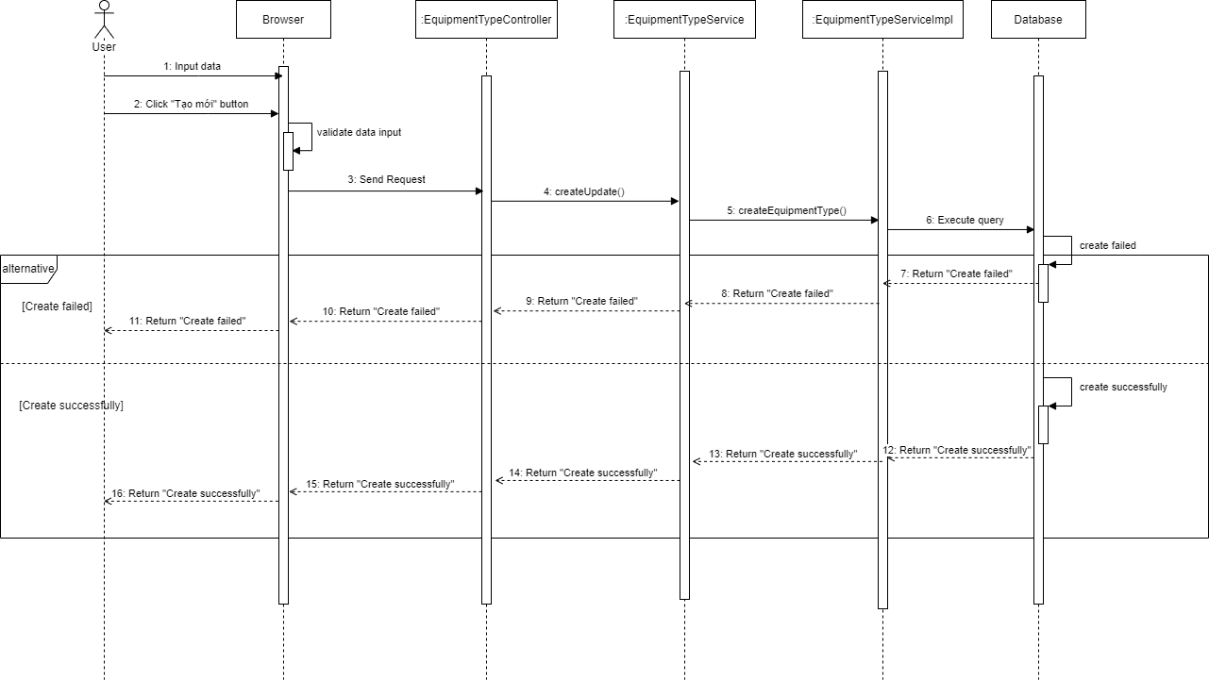

- Update device

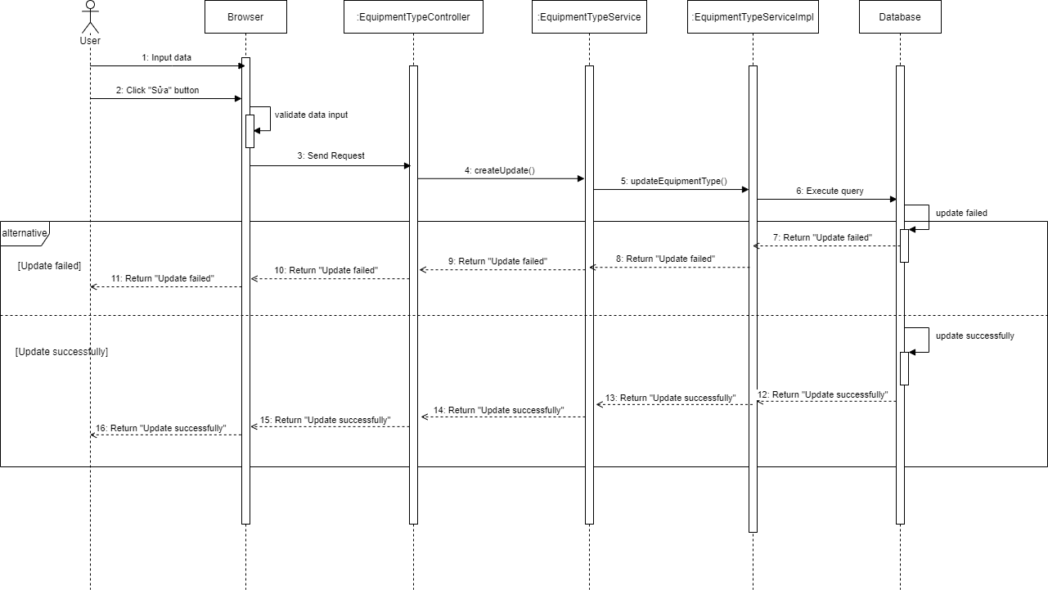

- Delete device

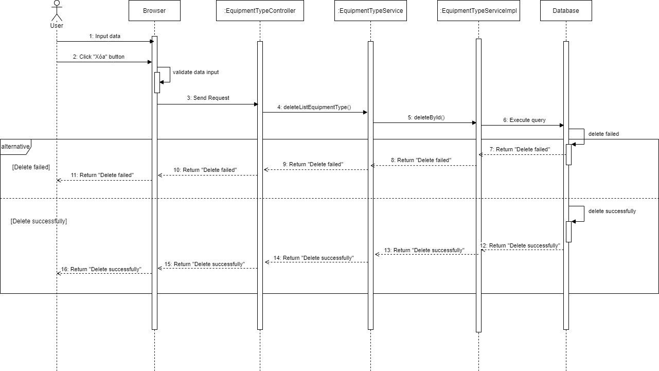

### 3.8 Manage Appointment

***3.8.1 Class Diagram***

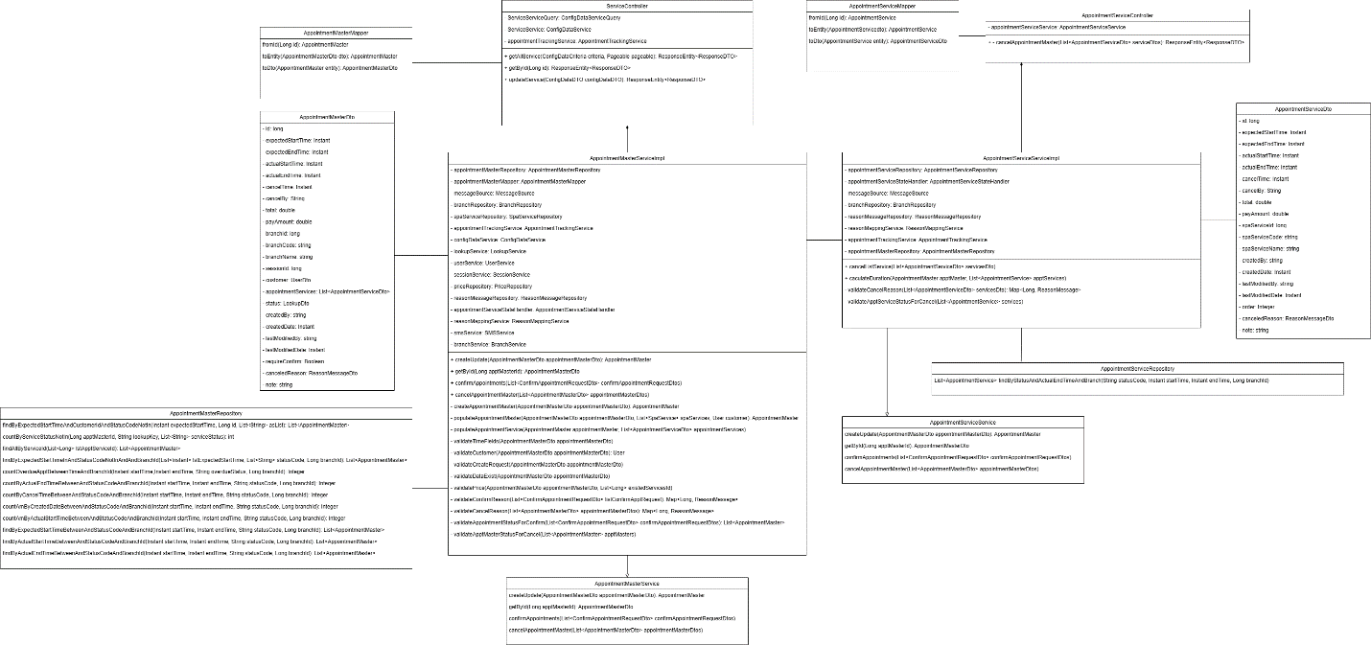

*Figure 3.8.1: Appointment’s Class Diagram*

***3.8.2 Sequence Diagram***

- View appointment list

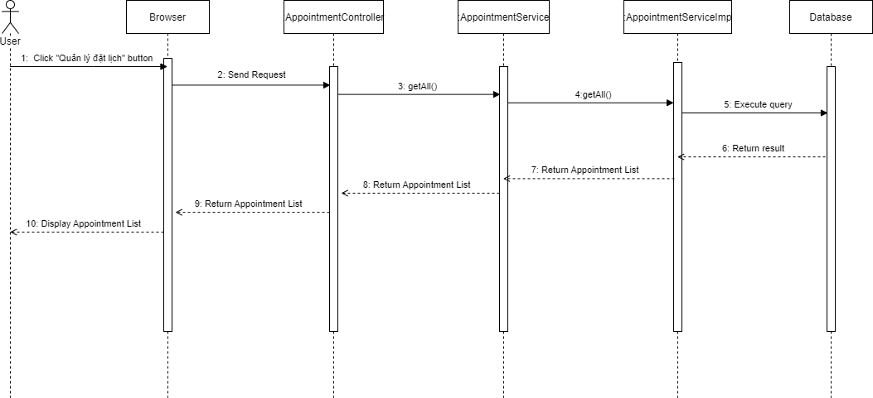

- View appointment detail

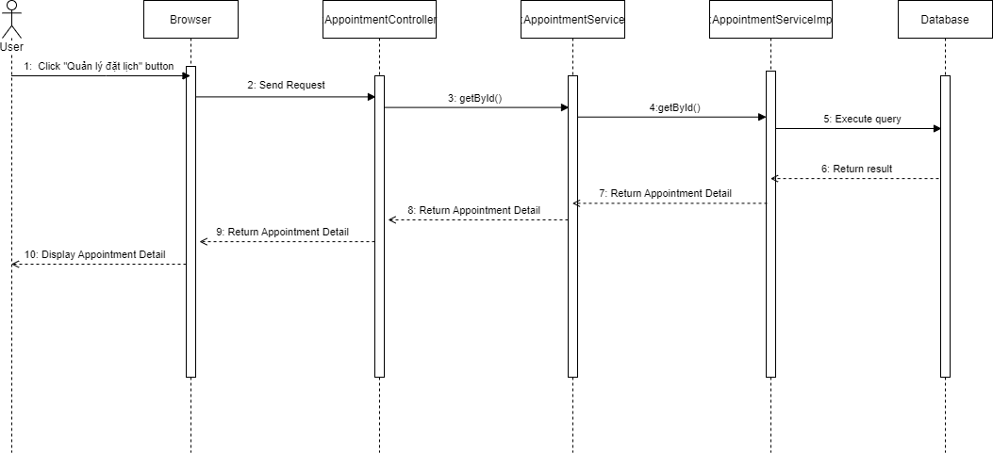

- Create appointment

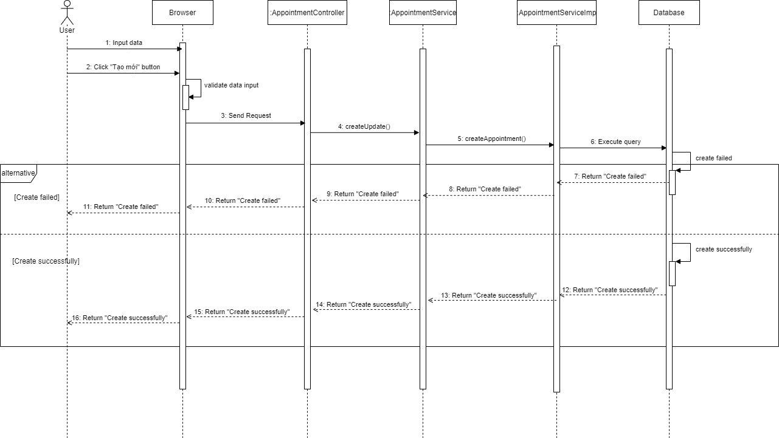

- Update appointment

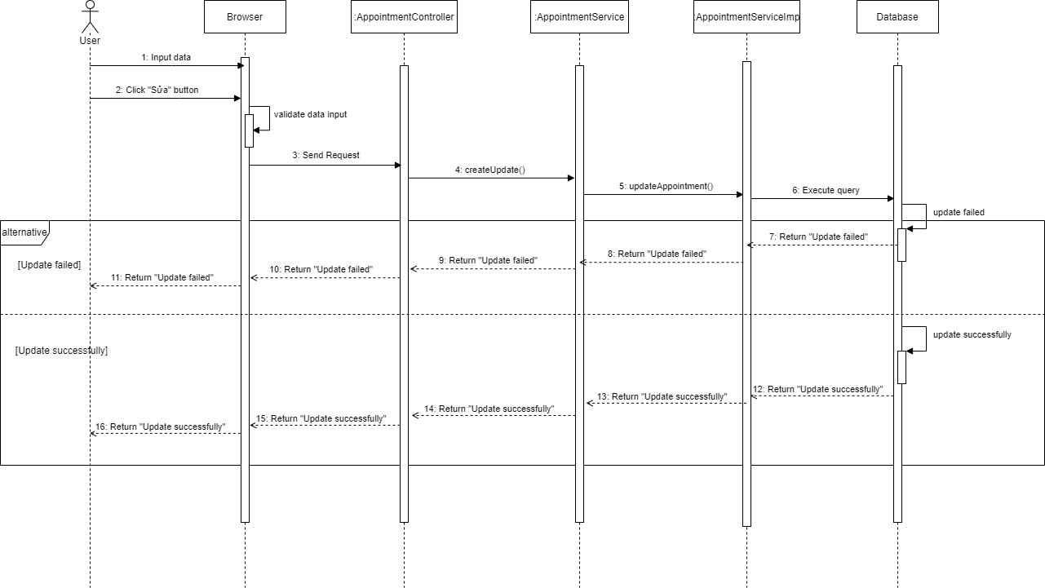

- Delete appointment

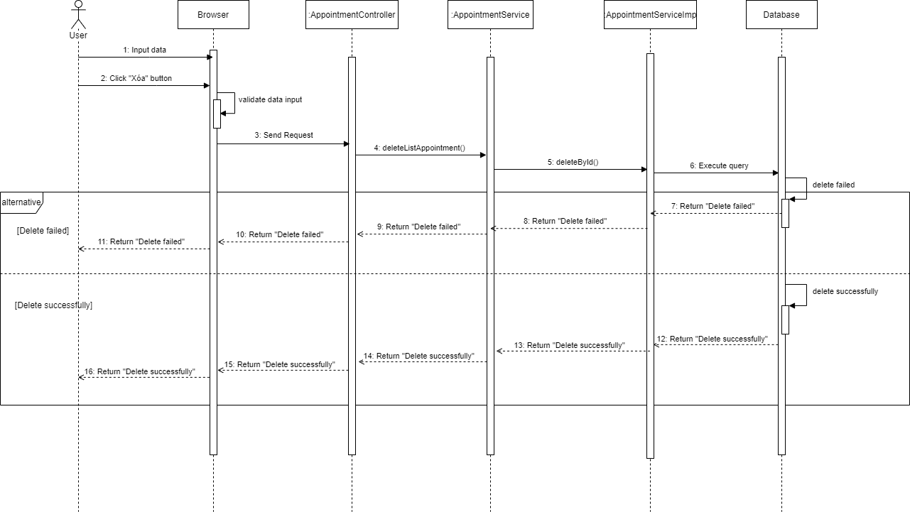

### 3.9 Manage Voucher

***3.9.1 Class Diagram***

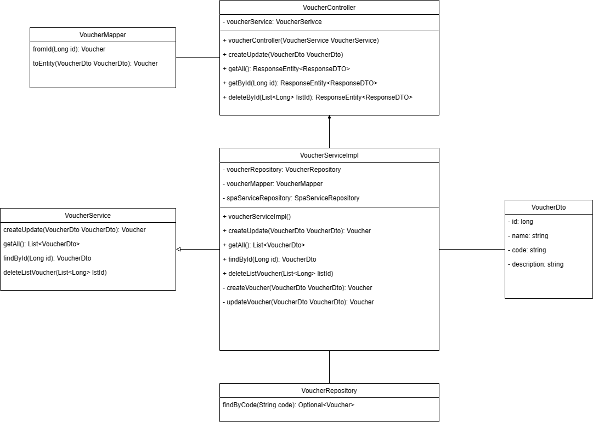

***3.9.2 Sequence Diagram***

- View voucher list

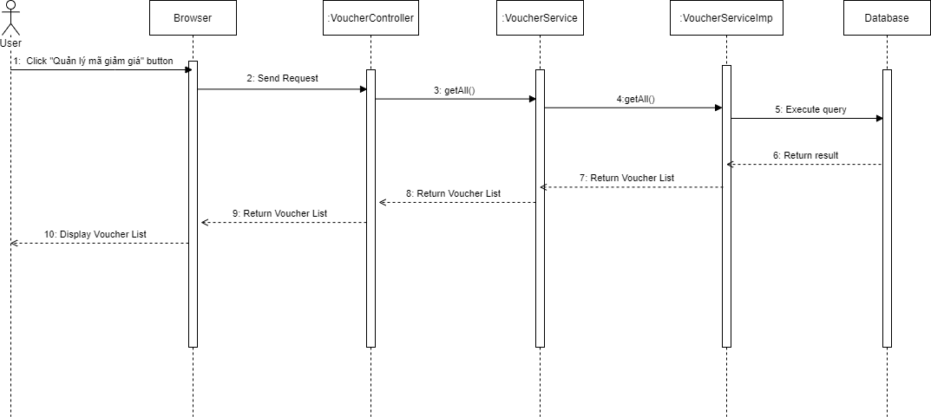

- Create voucher

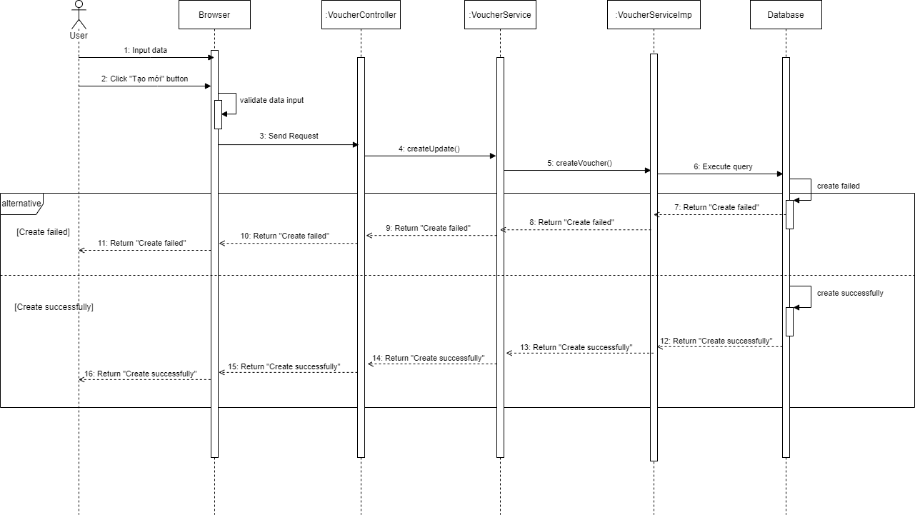

- Update voucher

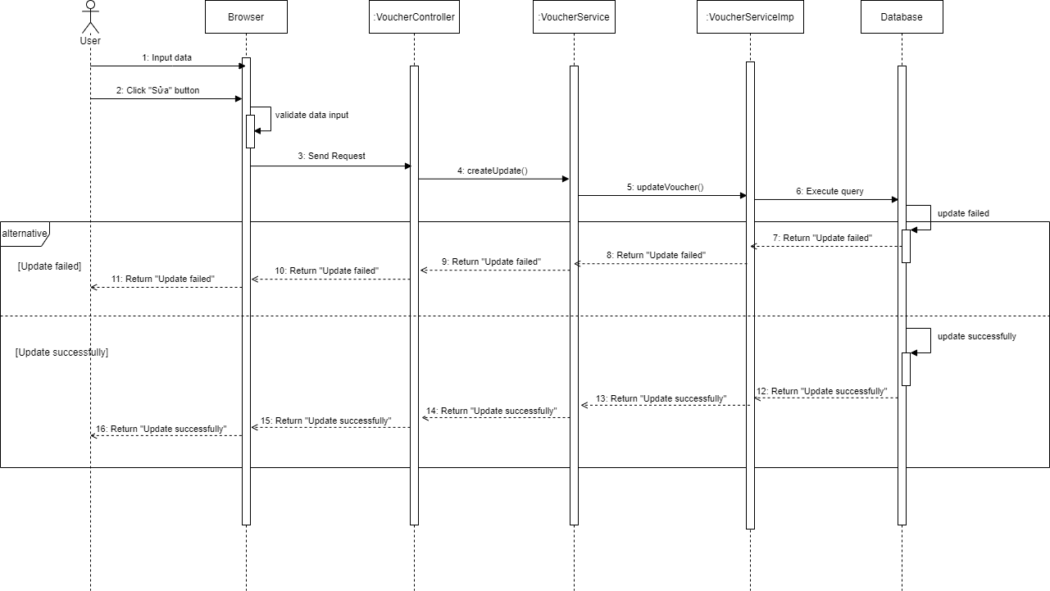

- Delete voucher

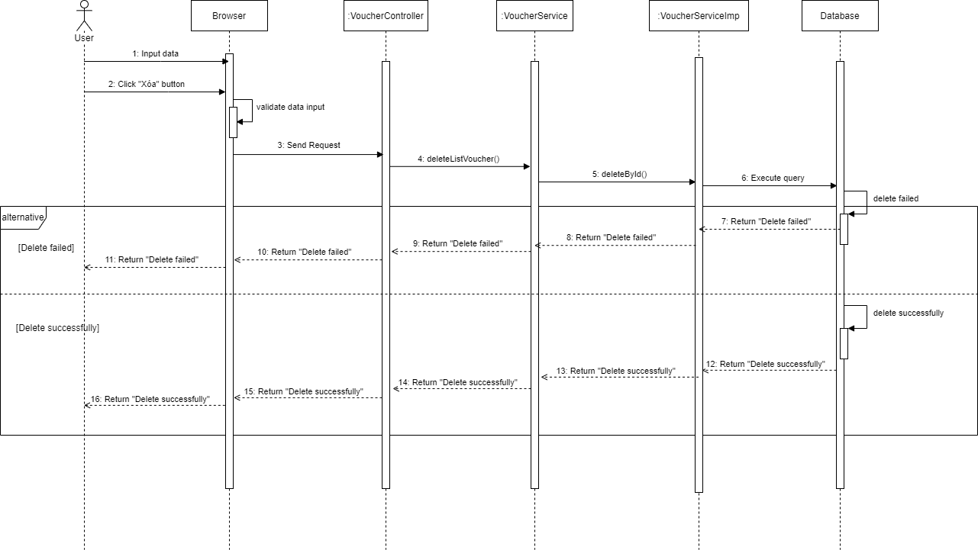

### 3.10 Manage SCA Form

***3.10.1 Class Diagram***

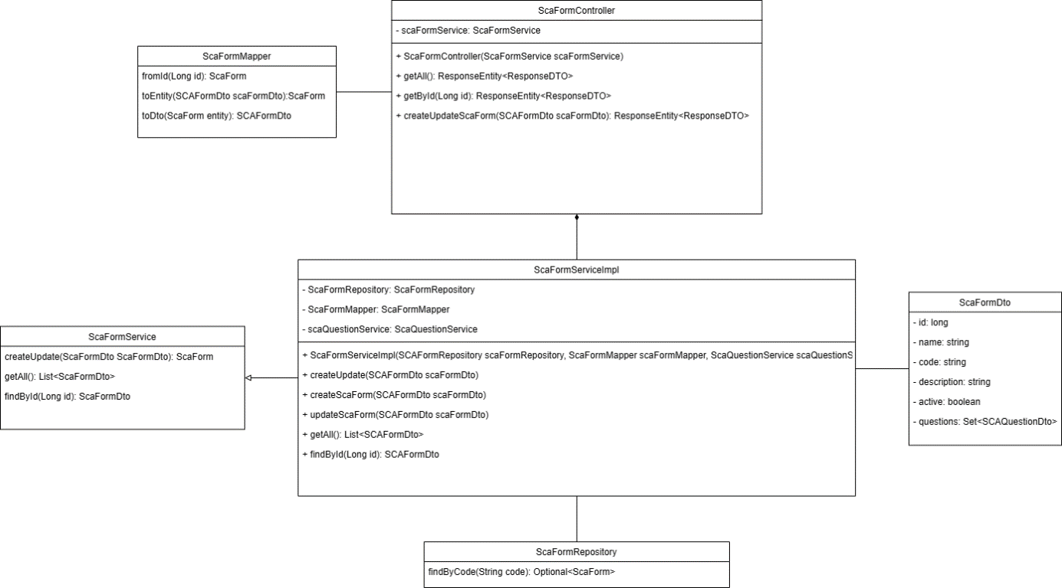

***3.10.2 Sequence Diagram***

- View form list

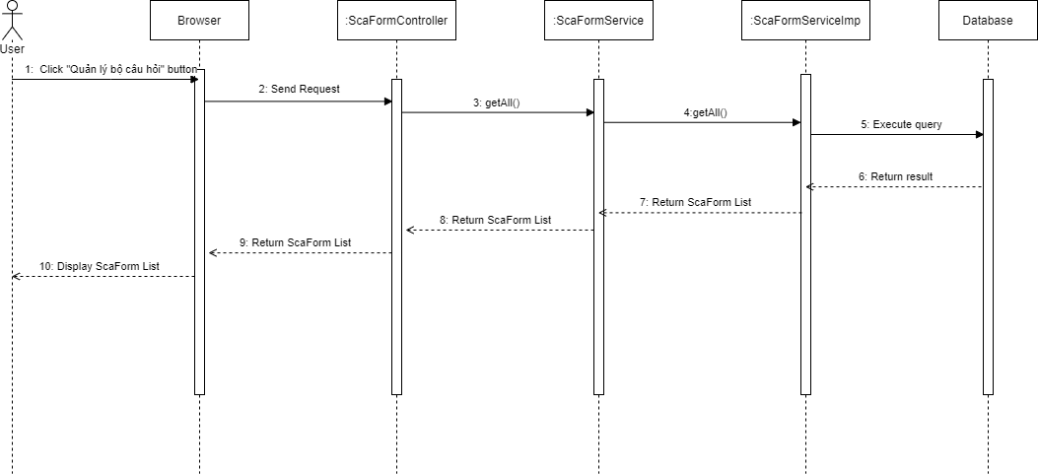

- View form detail

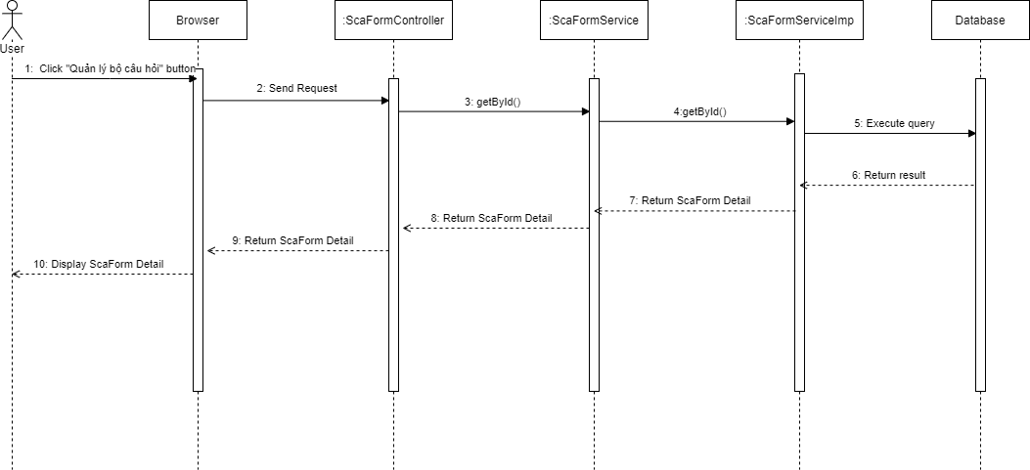

- Create form

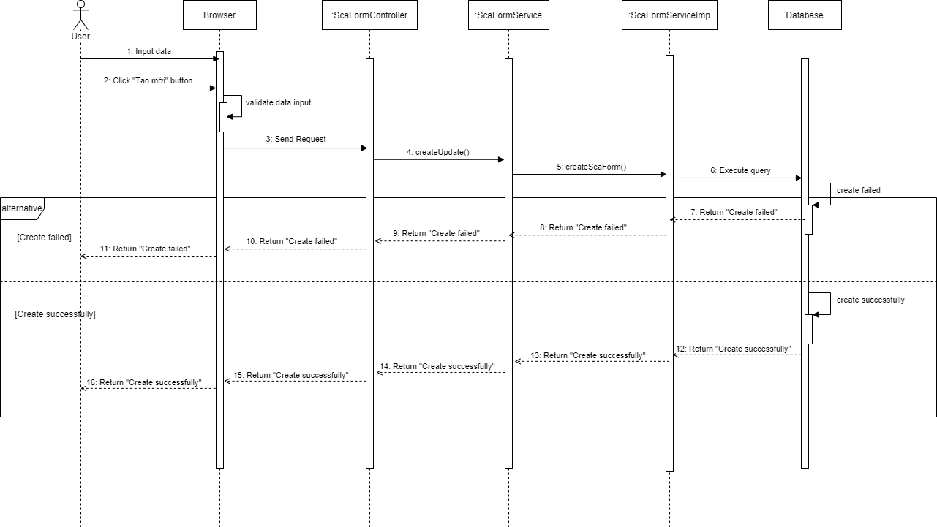

- Update form

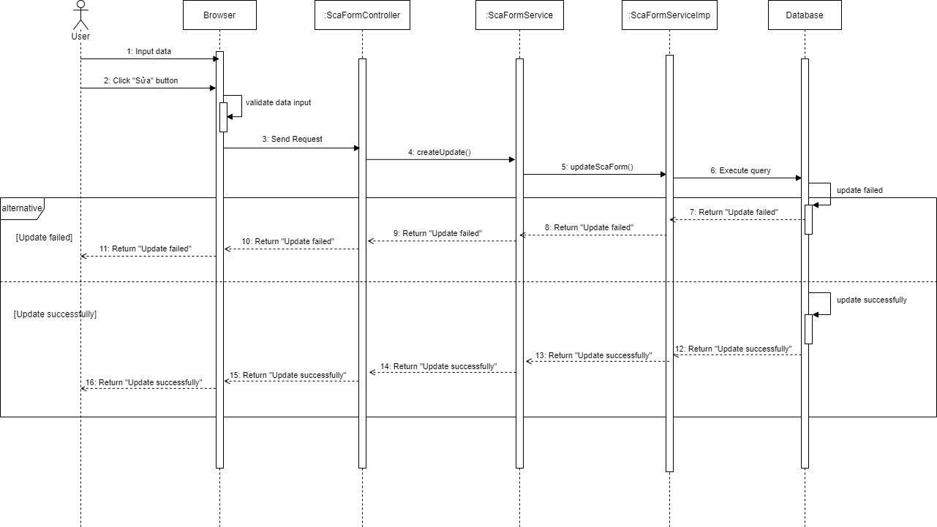

- Delete form

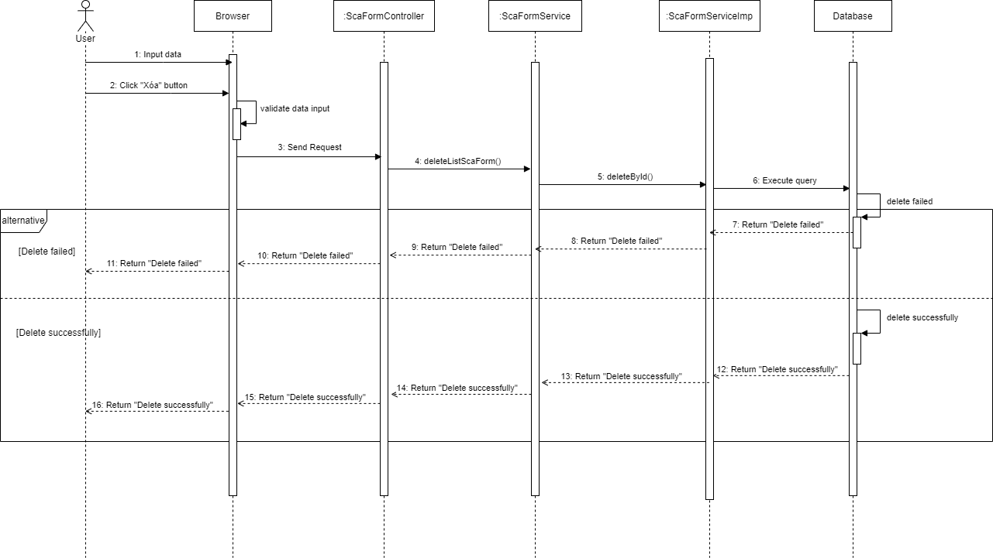

### 3.11 Manage Account

***3.11.1 Class Diagram***

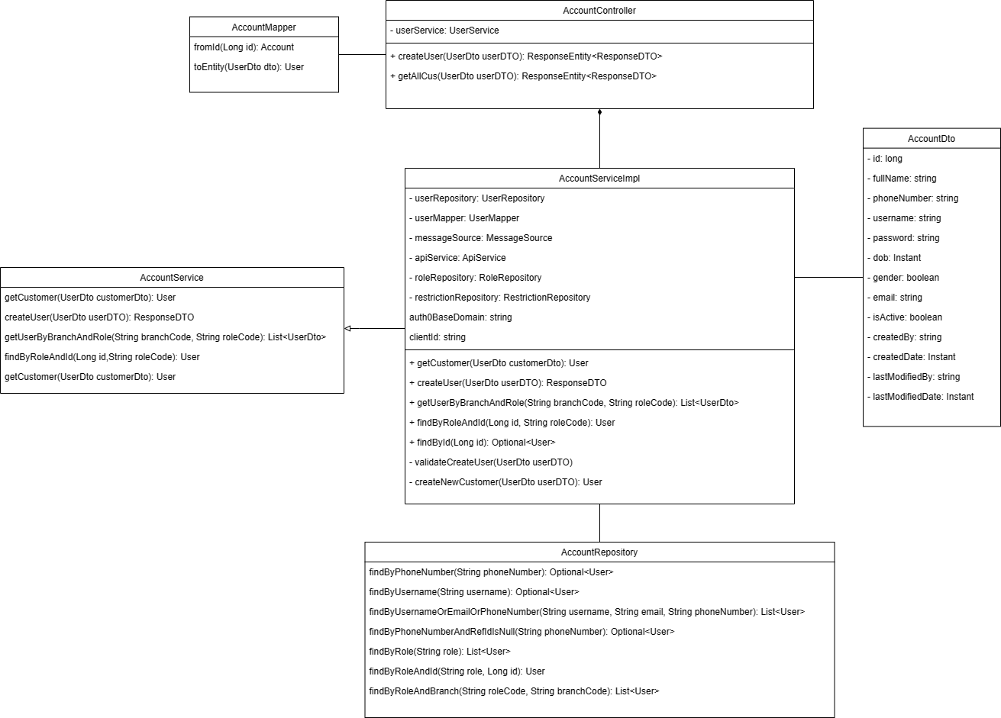

***3.11.2 Sequence Diagram***

- View account list

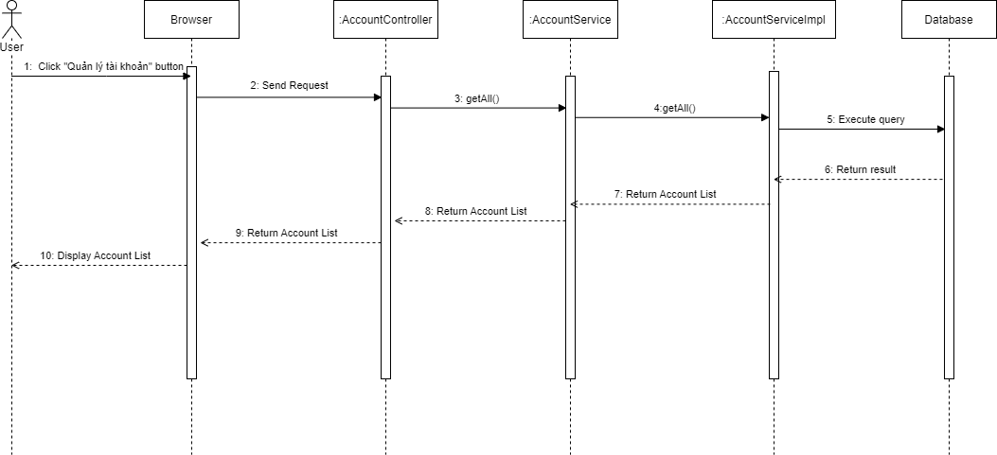

- Create account

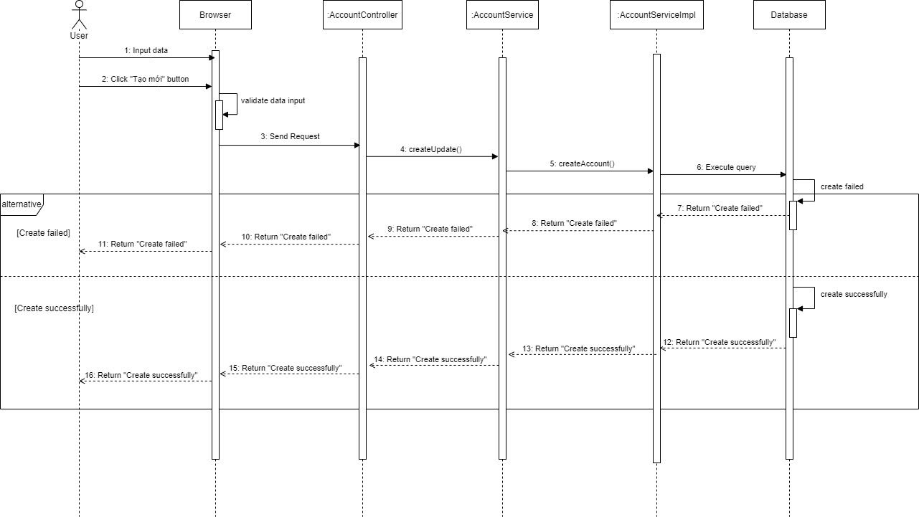

- Update account

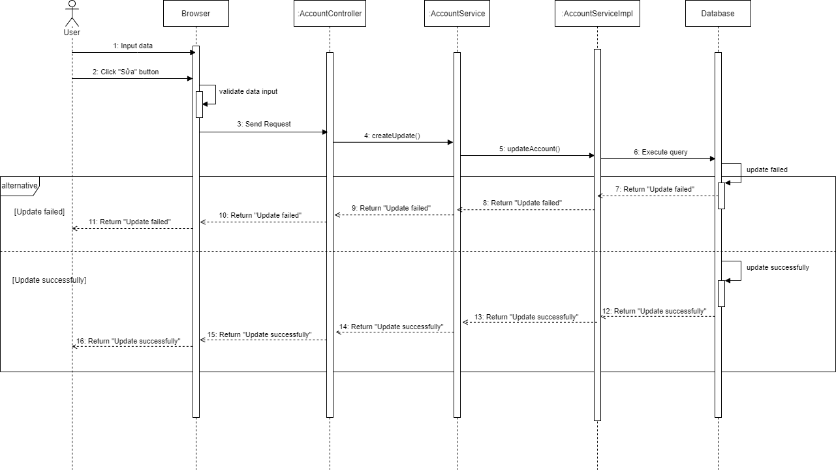

- Delete account

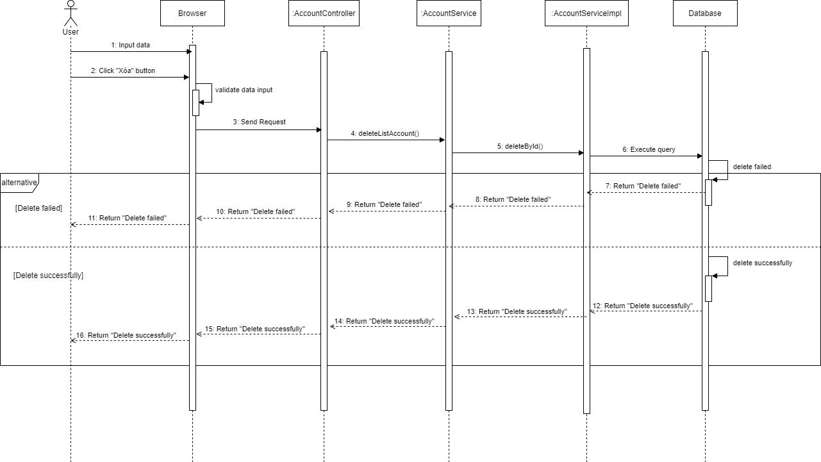

### 3.12 Manage Notification

***3.12.1 Class Diagram***

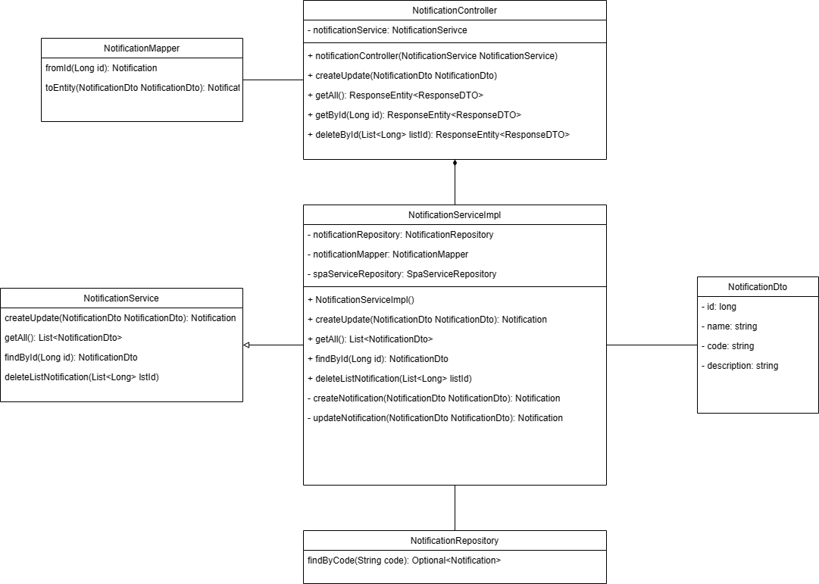

***3.12.2 Sequence Diagram***

- View notification list

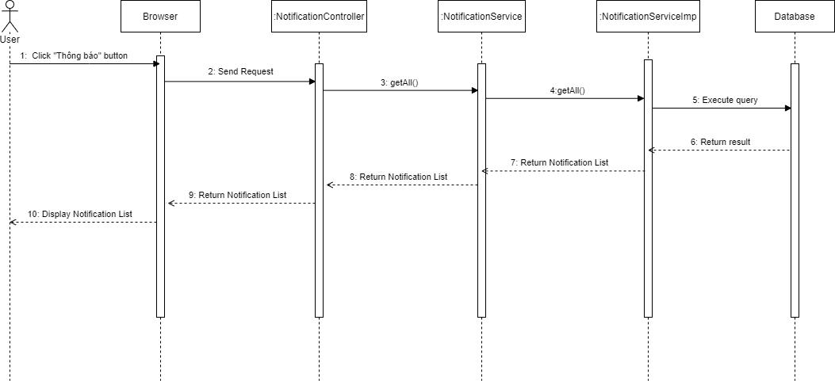

# V. Software Testing Documentation

# VI. Release Package & User Guides